Activity course makes life-changing difference to teenagers
Monday, 26 March 2018
A special course which combined ground-breaking therapy with outdoor activities has made a dramatic difference to two teenagers’ speech problems.
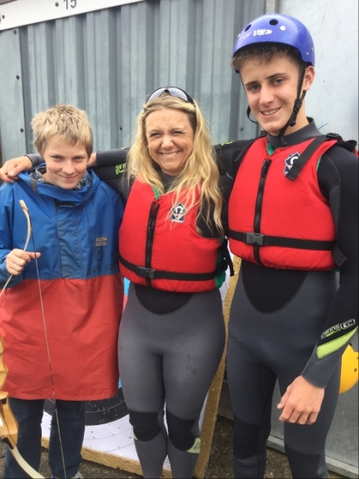
Kieron Owen and Harvey Jones-Davies, both 14, attended the five-day course along with their speech and language therapist ABMU’s Lowri Roberts who has been helping them cope with stammering.

The boys say the residential course, held at Skern Lodge activity centre in Devon, has made a remarkable difference to their lives – giving them confidence and techniques to manage stammering more positively.

Kieron Owen (left) and Harvey Jones-Davies with speech and language therapist Lowri Roberts during the course.

Kieron, of Bridgend, said: “It was fun, fantastic. It helped me a lot coming to Skern Lodge. I stammer less and feel better about myself.”

Harvey, from Clydach, added: “I was asked if my expectations of this course were fulfilled, my response was no. My expectations were to cut my stammer out of me completely but what instead happened was something much better - I learnt how to accept and work with my stammer.”
The course was a unique opportunity to combine intensive speech therapy with challenging outdoor activities.

Because therapist Lowri volunteered to assist during the course the two boys were offered free places and were among nine young people from all over the UK who attended.

She said: “It has been wonderful to share Kieron and Harvey's journey in becoming more confident and positive about their communication.

“The residential course helped them manage their stammer and increase the feeling of fluency control.

“The balance of physical activity and group work helped them overcome their fears about speaking. Both have demonstrated that they are strong young people who can deal with their stammer."

Developing confidence and self-esteem are vital factors in dealing with the emotional and physical challenges of stammering.

Lowri explained that by taking part in a variety of activities including an assault course and tackling a climbing wall, high ropes and river kayaking, the teenagers overcame their fears and transferred this to speaking situations.
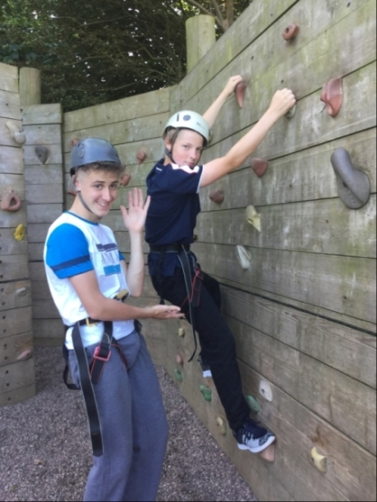
During the course the youngsters taking part followed a specific programme which included up to five hours of intensive speech therapy in addition to the outdoor activities.

Harvey Jones-Davies and Kieron Owen tackle one of the challenges.
Daily group time sessions consisted of intensive speech therapy using the award-winning Swindon Fluency Packs which provide ideas, activities, games and worksheets to help teenagers.

Kieron’s mum Laura Sedgebeer added that since doing the course her son was much happier in himself.

“He really is so much more confident. The course brought him that confidence, it was good for him to be part of a team with other people,” she said.

Harvey’s mum Danni added: “Skern Lodge was a life-changing experience for our son. He came back well equipped for dealing with his stammer.”

Source: Abertawe Bro Morgannwg University Health Board

