Donation helping to bring high-tech support to youngsters in their communities
Thursday, 1 March 2018
A high-tech new initiative to bring specialised ABMU speech and language therapists into the classroom of their young patients at the touch of a button has been given a major boost by fundraisers.

The telemedicine project using iPads to connect youngsters with expert staff at Morriston Hospital has been successfully trialled over the past few months.

Now Helen Extence, lead speech and language therapist with the cleft lip and palate team, is hoping to be able to buy more specialist equipment to allow more children in the community to access therapy support from the Welsh Centre for Cleft Lip and Palate.

Tele health links are made via Skype for Business to the child’s school where the local speech and language therapist or assistant can be directly supported to deliver therapy. This can save children and their parents having to come to Swansea for appointments.
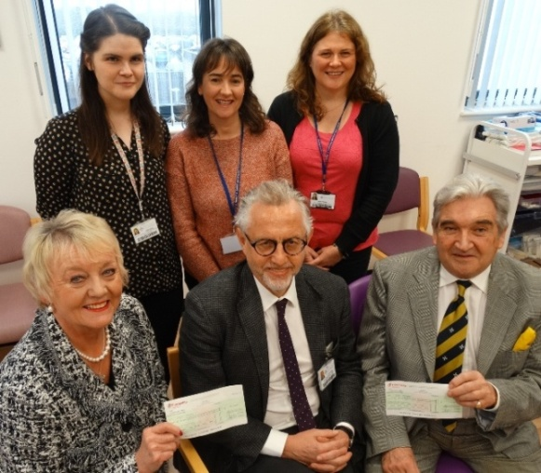
(From left, back) specialist speech and language therapist Niamh Ward, lead speech and language therapist with the cleft lip and palate team Helen Extence and Shirley Williams, speech and language assistant. (Front) Paulette Smith, consultant in restorative dentistry Karl Bishop and Roger Smith

The plan has been given a helping hand by the family of a Swansea Valley-born mum who was treated at the Morriston-based centre during her own illness.

Former nurse Rebekah Bartolozzi died in 2015 aged 43 but the care she received from the team left a lasting impression on her parents Roger and Paulette Smith, of Clydach.

They have now handed over a cheque for £1,300 which will be used to give the project a helping hand.
Rebekah was diagnosed with chordoma, a rare type of cancer, in 1992 and was treated by surgeons in Liverpool and at Morriston where she also received rehab care from the cleft team, especially speech and language therapists and restorative dentists, including Helen and consultant Karl Bishop, now ABMU’s Dental Director.

Mrs Smith, who represents Clydach on Swansea Council, said the money was raised at a fashion show by June Jones of Rowberry’s held in Rebekah’s memory at Manor Park in Clydach last year.

She said: “The event featured a fashion show as well as a two-course dinner and raffles. It was a super evening and everybody really went the extra mile to support such a good cause.

“We are delighted that their generosity means we are able to help the team with such a fantastic project. The more children that can be reached the better.”

This is the second significant gift the family have made to the centre in their daughter’s memory. Last year they handed over £1,710 which was donated by the community following Rebekah’s death.
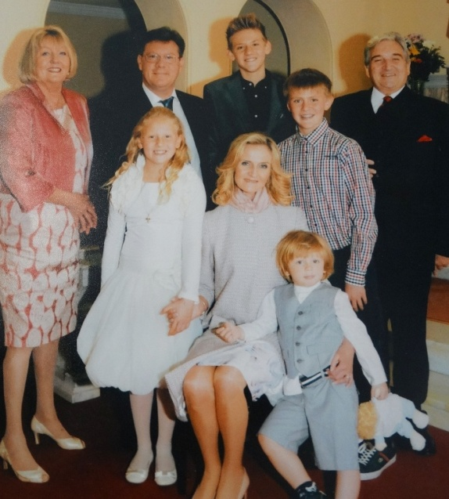
She and her husband Fabio, a cardiothoracic surgeon, met while working at the University Hospital of Wales in Cardiff. They had four children – Edward, Henri, Sophia and Federico - and lived in Galway.

Rebekah Bartolozzi (centre) with her parents, husband Fabio and four children.

Specialist speech and language therapist Niamh Ward, who is from the same part of Ireland where Rebekah made her home, explained to the Smiths how the project would work.

Around 40 babies a year are born with cleft lip or palate within the South Wales region and approximately half of the children will go on to require speech and language therapy following their surgery.

Helen said: “Where possible, therapy is delivered close to the child’s home and often in school by a community speech and language therapists, assistant or class support teacher. Tele health allows us to support this therapy, providing advice and direct intervention.

“Because we offer a regional service some patients live a very long way from here – we see children from Monmouth to Aberystwyth – this can place a huge burden on families to attend for specialist therapy so using telemedicine is the next natural extension of our care.”

Niamh added: “We can leave iPads with speech and language therapy assistants or classroom assistants at a child’s school and we can hold a consultation using Skype.

“When that child no longer needs the same level of assistance the iPad can then be passed on to someone else. It means that we can support children to develop their communication skills in their everyday environment and this requires less time out of school to travel to Swansea.”

Mr Smith said: “This was a cause that was very close to Rebekah’s heart. During her nurse training she worked in paediatrics and was a devoted mother but she also had first-hand experience of the care and support the cleft lip and palate team can offer. She would very much approve of this project.”

The couple also handed over a cheque for £100 towards the Northern Cleft Foundation, a charity supported by Morriston cleft surgeon David Drake which sees UK doctors providing surgery for cleft lip and palate patients in India.

Source: Abertawe Bro Morgannwg University Health Board

