Expert advice to cope with your ailment - without waiting to see a GP
Tuesday, 27 March 2018
If you don’t like bothering your doctor with minor ailments, the good news is now you don’t have to.

Under a new service being offered at a growing number of local chemists, specially trained pharmacists are now able to prescribe medicines and advise patients about 26 minor conditions.

The Common Ailments Scheme is giving people faster access to the treatment they need while at the same time giving GPs more time to help sicker patients.

People can either be referred by their doctor, without the need for a GP appointment, or can register for the service themselves. Either way, all consultations with the pharmacist are done confidentially and in private.

The service is operating in many pharmacies already in the Swansea, and is planned to be available in all 125 pharmacies in the ABMU Health Board area by August this year.

One patient who has already seen the benefits of the scheme is 85-year-old Edward Holland, from Fforestfach, Swansea (right).

He said: “I normally see the doctor but my daughter told me about the new scheme and suggested that I come to the pharmacy instead.”

Edward had a skin rash on his leg for which pharmacist Eileen Davies, of the Well Pharmacy in Ravenhill Road, Fforestfach, prescribed an ointment and a moisturiser.

“It’s definitely easier than going to see my GP,” said Edward. “You just walk in. I reckon it’ll take a lot of pressure off the doctors and get us seen a lot quicker.”

Eileen has undergone additional training to become registered to provide the Common Ailments Service.

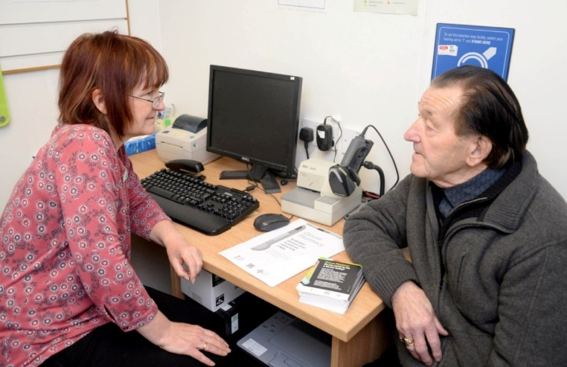
“When a prescription-only drug is given by anyone other than a doctor, certain conditions must be met. That is why pharmacists are getting extra training to provide the service,” she said.

The registered pharmacists also carefully assess each patient’s needs.

Edward Holland has a consultation with pharmacist Eileen Davies.

“After I’ve spoken to someone I might decide they need to see the GP after all,” said Eileen.

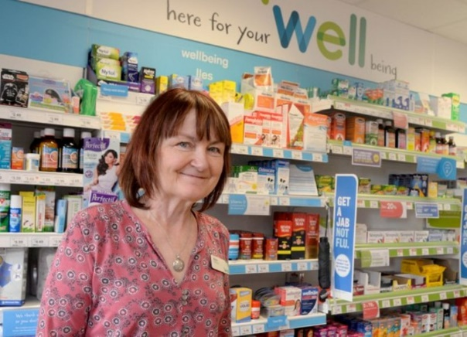
“For example a young man came in to get a sore throat treated but I spotted he was wheezing badly so I referred him back to his doctor.

“We also put a lot of emphasis on advising the patient on how to avoid problems or manage the condition themselves in the future. Whatever advice or treatment I prescribe, the patient’s GP gets a full record of everything within 72 hours, and we usually do it within 24 hours.”

The Common Ailments Scheme was launched at the Well Pharmacy in October so word is still getting out to patients.

“We’ve got signs up in the surgery and we are spreading the word,” said Eileen. “Our priority is to make the pharmacy the first stop for medical advice.”

In the meantime, the scheme has been given a warm welcome by local GPs.


Dr Daniel Sartori, who is based at Fforestfach Medical Centre, which is right next door to the pharmacy (right), said: “When we heard the scheme was coming we jumped at the chance.

“We welcome anything that alleviates the pressure on primary care, especially in our local area where there is a lot of demand.

“Reports we’ve had from pharmacies and our staff show there have been a lot of patients who have used the service who would otherwise have used up a doctor’s appointment.

“This is allowing GPs to concentrate on people who are sicker and need more time. It is taking some of the heat out of our system.”

Dr Heather Potter, of Skewen Medical Centre, added: “Pharmacists have been so underutilised. The quality of their work is huge. They undergo a five-year training so we need to let them in and use them more.”

Facts about the Common Ailments Scheme:
- People who are eligible to use the service are those who live in Wales and who are registered with a GP. You may be asked for some form of ID if the pharmacist does not know you;
- Patients have to register to use the service in order to receive prescribed medicines free of charge;
- You can only register with one pharmacy at a time;
- The 26 ailments covered by the Common Ailments Scheme are acne, athlete’s foot, back pain, chickenpox, cold sores, colic, conjunctivitis, constipation, diarrhoea, dry eyes, dermatitis, haemorrhoids, hay fever, head lice, indigestion, ingrowing toenails, ringworm, mouth ulcers, nappy rash, oral thrush, scabies, sore throat/tonsillitis, teething, threadworms, vaginal thrush, and verrucae.
Find out if your local pharmacy is offering the service by visiting this link and entering your postcode.

https://www.youtube.com/watch?v=WAbgg-iDink

Source: Abertawe Bro Morgannwg University Health Board

