Favourite view inspires husband’s special gift to hospital
Friday, 16 March 2018
A view of one of Gower’s best known beauty spots has now gone on display to visitors at Morriston Hospital’s Emergency Department.

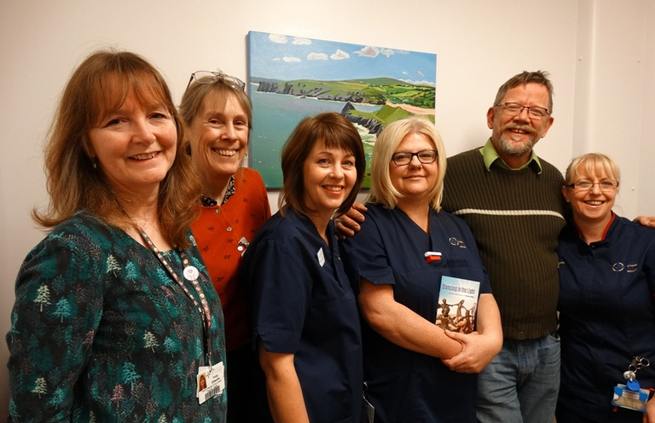
The painting has been donated to the department’s family room as a lasting legacy to patient Siobhan Miles who died at the hospital in August 2016.

Fiona Edwards, Prue Thimbleby, Karen Evans, Rebecca Clarke and Andrea Bradley with Glenn Miles.

Her husband Glenn, from West Cross, returned to the department to see the specially commissioned canvas by Swansea artist Emma Cownie in its new location.

He was also reunited with senior sister Rebecca Clarke who had cared for Siobhan when she was brought to A&E suffering from a kidney infection. Sadly her condition deteriorated rapidly, she developed septicaemia and passed away.

At the time Mr Miles and his daughter Sarah had used the family room but he said: “We felt the room was a bit stark and clinical. We wanted to do something that might help other families in the same situation that we were – something that would make it look just a little more homely.

“This painting is of a favourite view of ours – looking across towards Three Cliffs Bay. We have one like this at home so it feels like we now have real connection to the hospital and this room in particular.”

Mr Miles was joined by ED lead nurse Andrea Bradley and senior sister Karen Evans along with ABMU’s arts in health representatives Prue Thimbleby and Fiona Edwards who were responsible for placing the painting and a plaque which explains the work is “celebrating the life of Siobhan Miles by her loving husband Glenn”.
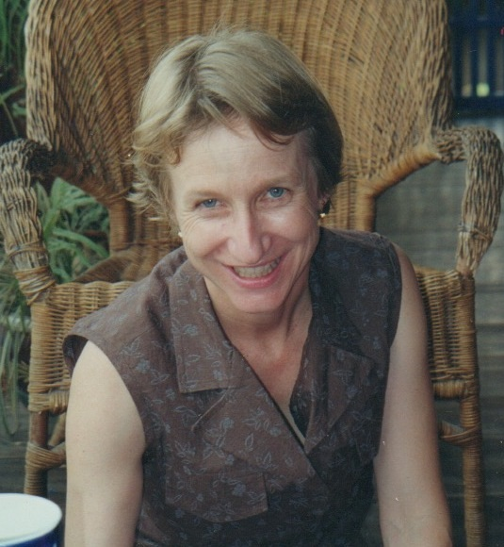
Karen Evans said: “The Emergency Department is very grateful to Mr Miles for his kind donation of this painting.

“It will make a big difference to our family room. This area is dedicated to relatives and offers a quiet and calm environment away from the clinical area.”

Mum-of-three Mrs Miles, (right) who was born in San Francisco, was just 56 when she died.

She and her husband, who both trained as nurses, met while they were supporting Cambodian refugees in Thailand and spent many years working overseas before settling in Swansea.

Her name now also lives on in the Cambodian capital Phnom Penh at the Siobhan Miles Memorial Library and Resource Centre which was funded with donations from the couple’s many friends around the world.

The family have also erected a bench, not far from the view captured in the painting, along one of the couple’s favourite Gower walks.

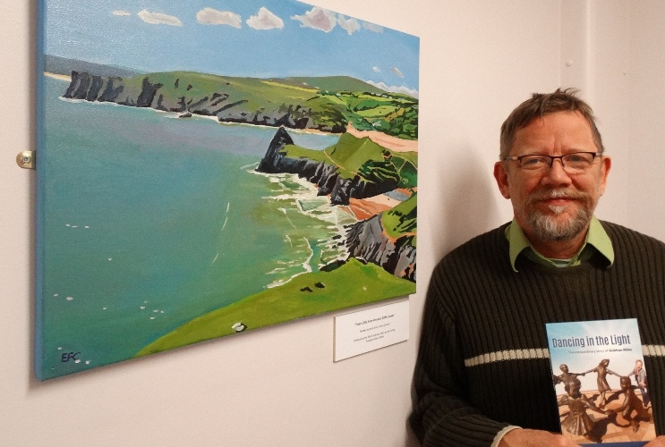
Mr Miles has also published his wife’s life story, Dancing into the Light, detailing their life together and her passion for her family, friends and faith, which he presented to staff who cared for her.

Glenn Miles with a copy of the book he has written as a tribute to his wife Siobhan and the painting he has donated to the family room.

Following his wife’s death, Mr Miles is now eager to raise awareness of sepsis, known as the silent killer.

Sepsis occurs when the body’s response to infection injures its own organs. Identification can be difficult because the symptoms often resemble other, less serious conditions.

The Emergency Department at Morriston is at the forefront of raising awareness about the condition and has established its own team, SeGMED (Sepsis Group Morriston ED) to highlight the issue.

Led by Dr Rangaswamy Mothukuri, the group has been enlisting a team of sepsis champions, clinical staff who are actively supporting the campaign and helping to spread the word about how important early detection is in treating the condition.

Source: Abertawe Bro Morgannwg University Health Board

