Hospital staff help Lindsay get to his wedding on time
Friday, 2 March 2018
Get me to the church on time took on a whole new meaning for Lindsay Griffiths when he was hospitalised a week before his wedding day.
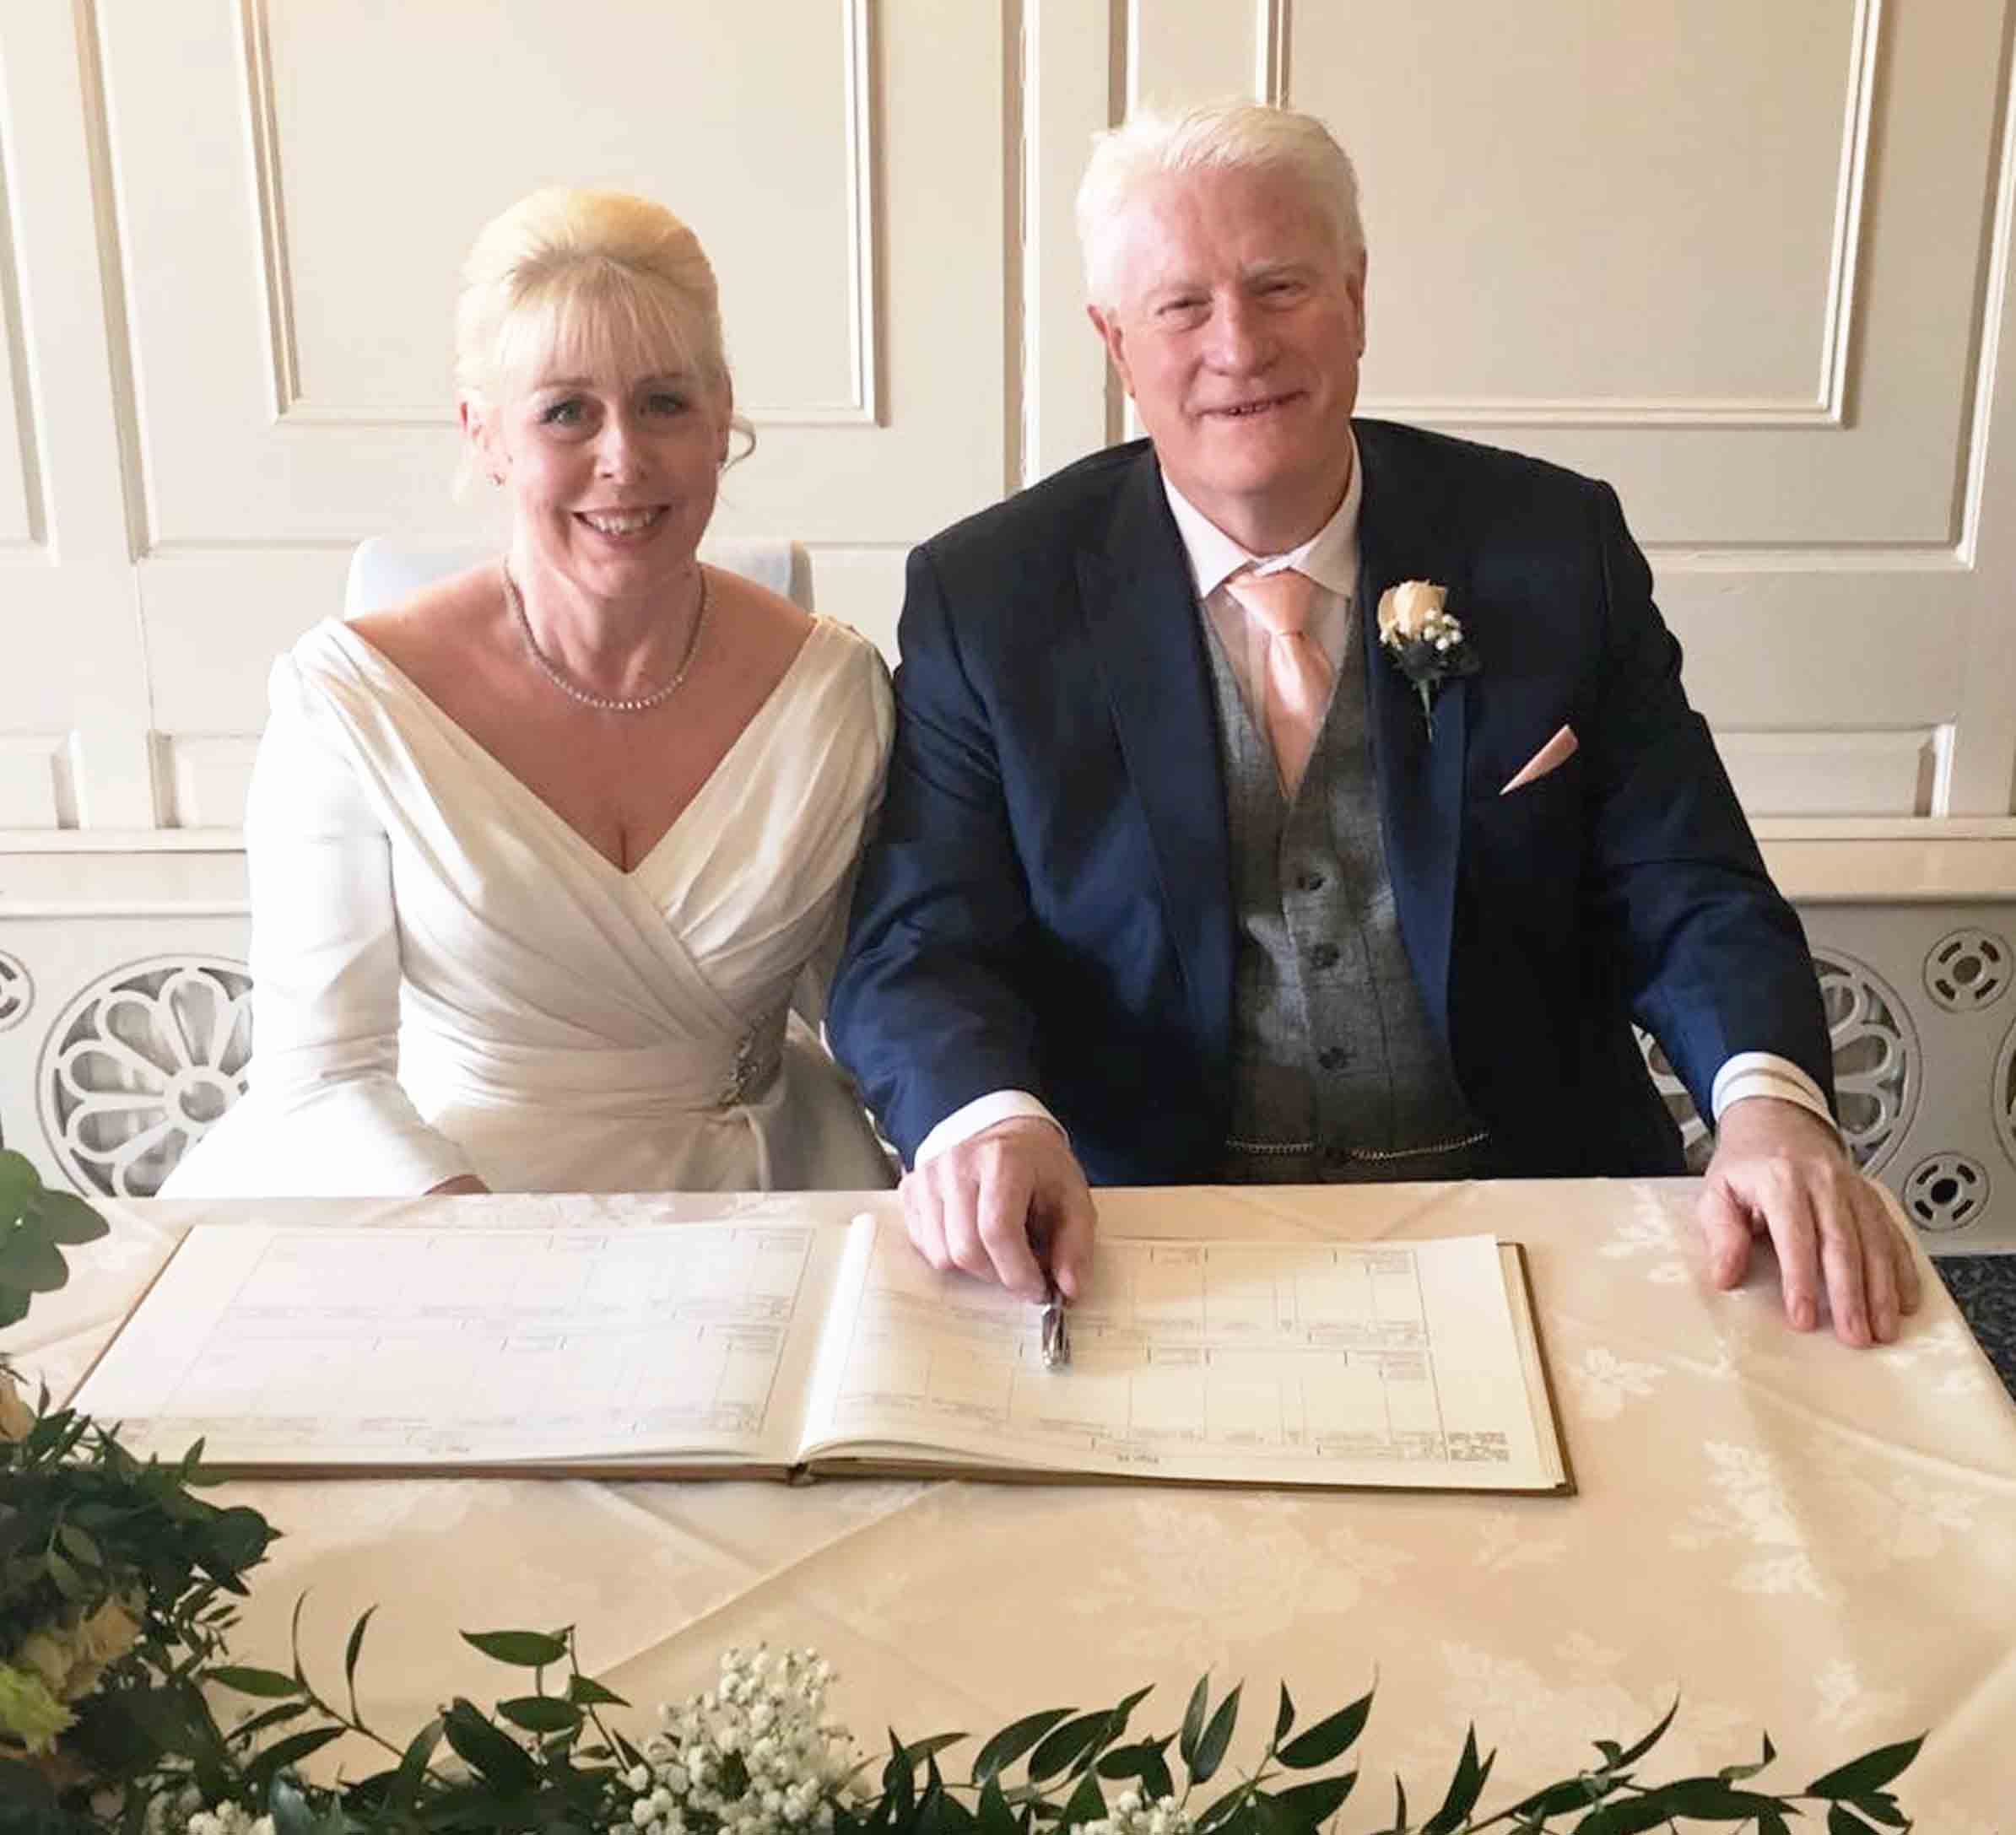
Lindsay and wife-to-be Shannon Robinson had known each other for 10 years and had talked about getting married when Lindsay retired.

But last year Lindsay was diagnosed with renal cancer and the couple decided to bring forward their plans to tie the knot.

They set a date this February and were looking forward to their big day – only for Lindsay to be admitted to hospital the week before.

Once it became clear he could still be there on their wedding day, the couple were faced with the prospect of having to call it off.

But with the support of Princess of Wales staff, their very special occasion went ahead as planned.

Lindsay, aged 64, a civilian employee with South Wales Police, was diagnosed with renal cancer last March.

Lindsay said: “With my drug treatment regime I have four weeks on and two weeks off to recover.

“Once we decided we were going to get married, we had to think about when would be the best time to do it.

“We decided to go for the end of my second week off because that is when I am usually at my best.”

So the date was fixed for Sunday, February 11th and the Coed-y-Mwstwr Hotel in Coychurch was booked.

But then, with just one week to go, Lindsay became unwell and had to be admitted to Princess of Wales Hospital’s Ward 5.

Shannon said: “We hoped he would only be there for a couple of days but as the week went on we started to become worried.

“We thought we might have to cancel. But the staff were fantastic. The aim became to get him well enough to come out of hospital just for the day so we could go ahead and get married.

“It was about putting everything in place for Lindsay to go to the wedding but, if he didn’t feel well, could come straight back to the ward without delay.”

Lindsay’s son and best man Darryl brought his suit to Ward 5 and, together with staff, helped his dad get ready.

From the hospital they went straight to the Coed-y-Mwstwr Hotel, where Shannon and their guests were waiting.
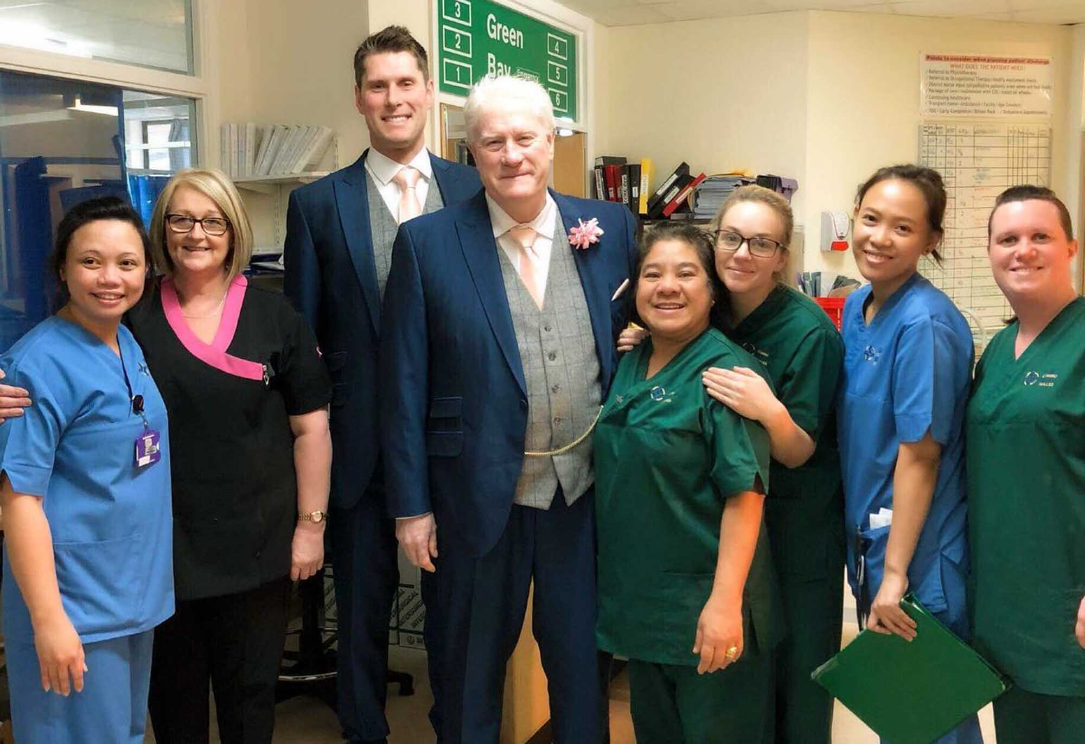
The wedding went off fantastically and Lindsay went back to hospital in the evening. He has since returned to the couple’s home in Pencoed.

Right: Ward 5 staff with Lindsay and son and best man Darryl

Lindsay said he and Shannon wanted to thank Ward 5 staff for making their big day feel like even more of a celebration.

“It wouldn’t have been much fun for me, being in a hospital ward and just getting out of bed to go to the wedding.

“But the staff were amazing. They joined in the preparations and made a real fuss over me. They helped me get ready and made sure I had everything I needed.

“They had photographs taken with me before I left for the hotel as well – I felt like a minor celebrity!”

Ward 5 clerk Cheryl Trotman, who made the groom a flower to wear in his lapel, said: “Lindsay is such a lovely man.

“When it looked like he may still be here on his wedding day we decided to do what we could to make sure it went ahead as planned.

“We’re so glad it did, and we all send our very best wishes to Lindsay and Shannon.”

Source: Abertawe Bro Morgannwg University Health Board

