Hospitals' front door assessment sees fewer elderly people admitted to wards
Tuesday, 20 March 2018
Older people who become unwell are now far more likely to be admitted to two ABMU hospitals only if they really need to be there.

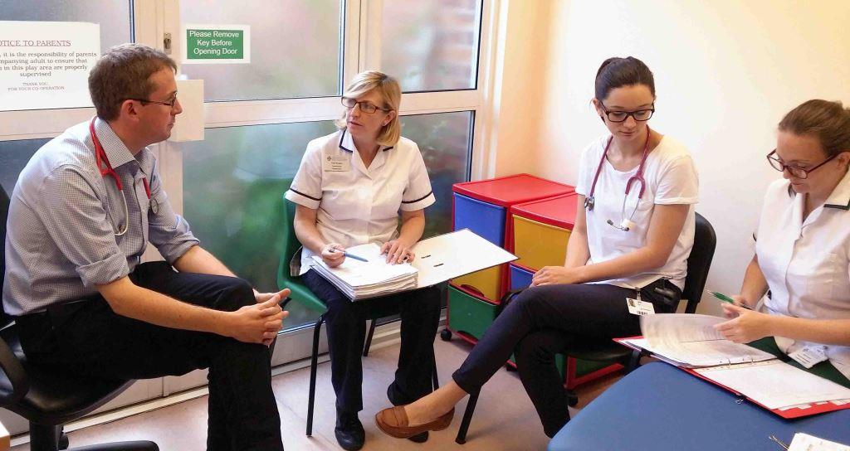
Increased use of “front door” assessment as patients arrive allows many of them to return home quickly with the support of their local community team, which includes geriatricians, nurses and other staff.

Dr Rhodri Edwards with (l-r) physiotherapist Paula Boughey, Dr Fiona Morris and occupational therapist Helen Evans

This means hospital doctors, nurses and allied professionals specialising in elderly care can concentrate on the most seriously unwell patients.

It’s better for patients too, as a stay in hospital can cause problems such as reduced mobility and loss of independence.

Changes have been introduced at Princess of Wales Hospital in Bridgend and Singleton Hospital in Swansea.

POWH Clinical Director for Elderly Care, Dr Ashok David, said 65 per cent of elderly people in the hospital did not need to be there.
Dr David said: “Hospitals are not good places for elderly people if they don’t need to be there.

“They become deconditioned, they lose muscle mass, lose their independence and there is the risk of hospital-acquired infection.

“Our vision is to provide the appropriate care for patients before they reach hospital – and if they are referred by their GP or attend the ED, to provide the appropriate care as soon as they arrive.

“The idea is to provide a comprehensive, consultant-led assessment as soon as they hit the front end of the hospital.

“If they are not very sick and don’t need an acute hospital, we put in place a plan and link up with the community services so they can go back home as quickly as possible.”

In February last year an Acute Frailty Unit was established on Ward 20 as the first phase of POWH’s elderly care reconfiguration.

This is where patients admitted after assessment are cared for during the acute phase of their illness.

They then transfer to a non-acute elderly care ward or go home, again with any necessary care provided by a community team.

Dr David said the changes had seen the average length of stay on Ward 20 reduce from 17 days to 11 days, sustained over a 12-month period.

He added: “This is without any increase on the average stay in non-acute elderly care wards – it’s not as if we have just moved patients from Ward 20 to these other wards.”

Phase two, which frees up doctors to provide front door assessment, saw Princess of Wales Hospital last month introduce a ward led by nurses and nurse practitioners.
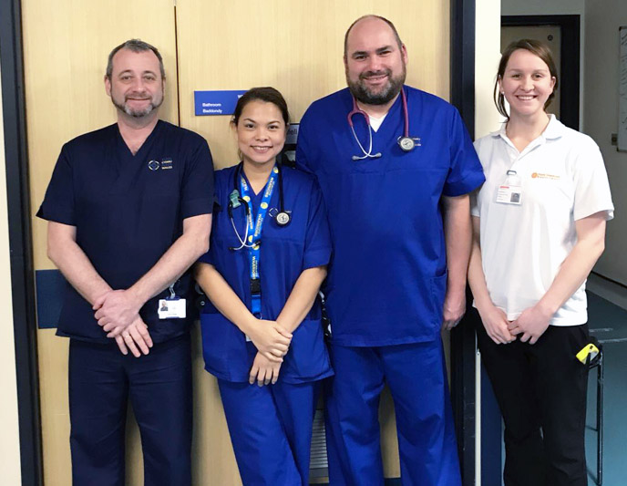
L-r: Ward 19 manager David Maggs, advanced nurse practitioners Sheryll Lat and Simon Williams, and occupational therapist Annie Bowen

The 25-bed Ward 19 is for patients who do not require acute medical care but do need reablement before they can go home.

Dr David said: “Neither phase has involved the use of any additional resources.”

Singleton has a different model of care, based on the development of an acute frailty service within the Singleton Assessment Unit (SAU).

Front-door assessment is carried out by a multidisciplinary team including a doctor, physiotherapist, occupational therapist and pharmacist.

Dr Rhodri Edwards, consultant in geriatric medicine at Singleton, said: “Traditionally, people would come in, they would see the team on call that day, they would have their medical history taken and be seen by a consultant.

“Then they would be handed over to another medical team, depending on what ward had a bed available.

“Another consultant would take over their care, who wouldn’t necessarily be a specialist in frail older people. If it was thought they needed to see a physiotherapist, one would be requested.

“The key element to our model now is that we have a multidisciplinary team that goes to the SAU and provides this holistic assessment when the patient arrives.

“They make the decision about how best to manage the patient, whether that be staying in hospital or going home with additional support.”

Between September and November last year, 118 patients had front door assessment on arrival in the SAU.

Of these, 38 per cent did not need admission to the wards and went home from the unit having spent, on average, two days there.

Dr Edwards said: “The service improved the quality of care provided for frail older people.

“More patients received an evidence-based review of their medicines and more patients were asked about problems they might be experiencing with their memory.

“The team were better able to recognise patients approaching the end of their life and refer them to the hospital or community palliative care team.”

Meanwhile, clinical lead Dr Liz Davies and her multi-professional team provide a well-established Care of the Elderly (COTE) service at Morriston Hospital with dedicated resource working within the Emergency Department to quickly identify frail older people, ensuring timely comprehensive assessment and pathways home whenever possible.

Strong links between community and the third sector are in place, supported by Liz’s work at Gorseinon Hospital leading reablement pathways and falls clinics.

Wendy Rees, Morriston Hospital Associate Service Director, Medicine Service Group, said: "The team has a home first, non-pyjama philosophy and strives to provide whole-system services for older people, avoiding admission wherever appropriate.

"This year we are building on this work with increased therapy resource within the team."

Source: Abertawe Bro Morgannwg University Health Board

