MIU play area opens to help keep young patients entertained
Tuesday, 13 March 2018
A dedicated new area designed especially for ABMU’s youngest patients has been officially opened – and was instantly given an enthusiastic welcome by its first customers.

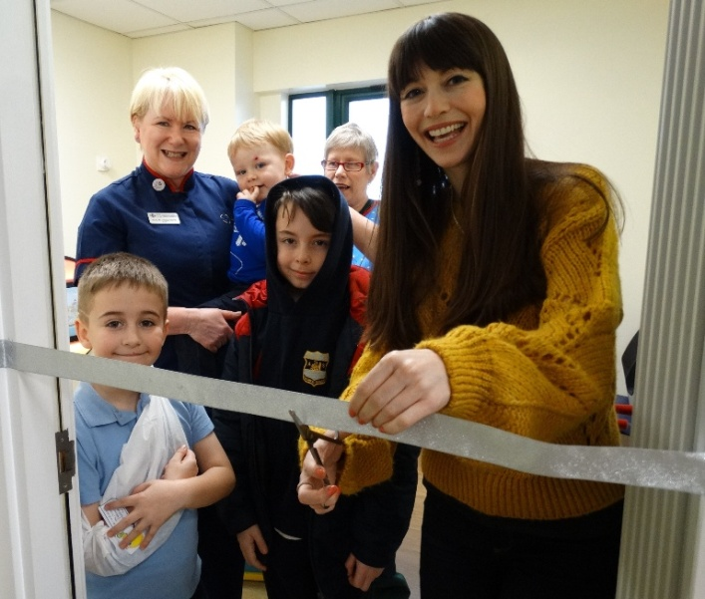
Even before special guest CBeebies star Rebecca Keatley could cut the ribbon to launch the paediatric waiting area at Neath Port Talbot Hospital’s Minor Injury Unit, youngsters waiting for treatment had joined her inside to start playing with the toys.

The play room has been fitted out with specialist furniture and interactive toys.

Presenter Rebecca Keatley cuts the ribbon with (from left) Ashton Larkman, matron Susan Woolford, Harry Rees, William Parry and healthcare support woker Lisa Bevan.

Susan Woolford, matron at the Minor Injury Unit, said: “It is fantastic to see from their immediate reaction just how much the children like the new room.

“It is certainly a welcome addition to the service we offer.

“Previously children would have had to wait to be seen in the main waiting area with the other patients and that was not always appropriate.

“This room is somewhere they can spend time which will help entertain and distract them.”

Neath Port Talbot Hospital quality, safety and improvement manager Angharad Higgins explained that the money for the improvements was made available from the health board’s endowments fund as well through a grant from convenience stores One Stop Shops. It supports local good causes by donating money raised by selling carrier bags to customers.

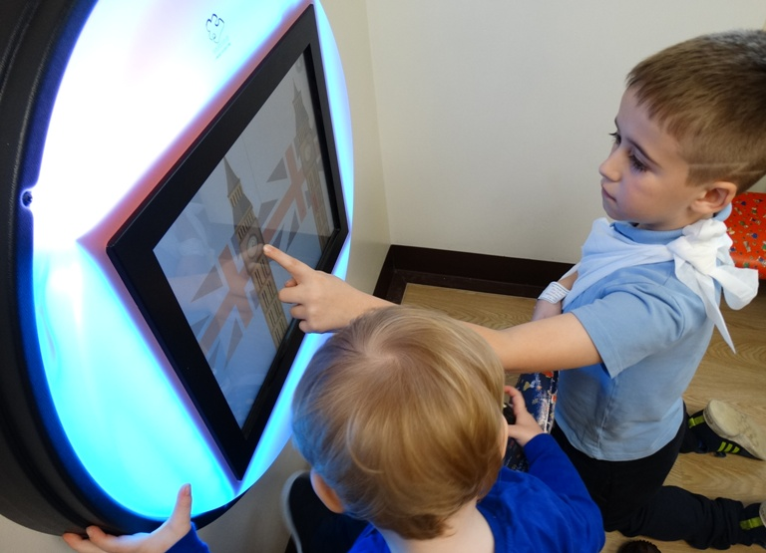
She said: “Our Patient Experience and Advice Service – PEAS – team carried out a consultation with patients and we also had input from the Community Health Council which identified the need for a facility like this.

Ashton Larkman shows Harry Rees how to play one of the new interactive toys.

“We wanted to create a funky place for children to play while they are waiting. It has interactive toys aimed at keeping even young babies engaged.

“This is the first stage of improvements, we are now also planning to revamp the treatment room to make it a more calming and soothing place for children”

Port Talbot-born Rebecca, who presents Let’s Play, declared the room open and spent time meeting and playing with young fans.

She said: “I am delighted to be here at the Minor Injury Unit and even more delighted not to be here with a minor injury myself.

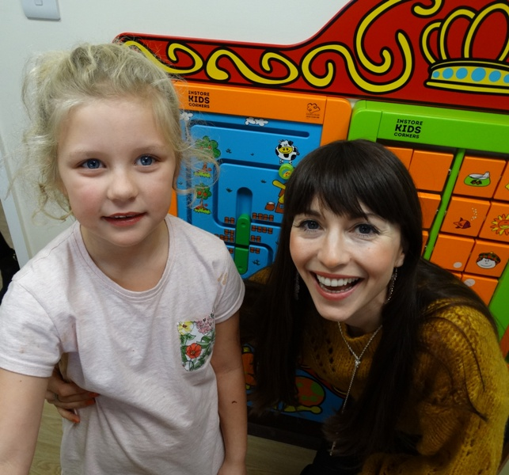
“I understand a lot of little patients come through the doors and many will be a scared or vulnerable about what will happen next.

“This family room is wonderful way to help the children feel a bit more relaxed and to distract them while they are waiting.”

Rebecca Keatley with 6-year-old patient patient Sophia Spendiff who came to the unit with a fractured foot.

Ashton Larkman, aged 7, from Port Talbot, was one of the first to try out its facilities.

His father David said: “The play room is a great idea. He loves playing games so is enjoying it already. It is particular good that there is something to keep children occupied when you are having to wait for them to be seen.”

Ashton was joined in the room by Harry Rees, aged two, from Neath who immediately started rearranging the brightly coloured chairs.

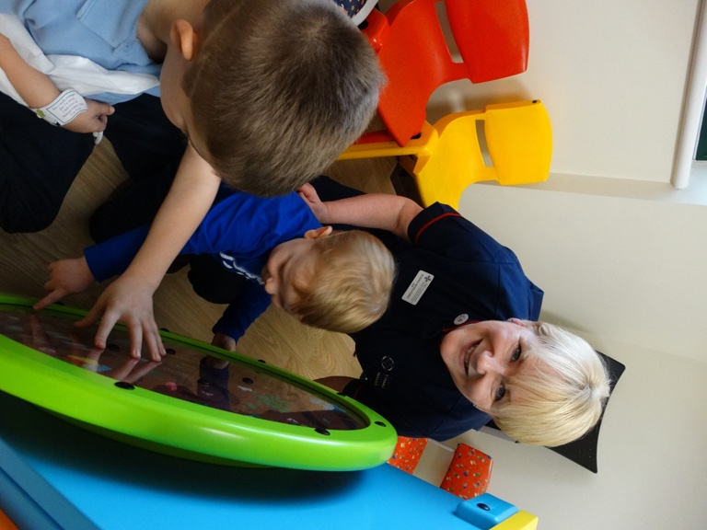
Matron Susan Woolford with Ashton Larkman and Harry Rees.

One mum said: “It is so nice that the children have their own space here. It is somewhere a bit positive during what might be a negative experience for a family.”

The new area enhances the existing services the Minor Injury Unit offers.

It is open from 7.30am to 11pm, seven days a week. It’s for adults and children over the age of one.

The MIU is able to assess and treat limb injuries including sprains, strains, broken bones (fractures) and dislocations of the shoulder, finger and toes; grazes, wounds and minor burns; head or face injuries without a loss of consciousness in the last 24 hours; neck injuries, where you are mobile with no pins and needles in your arms; back injuries you are mobile and the pain has not occurred from you twisting your back or lifting something; foreign bodies to eyes, ears and nose; non-penetrating eye and ear injuries; rib injuries where you are not coughing up blood and you don’t have a chest infection; bites (insect, animal or human); insect stings and assaults.


The MIU also offers treatments for wound closure including stitches and gluing; application of dressings; plaster casts, splints, strapping and slings; reducing shoulder, toe and finger dislocations; removal of foreign bodies and eye washes. If necessary staff can provide antibiotics or tetanus vaccinations.

If you have a minor injury, please consider going to the unit at Neath Port Talbot Hospital, SA12 7BX. You are likely to have a much shorter wait.

Source: Abertawe Bro Morgannwg University Health Board

