New service at the heart of the community
Monday, 12 March 2018
A new community-based way of screening for heart disease and strokes is giving people the tools they need to live to a healthy old age.

Forty to 64-year-olds living in some of the ABMU health board’s less affluent areas are being invited to have a cardiovascular disease check if they are not already being treated for a chronic condition.

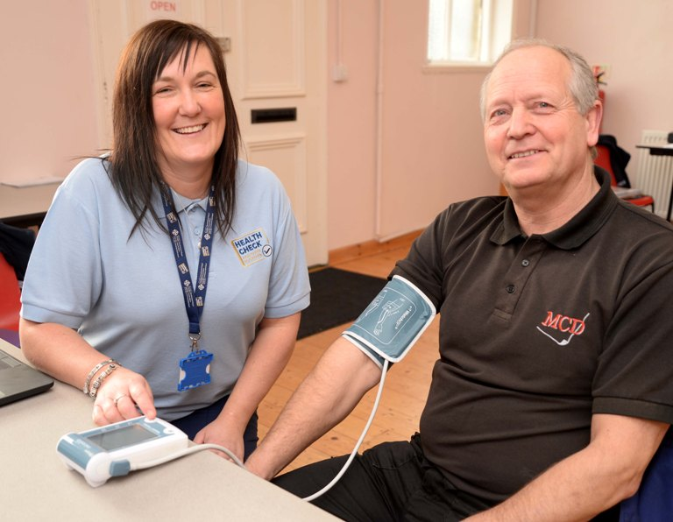
The idea is to catch people who may not normally go to see their doctor but whose lifestyles are storing up health problems for them later in life. It’s already making a big difference to people in north Bridgend, where the scheme has been launched.

Neil Fraser, 62, pictured here with healthcare support worker Louise Kenny, was expecting a good result from the test at Tondu parish hall because he is lean and very active.

“I was under the impression that I was fit and healthy because I don’t drink or smoke and I exercise a lot,” said the warehouse manager from Llangeinor.

“I was expecting my heart age to be under my real age, but it was actually over. My blood pressure and cholesterol are too high as well, apparently because of what I eat, and my stress levels.

“This test has been a huge benefit to me. I couldn’t remember the last time I had my blood pressure or cholesterol checked and if I hadn’t have come here today I wouldn’t have known.

“It’s opened my eyes and made me realise some people are walking around with a health time bomb. I can change what I eat and I will. The staff here are lovely and they give you ways to tackle the problems. I can’t recommend this service enough.”

Health care support workers Louise Kenny, Heather Dawes and Anne Williams are carrying out the checks, which are designed to screen for the risk of developing conditions like coronary artery disease, atherosclerosis and stroke.

Each one takes 45 minutes and begins with the patient being weighed and having their height and waist measured. A finger-prick cholesterol test is given and blood pressure taken too. Patients are asked about their family health history, and their habits around diet, exercise, smoking and drinking.

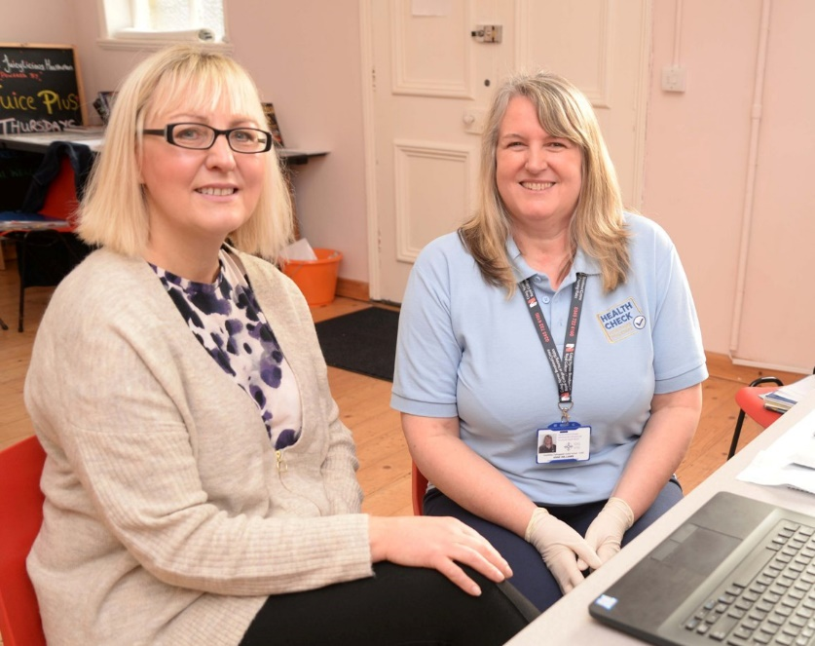
At the end of the assessment each person is given a heart age, which can be quite different from their actual age, and told what risk they have of developing cardiovascular disease over the next few years.

Heather Jenkins, 51, from Brynmelin, pictured with healthcare support worker Ann Williams, was at the clinic to find out if her attempts to lower her cholesterol levels had been successful.

“I was worried about coming here today but it’s been really positive for me. I joined a gym in May last year and did a health MOT and found that my cholesterol level was very high at 7.9.

“Since then I’ve been exercising, lost a stone in weight and changed my eating habits. I was nervous about getting my results today but I was really happy to hear that my cholesterol level is 5 now, which is normal.”

Heather is encouraging anyone who gets an invitation for a cardiovascular disease check to take advantage of the opportunity to find out more about their heart health.

“Personally I wouldn’t go to the doctor unless I was really unwell. It’s a faff to make an appointment and I don’t like to bother them.

“But I think this is a very good idea. Unless you do a check like this you might never know if you had high cholesterol.”

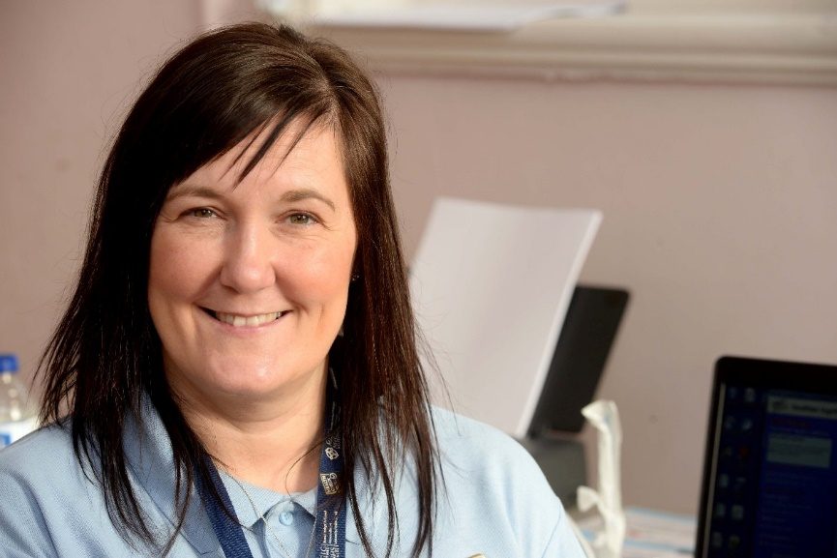
Health care support worker Louise Kenny, left, said: “Even if you think you live a healthy lifestyle, a check-up like this can reveal hidden problems.

“We had one gentleman attending whose heart age was 34 years older than he was because of his smoking, family history, high blood pressure and cholesterol.”

After completing her assessment at Tondu parish hall, Sian Howell, 49, from Sarn, discovered that her heart age was 56, but was given information by Ann Williams on how she could bring that back down to 49 by exercising and changing her eating habits to include foods like fish, avocados, nuts, porridge, olive oil and avoiding saturated and hydrogenated fats.

“I want to lose weight so I am going to join the gym at work. My results were not ideal but they were better than I thought they would be,” she said. “It has set my mind at ease, which is good because I wouldn’t normally go to see my doctor.”

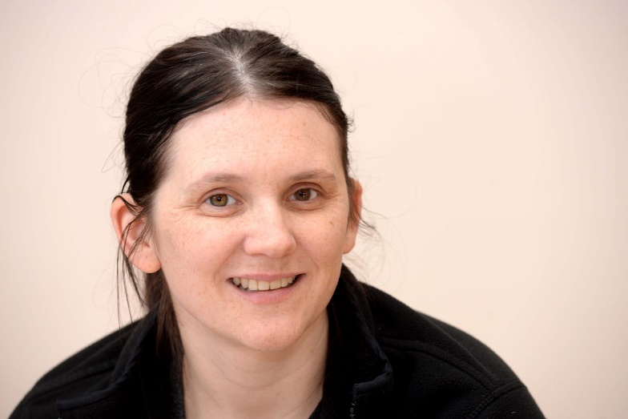
If patients are discovered to have a high risk of developing problems, they are referred back to their GP. If they are low to medium risk, they are invited to talk to lifestyle coach, from HALO, Louise Skevington, right, who is also on hand at the sessions.

She can sign up attendees for a free 12 week exercise and weight management course.

“The course teaches them about food and how to change their habits – it’s not a diet – as well as getting them to exercise. Everybody who has completed the course has reduced their BMI and lowered their blood pressure.”

Patients can also be referred for help with stopping smoking or drug and alcohol misuse.

The Cardiovascular Disease (CVD) Clinic is currently running five days a week in Tondu parish hall or Aberkenfig church hall and both early morning and evening appointments are available.

“It’s being offered in certain postcode areas where the need is greatest,” said Louise Kenny.

“From Bridgend to Ogmore and the Ogmore Valley, then the Garw Valley and the Llynfi Valley. Hopefully with funding we will roll it out to the Afan Valley and beyond.”

Patients are invited by letter to ring up and make an appointment at a time convenient for them.
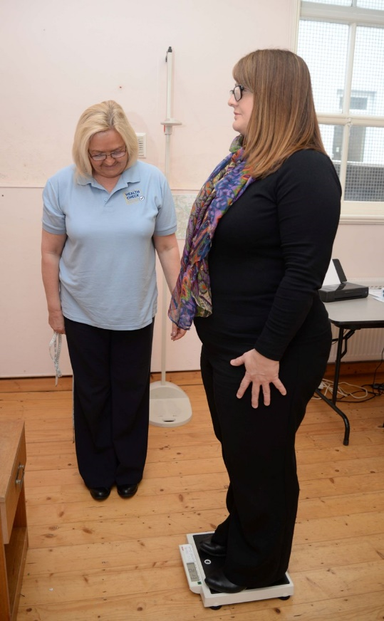
“The take-up of the scheme has been twice as high as we were expecting it to be,” said Heather Dawes. “We can’t believe how popular it has been.”

“A lot of people say they feel more comfortable coming here than to the doctors,” added Anne Williams. “It’s a friendly atmosphere and people are really taking on board the advice we give them.”

Left, Heather Davies weighs patient Lisa Rosser, from Tondu.

Access to the scheme is by invitation only from the GP surgeries in the Bridgend North primary care cluster. This is a group of GP surgeries in the north of the borough who work together to provide additional services for patients.

CVD health checks are currently being delivered in Tynycoed and New Street Surgery/ The team will then move onto Ogmore Vale and Nantymoel in the spring, then Cwmgarw then the Llynfi Valley practices later in the year (Llynfi, Bron y Garn and Woodlands).

https://www.youtube.com/watch?v=ZIe1AQvsMlI

Source: Abertawe Bro Morgannwg University Health Board

