Nurse Nathan's £500 donation will help children across South Wales
Friday, 23 March 2018
A service which cares for youngsters across South Wales has been given a £500 boost thanks to specialist nurse Nathan Morrison.
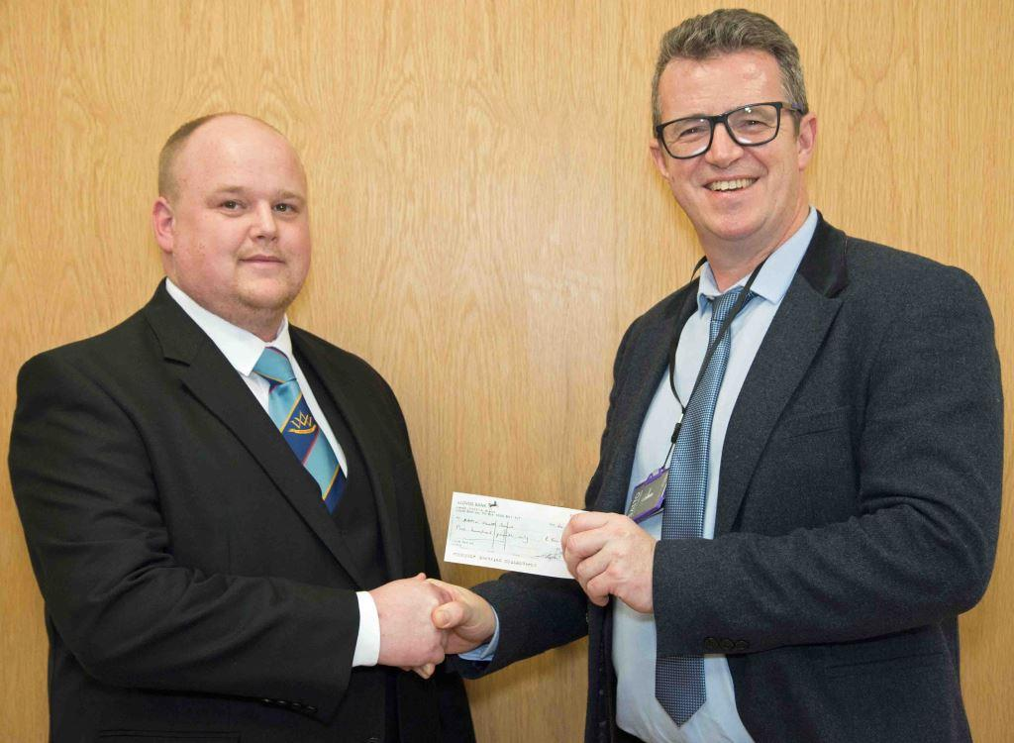
Nathan is lead dental nurse in the oral and maxillofacial department in Morriston Hospital.

Last year he was installed as Worshipful Master of the St Teilo Lodge of Freemasons in Llanelli.

Nathan (left) is pictured presenting the £500 cheque to consultant cleft and maxillofacial surgeon David Drake

During Nathan’s installation banquet, a raffle was held with the proceeds going to the cause of his choice.

The raffle raised £500, and Nathan decided to donate it to the Welsh Centre for Cleft Lip and Palate. This is based at Morriston Hospital and is one of only nine cleft centres in England and Wales.

“I work alongside the cleft team in outpatients so it’s something that is close to my heart,” said Nathan.

“It’s a very worthy cause and it’s great that the money will help benefit children in South Wales.”

Morriston Hospital has the only cleft centre in Wales, looking after children and adults from across the ABMU, Hywel Dda, Cwm Taf, Aneurin Bevan and Cardiff and Vale health board areas.

Morriston is the surgical centre for the service, while cleft lip and palate speech and language therapists based in the hospital work with community therapists across South Wales and some parts of mid Wales.

A cleft lip is often diagnosed at the mother’s 20-week scan. Immediately following this they are introduced to the staff at the unit, who see around 50 new babies every year.

The team includes three specialist nurses who visit the mums-to-be so they are prepared for the arrival of their baby.

Nathan’s donation has helped buy information leaflets for the mums, and specialised bottles and teats.

Morriston consultant cleft and maxillofacial surgeon David Drake said: “We are absolutely delighted to receive such a generous donation from Nathan. We are so grateful he wanted to raise money for our service.

“Most of the patients we see come to us as babies and they usually have surgery before their first birthday. However, our work doesn’t stop there.

“We continue to support the patient as they grow up, providing other treatment such as speech and language therapy and specialist orthodontics and dental care.”

Source: Abertawe Bro Morgannwg University Health Board

