Project to support young parents lands top award
Thursday, 8 March 2018
A Swansea project to help improve maternity care for teenagers and young women with complex social factors has scooped a top national award.

Midwives Sally Roberts and Julie Morgan were part of the multi-agency JIG-SO team which won the Reducing Inequalities category at the Royal College of Midwives (RCM) Awards.

JIG-SO is a joint ABMU Health Board and Swansea Council project which has been running since May 2016.
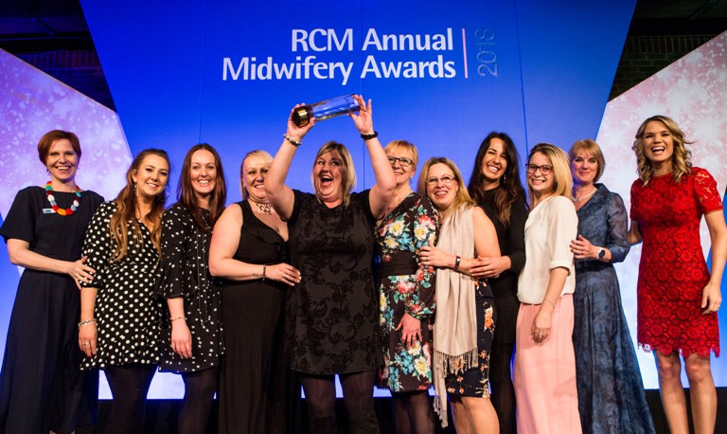
(From left) Mary Ross-Davie, Director for Scotland at the Royal College of Midwives, members of the JIG-SO team including Sally Roberts with Gill Walton, Chief Executive of the RCM and event host Charlotte Hawkins.

It sees a team of Families First midwives, community nursery nurses, family facilitators and early language development workers offering additional support to young women aged up to 25 and their partners.

It aims to improve care throughout pregnancy and afterwards with family facilitators and early language development workers able to provide support up to the child’s third birthday if needed.

This means a better experience of pregnancy for the woman and the best possible start in life for the baby.

Young parents who have used the service provide feedback which is used to continually improve the care the team offers.

The award judges were impressed with the way the project brings together professionals from different disciplines to offer a rounded and long-term approach to care. This fits well with the Well-being of Future Generations (Wales) Act 2015.

The project has been very successful. Breastfeeding rates for women using it are impressive and the number who have stopped smoking in pregnancy is well above the average for the health board area.
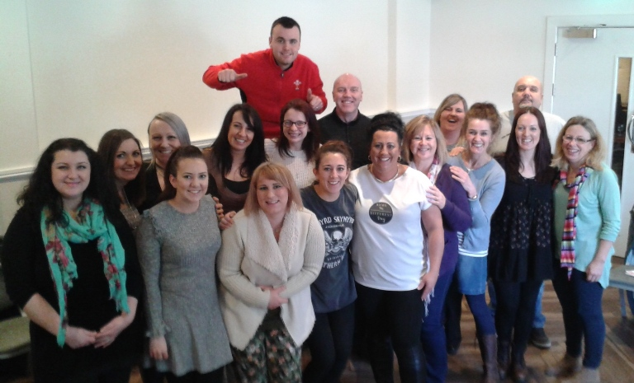
It has also had major personal benefits for these young families. A significant number of mothers who went through the JIG-SO team have had their children removed from the Child Protection Register. A similar number of families no longer need the support of social services.

The multi-agency JIG-SO team.

Sally, who attended the ceremony along with other members of the team involved, said: “The whole JIG-SO team is delighted to have won this award.

“The way we work and the unique service we provide to young families are prime examples of the benefits of multi-agency working.

“This recognises the vital role that midwives play at the very start of the parenting journey.

“I feel that the project’s success has been achieved due to the enthusiasm of the whole team made possible by the vision and confidence of senior managers within the local authority and our head of midwifery to invest in this collaborative approach.”

ABMU’s head of midwifery Jane Phillips said: “The health board maternity service has been delighted to work collaboratively with Swansea Council to support the programme. The outcomes and benefits of working in a multi-agency team have been experienced by the woman and their families and the staff. Massive congratulations to everyone we are very proud!”

Gill Walton, Chief Executive of the Royal College of Midwives, said: “This is such a great example of how cooperation between health and other professionals in areas such as social care can really make a difference to women, babies and their families.

“I congratulate Sally and Julie on their award and for their commitment and dedication to the people they care for; it is well deserved.”

The annual awards, hosted by Good Morning Britain presenter Charlotte Hawkins, celebrate the midwifery profession’s best and brightest talent and this year the expert judges say their task of selecting winners was made harder by the unprecedented number of quality entries.

ABMU colleague Julia Atterbury, who works with mums-to-be at Neath Port Talbot Hospital’s antenatal clinic, missed out on the Maternity Support Worker of the Year title at the awards.

She had been shortlisted after her passion for breastfeeding and talent for explaining its benefits to pregnant women was credited with helping to improve breastfeeding rates in Neath Port Talbot.

Source: Abertawe Bro Morgannwg University Health Board

