Rachael shares healthy message with mums-to-be
Friday, 2 March 2018
As a long-term diabetic, Rachael Edwards knows just how important it is for mums-to-be to look after their health.
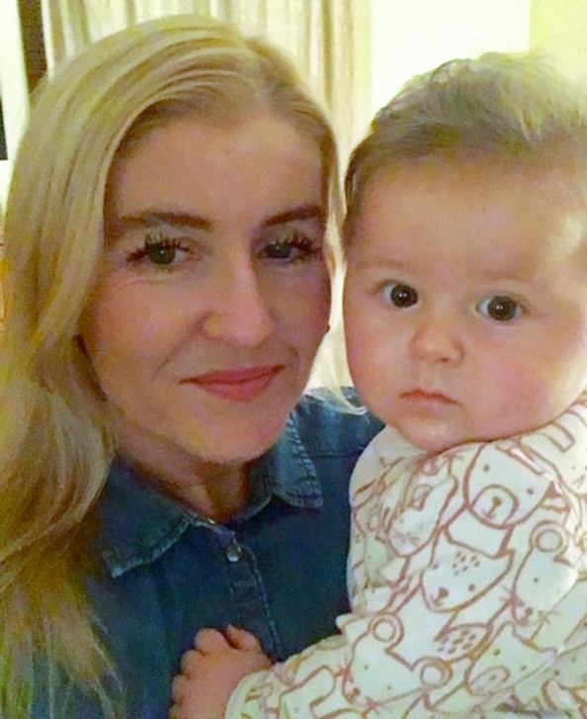
Mother-of-three Rachael developed kidney problems during her first pregnancy and went on to have a renal transplant.

Her second pregnancy was more straightforward so when she started thinking about a third baby, she sought professional support from the outset.

Rachael pictured with third son Aled

Rachael, from Swansea, has told her story as part of the run-up to this year’s World Birth Defects Day on Saturday, March 3rd.

This international initiative aims to increase awareness of birth defects (congenital abnormalities), along with prevention, care and research.

Rachael said: “I’ve had type 1 diabetes for 30 years and developed kidney problems during my first pregnancy.

“Because of this I needed haemodialysis towards the end of the pregnancy, and required a renal transplant in 2010.

“I decided to ask for help early on because I was very aware of the importance of the care I needed to take before I actually conceived.

“As a result I decided to discuss it with the Diabetes in Pregnancy team in Singleton and the renal team in Morriston.”

The advice Rachael was given included getting as close to excellent blood glucose control as possible.

This reduces the risk of the baby having a problem during development – type 1 diabetic mothers are three times at risk of a congenital anomaly.

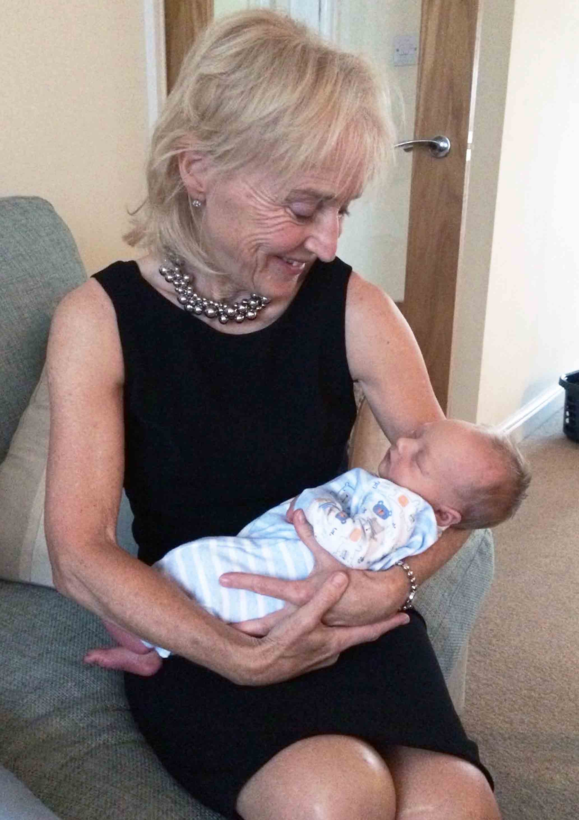
Singleton Hospital consultant obstetrician and gynaecologist Margery Morgan (pictured right with her grandson Max) said: “As you can imagine, Rachael was taking a variety of drugs to help with her renal transplant.

“These had to be carefully checked to ensure none would be dangerous for the developing baby.

“Her immunosuppressant medication was replaced with a drug safer in pregnancy. Rachael had to take these for a while to ensure blood tests were fine and good renal function continued.

“Certain drugs used for other conditions, like epilepsy and mental health, may also be harmful.

“So it is always a good idea to check with your GP or pharmacist before stopping contraception if you are taking any medication.”

Dr Morgan said women with a long-term health condition or taking regular medication should be aware of the importance of planning a pregnancy.

It’s important for them to make plans, which may include lifestyle changes such as avoiding alcohol and giving up smoking. Medication which could harm the baby can then also be stopped or changed.

All women considering a pregnancy should take folic acid daily once they start trying. This is something Rachael did too – it can reduce the chances of having a baby with conditions such as spina bifida.

Dr Morgan said: “These plans will give a future pregnancy the best chance of success.

“Health professionals such as GPs, hospital consultants and pharmacists are good sources of advice.”

Dr Morgan is lead clinician for the Congenital Anomaly Register and Information Service for Wales (CARIS), based at Singleton Hospital. The service has been collecting data about birth defects for the last 20 years.

CARIS will hold its annual meetings in Bridgend on 13th November and Wrexham on 15th November. They will include a focus on new plans for Down’s syndrome screening.

Happily, Rachael’s third pregnancy went smoothly, with third son Aled born at 36 weeks by Caesarean section, weighing over 5lb.

Pictured left: Aled’s brothers Oliver, aged nine, and five-year-old Gethin

Rachael said: “Aled is now aged six months. He’s a perfect little boy, a contented baby adored by his two big brothers.

“I’m still attending renal and diabetic clinic appointments for general monitoring, and I’m glad to say I’m doing very well.”
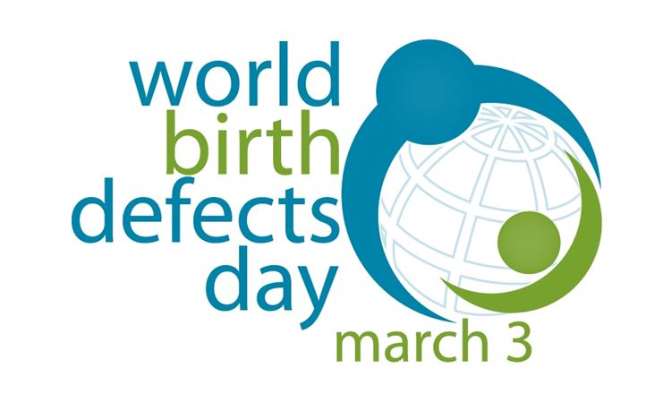
For further information and advice click here

Source: Abertawe Bro Morgannwg University Health Board

