Sandra in the swim again 16 years after cancer surgery
Wednesday, 28 March 2018
A school worker who loved swimming before cancer surgery forced her to give it up has made a triumphant return to the water 16 years later.
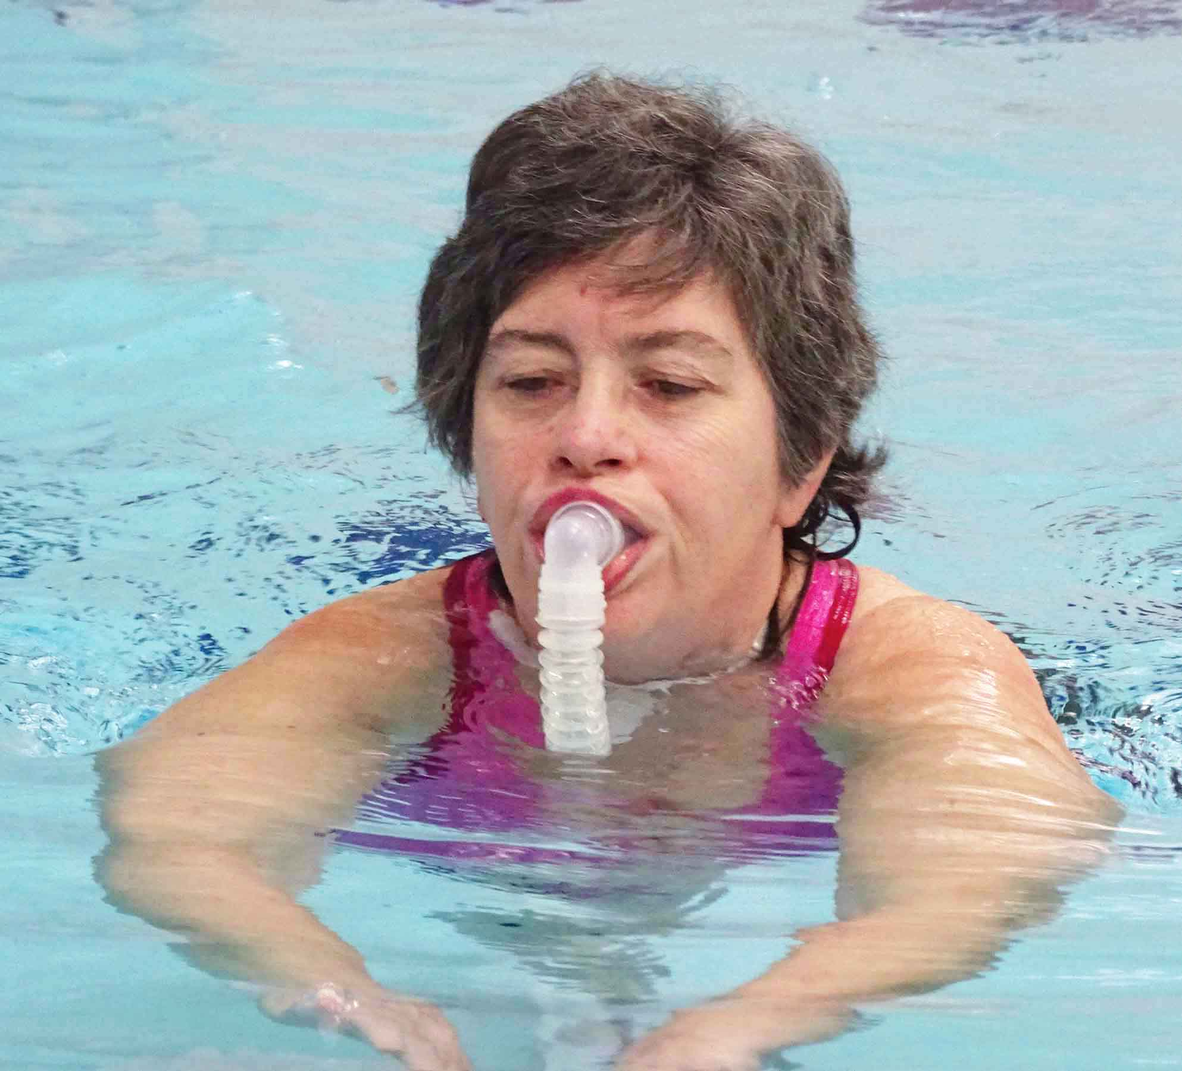
Sandra Davies was aged just 41 when she had her larynx removed following a diagnosis of head and neck cancer.

She always dreamt of swimming again. But, because she breathes through a stoma (a hole in her throat) it seemed like an impossible dream.

Now it’s dream come true, with Sandra completing a trial swim using special breathing equipment.

It took place in Swansea’s Wales National Pool – a few hundred yards from Singleton Hospital where Sandra had the laryngectomy in 2002.

Her triumph was achieved through her own determination and the support of her speech and language therapist Jodie McCord, Swansea Council water safety coordinator Andrew Suter and National Pool staff and management.

Sandra, who lives in Llanelli and is a breakfast club assistant in Bynea School, said: “We used to go swimming in the old Jubilee Pool in Llanelli – it’s the leisure centre now.

“After my surgery, the first thing I did was ask if I could go swimming again but it just wasn’t possible.

“But I kept telling myself that, one way or another, I was going to do it.”

As Sandra’s larynx was removed there is no connection between her nose and mouth and her lungs. Instead she breathes through the stoma.

Jodie, ABMU’s Macmillan clinical lead speech and language therapist, explained: “Ever since Sandra had her operation she has been desperate to get back in the water.

“Obviously, that’s a complicated task given that you have an open airway in your neck and there is no way to stop the water going into your lungs.”

Jodie found out about a pilot training programme run by Royal Devon and Exeter NHS Foundation Trust and funded by FORCE Cancer Charity.

“I suggested it to Sandra and she was really keen straight away. She didn’t hesitate.”

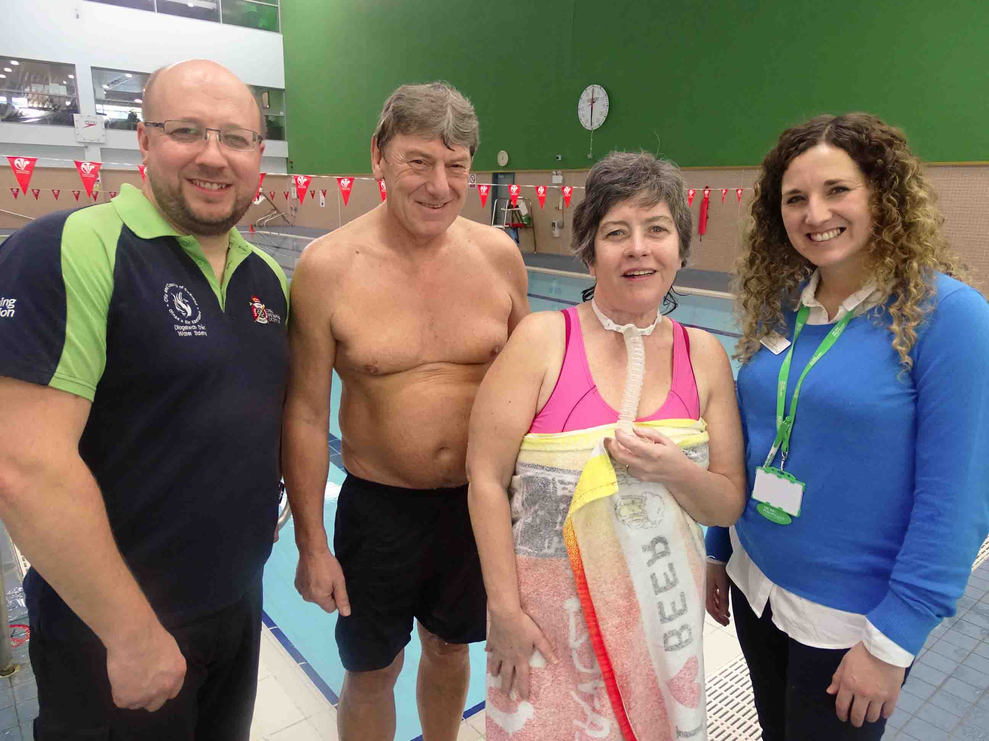
Sandra attended the course, which teaches neck-breathing patients how to return to the water safely using a special breathing device.

Sandra and husband and swimming buddy Phill are joined by Swansea Council water safety coordinator Andrew Suter and Macmillan clinical lead speech and language therapist Jodie McCord

This comprises a cuffed tube that goes into the stoma and prevents water getting in. A separate tube runs from the stoma to the mouth to reconnect the airway.

Swimmers must also have a designated buddy to go in with them, which in Sandra’s case was her husband Phill.

Having completed the course, Sandra bought her own breathing device and the aim then became to get her into a pool closer to home.

Jodie, who is based in Morriston Hospital, said: “I contacted Andrew and he was really keen to see if we could support Sandra to swim in the National Pool.

“We then devised a plan to get her in for a test session.”

Andrew’s team provides lifeguard training throughout Swansea Council and for its partners such as the LC and the Wales National Pool.

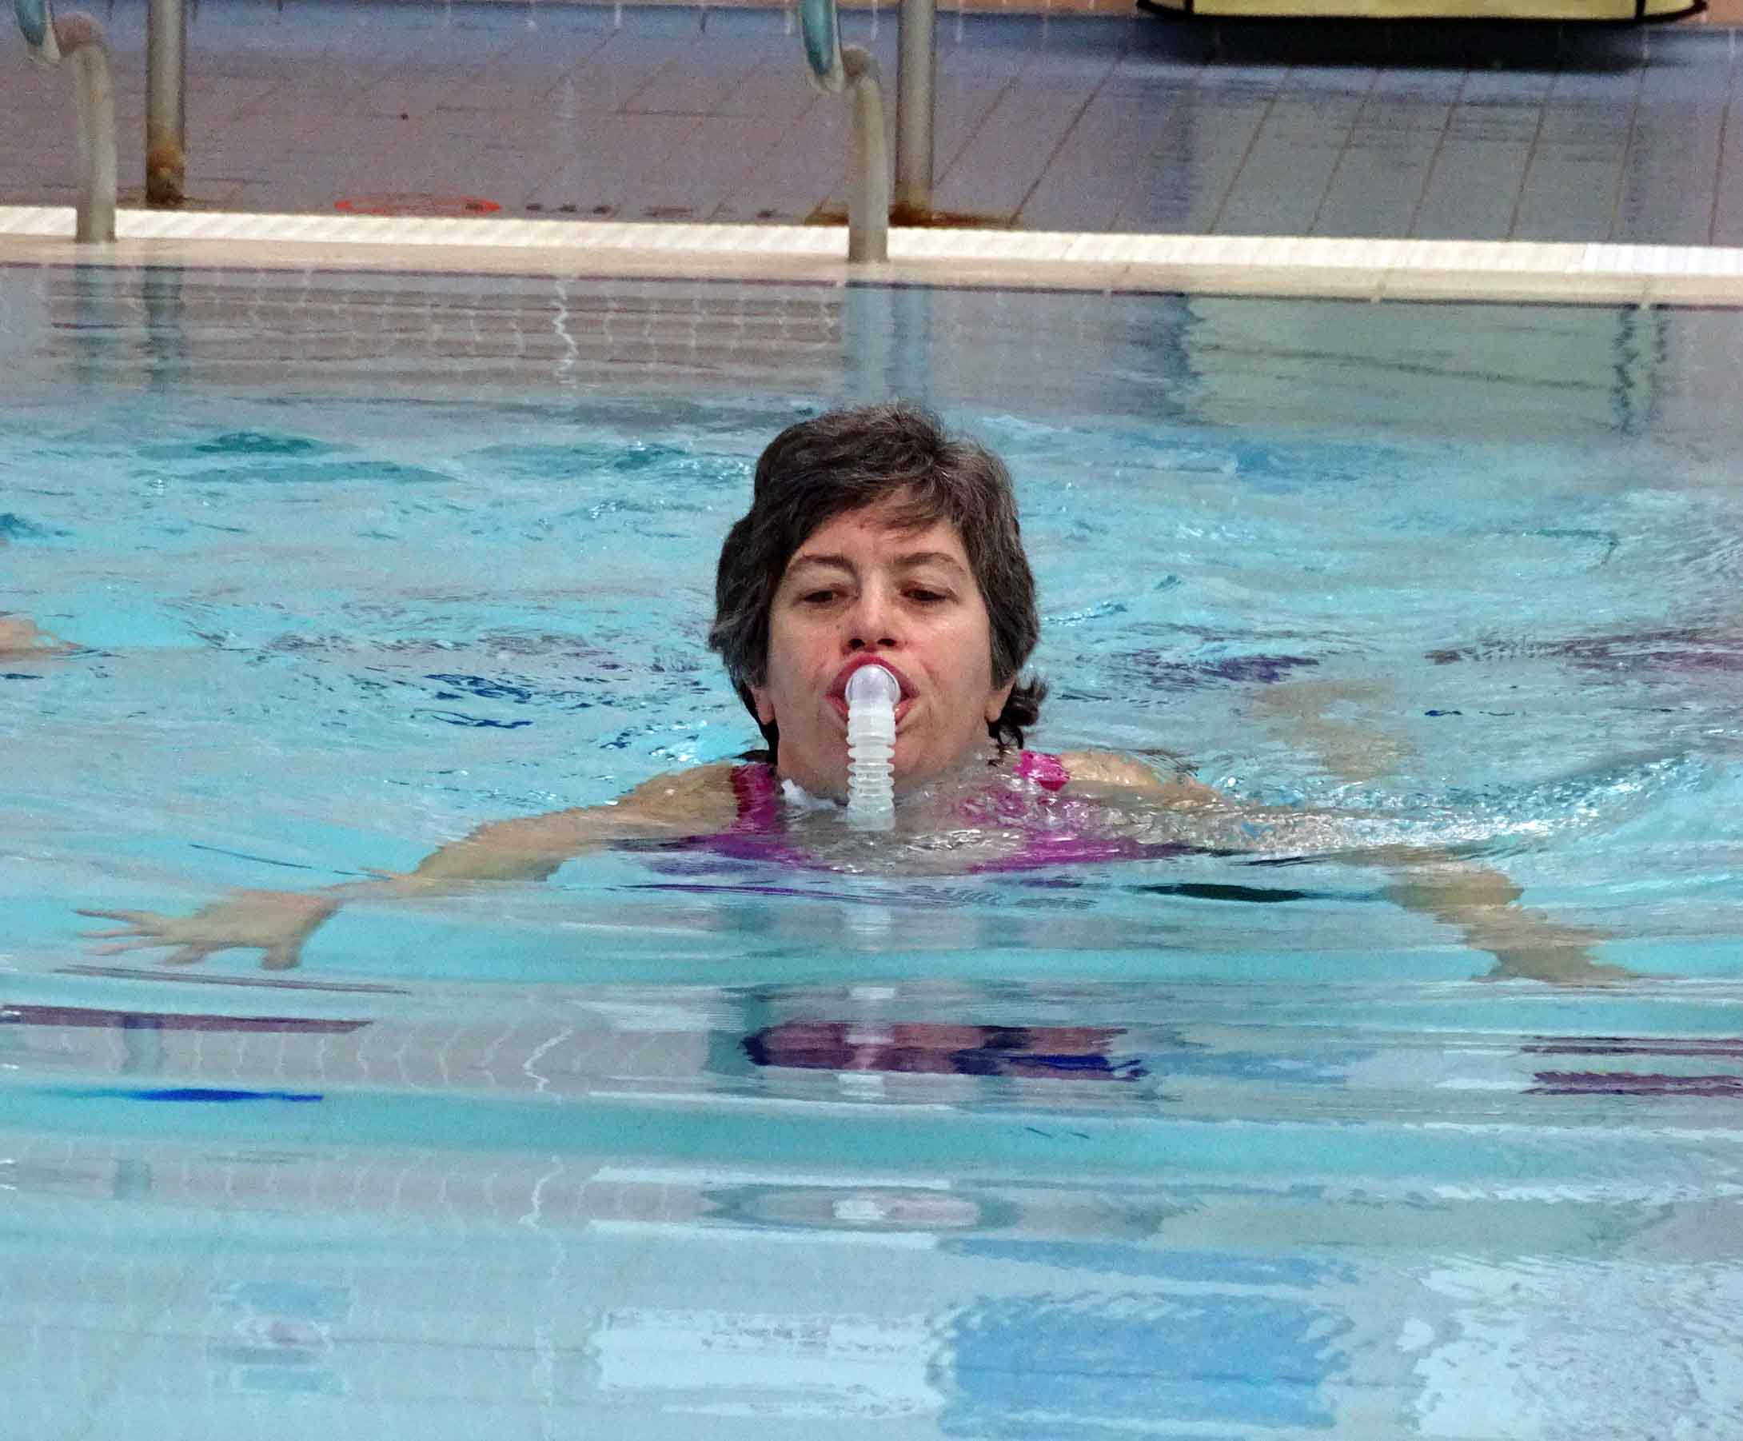
There the lifeguards were briefed about Sandra’s test swim, in case their assistance was required – which it wasn’t, as the session went as well as everyone had hoped.

Andrew said: “It was something unique for us, and I think it’s brilliant that Sandra is able to enjoy swimming again.

“We’re all about accessibility, and this is the next step as it opens it up to people who were not able to go swimming before.

“We’ll now provide training for all our lifeguards to raise awareness, and we can pass the information on to other pools – not just within the City and County of Swansea but anywhere else too.”

After completing several widths in the Wales National Pool, a tired but delighted Sandra said: “Being in the water again was lovely. I’m elated. This wasn’t a one-off – I’ll definitely be coming back.”

Pool general manager Jeremy Cole said: “We are thrilled Sandra has been able to return to swimming, something she clearly loves to do.

“We’re very pleased that the team effort between ourselves, Swansea Council and ABMU has been able to help Sandra achieve her dream. We’ve always believed that swimming is for everyone and Sandra’s story just proves that is true.”

Robert Francis-Davies, Swansea Council’s Cabinet Member for Culture, Tourism and Major Projects, added: “Our water safety team have done a fantastic job supporting staff at the pool so that Sandra and her husband can feel confident they will be safe in the water.

“Sandra is setting an example to others of the great health and wellbeing opportunities that swimming offers and there really are very few barriers to making it an enjoyable and rewarding experience.”

Watch a brief video of Sandra swimming below - double-click to view full-screen.

https://www.youtube.com/watch?v=ZIe1AQvsMlI

Source: Abertawe Bro Morgannwg University Health Board

