Clean-up helps restore clinic sculpture to former glory
Thursday, 11 May 2017
A neglected piece of art in the centre of Swansea is now far more eye catching thanks to the hard work of ABMU’s Heritage Group.

They have given the distinctive mural on the front of Central Clinic a much-needed wash and brush up and now hope it will be celebrated for its importance as part of the city’s artistic history.

To the amusement of passers-by in Swansea’s busy Orchard Street, the group’s members donned rubber gloves and aprons as they stripped back decades of grime and dirt from the mural’s panels.

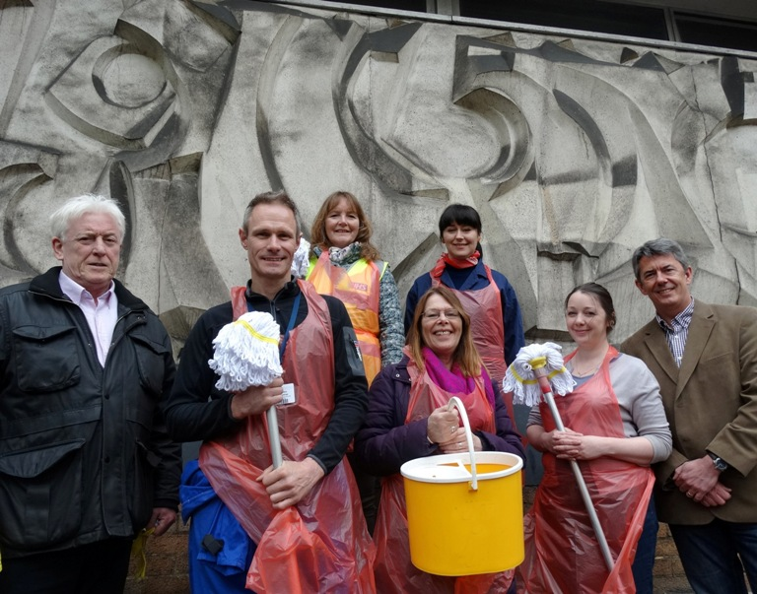
Joining them for the clean-up was Swansea artist Catrin James whose original Guerrilla Restoration art project, which saw her cleaning up isolated parts of city centre buildings, armed with mop, bucket and video camera, helped draw the group’s attention to the sculpture

(From left), Kevin Reilly, Martin Thomas, Fiona Edwards, Judith Everington, Catrin James, Rebecca Kelly and Professor Ian Walsh.

Heritage Group lead Martin Thomas (right) said: “When we started this group we carried out a scoping exercise to see what historical artefacts the health board owned and this mural came up.

“When I did more research I found out about Catrin’s project and we thought it would be a good idea to help finish what she had started.

“We thought this would be a great opportunity for us to clean a very neglected sculpture.

"This is quite an important one, we own it, so we should look at after it and because it’s in the centre of Swansea I think we’ve got a responsibility to keep it clean.”

Catrin said: “I am so pleased that the Heritage Group is giving the mural the attention it deserves.”

She explained that the reason she had chosen to clean the scultpture in the first place was because of her close family connection to Central Clinic - her grandfather was the building’s first caretaker and lived in the top floor flat while her mother Margaret works as a dental receptionist at the clinic.

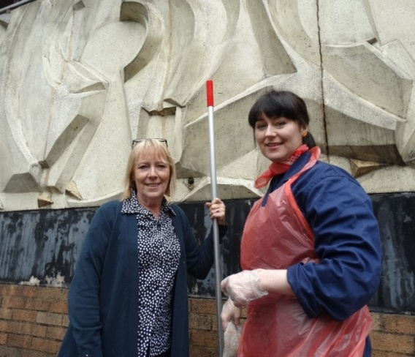
Catrin added: “I have such fond memories of this building, it’s been a big part of my family’s life so I am really delighted to be here today.”

Dental receptionist Margaret James with her daughter artist Catrin James.

Eager to witness the mural’s transformation was Judith Everington whose father Harry was an inspirational sculpture lecturer at Swansea Art College.

It was under his guidance that students from the college produced the mural which was put on the building’s exterior back in 1969.

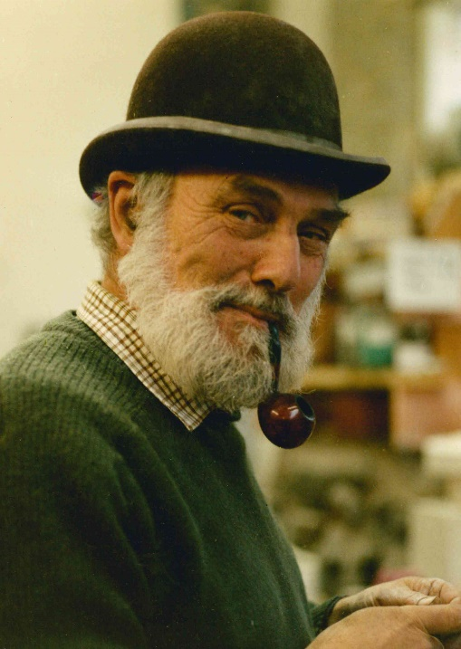
Returning to Swansea for the first time in half a century she instantly recognised her late father’s influence on the sculpture.

“I am delighted to be here to see this – the minute I saw this mural I thought of my dad. He was passionate about his work and he would have been very pleased to see this being restored to its former glory, I think this is a brilliant idea,” said Judith, who had travelled from her home in Birmingham accompanied by her partner Kevin Reilly.

Sculpture lecturer Harry Everington who died in 2000.

Also on hand was Ian Walsh, Dean of Art and Design at Swansea College of Art which is now part of the University of Wales Trinity St David. He is now keen to see the importance of the mural in the city’s artistic heritage recognised.

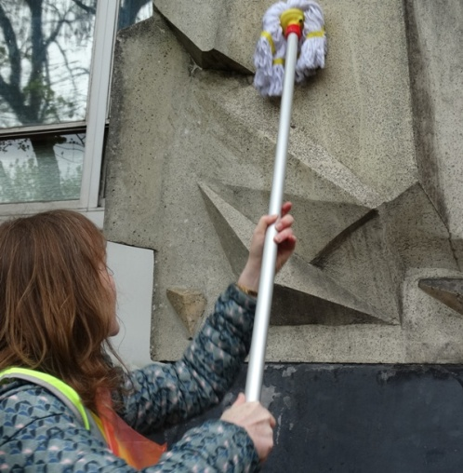
Professor Walsh said: “It’s great to see this unique piece of Swansea art restored to its former glory.

“It stands as a testimony to the long partnership between the health board and Wales’ oldest college of art. It also highlights the vital importance of the arts to health and wellbeing.”

Because the exact composition of the stone used for the sculpture was not known at the time of the clean-up, the team of Martin, Rebecca Kelly, Fiona Edwards and Prue Thimbleby couldn’t risk using any strong chemicals or pressurised water jets.

“It had to be all done with water, simple detergent and elbow grease but we are delighted to see what a difference we have made,” said Martin.

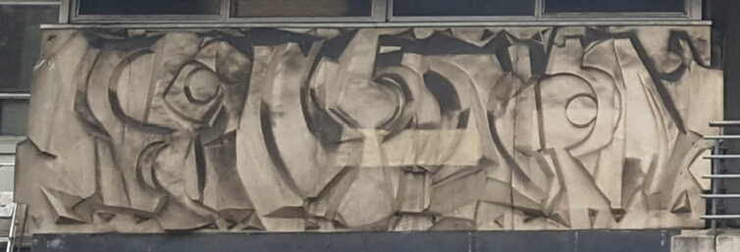

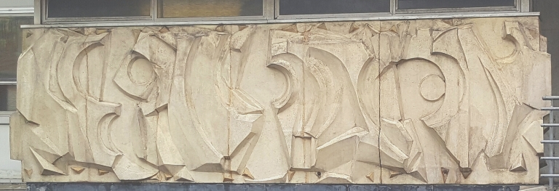

The mural before and after the spring clean

https://www.youtube.com/watch?v=vUuVXpPJ6_o

Source: Abertawe Bro Morgannwg University Health Board

