Getting up and getting dressed helps patients get better quicker
Friday, 5 May 2017
Getting dressed is something we do every day – but for hospital patients it can mean the difference between going home or into a home.

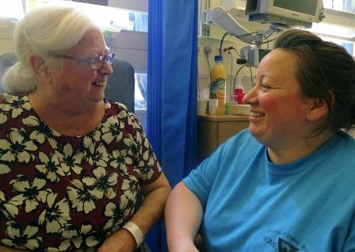
A team of professionals at Princess of Wales Hospital have spent this week spreading the word about the End PJ Paralysis campaign.

Valerie Worrall, up and dressed, chats to occupational therapist Rebecca Davis

The idea behind it is simple: supporting patients in hospital to get up, dressed and moving can prevent deconditioning, which is when patients quickly lose physical function and the ability to do everyday activities.

This is important because 65 per cent of patients admitted are 65 or older and a person aged over 80 can lose 10 per cent of their muscle mass after just 10 days in a hospital bed.

There’s extensive evidence that dressing patients in their own clothes is more dignifying, provides a sense of normality and allows them to be more independent while in hospital.

End PJ Paralysis started on Twitter and has spread across the UK and internationally. It has now been embraced by Princess of Wales Hospital.

Consultant physician Tony James said: “The campaign is about making people aware that older patients can become deconditioned very quickly after a few days in a hospital bed.

“It can mean the difference between being able to live at home independently and do things for themselves, and getting to the point where they can’t manage on their own.”

Consultant surgeon Barry Appleton added: “If we can encourage staff, patients and families to think about the fact that we need to get patients up earlier, and do things for themselves much earlier, it actually helps them to recover quickly.”

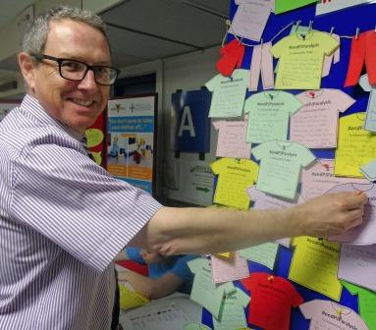
Right: Tony James adds his pledge

End PJ Paralysis is one of several initiatives being undertaken by Princess of Wales Hospital’s Home First team.

This is a multidisciplinary group of professionals whose aim is to improve the experience of patients while they are in hospital but, crucially, to get them back home as quickly as possible.

To promote End PJ Paralysis, the team has had a stall and display in the main foyer throughout this week for patients, families and staff to learn why getting up, dressed and moving is so important to recovery.

Hospital staff can also write a pledge saying what they are doing to support this.

The Home First team is also visiting wards to provide information and support during the week.

But physiotherapist Suzannah Minns said the campaign would be ongoing at Princess of Wales Hospital after the week concluded.

She added: “This is how we’re going to work from now on.”

Occupational therapist Rebecca Davis said Home First was about developing initiatives that were simple, straightforward and could be taken up across the hospital at no extra cost.
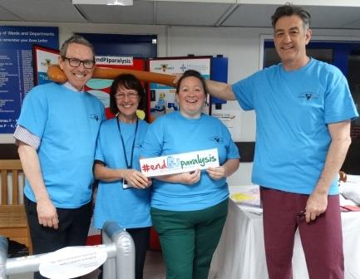
“You don’t need special training to walk someone to the bathroom or ask them to get dressed to improve their recovery,” she said.

A lighter moment as (l-r) consultant Tony James, head of patient flow Helen Greenwood, occupational therapist Rebecca Davis and POWH Medical Director Jonathan Goodfellow help spread the word

Valerie Worrall, from Porthcawl, was admitted to Princess of Wales Hospital with a serious infection three weeks ago.

Valerie, who was up and dressed after the first week, said: “I think it’s a good idea. It definitely helps you feel better.”

Source: Abertawe Bro Morgannwg University Health Board

