Healthcare staff unite to mark International Nurses’ Day
Monday, 15 May 2017
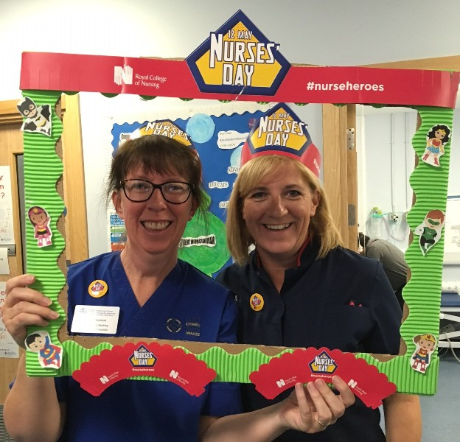
From cakes to choirs and smiling superheroes to staff celebrations, teams across ABMU turned out in force to mark International Nurses’ Day.

The annual event held on 12th May, the anniversary of Florence Nightingale’s birth, aims to mark the contribution that nurses make to society.

At hospitals across ABMU staff took part in a variety of events to congratulate and celebrate their nursing achievements.

Paediatric nutrition nurse Louise Heywood and acting lead nurse for paediatrics Vicki Burridge at Morriston Hospital children’s ward.

Nurses on the children’s wards at Morriston and Princess of Wales Hospitals took this year’s theme of nurse heroes to heart, sporting superhero masks and posing for photos, to the delight of their patients.

At Singleton, Princess of Wales and Morriston there were musical contributions to entertain staff and visitors while Neath Port Talbot Hospital hosted a cake stall and special display in the foyer.

Director of Nursing Rory Farrelly said: “International Nurses’ Day gives us all the opportunity to pause, look back and remember why we entered the nursing profession.

“For our younger colleagues this look back isn’t too far, but for some of us it’s a long time. Whatever the length of time, we all share something in common – we came into this profession because we care and we want to care for others.

“The role of the nurse has developed over the years but caring always remains at its core.”

During the course of the event members of the public and nursing profession were asked to share details of a nurse, midwife, support worker or student who had made a difference to their lives or inspired them.
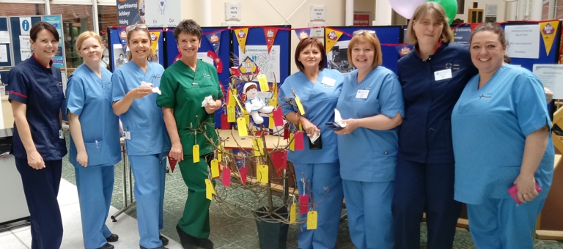
Members of the nursing team at Neath Port Talbot Hospital.

Their contributions were added to special message boards and Trees of Appreciation displayed at the sites.

These included the message: “To do what nobody else will do in a way that nobody else can do it, in spite of all that you go through, that is to be a nurse.”

Prof Farrelly also sent a special message to staff working in wards, clinics and the community: “To all my nursing colleagues across ABMU, thank you for your unwavering commitment and dedication to nursing and caring for our patients.”
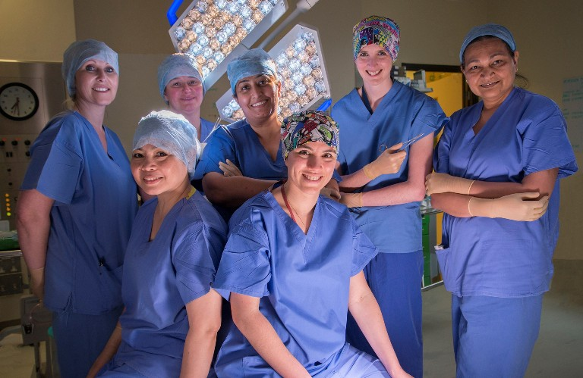
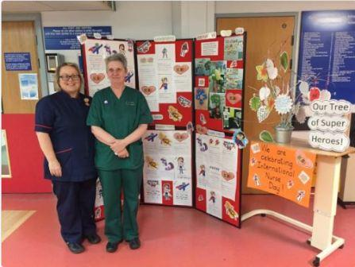

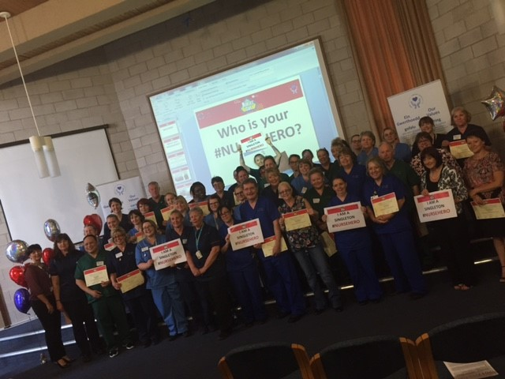

Source: Abertawe Bro Morgannwg University Health Board

