Lee’s latest goal is helping boost cancer charity
Wednesday, 10 May 2017
Former Swansea City favourite Lee Trundle has been doing his bit to cheer up cancer patients while helping to raise awareness of ABMU’s own Golau Cancer Foundation.
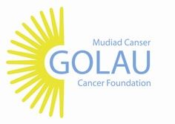
Lee, who is now the club’s ambassador in the community, visited the chemotherapy day unit and radiotherapy department at the South West Wales Cancer Centre to meet patients and staff and find out more about their treatment.

He was invited along by Michelle Barrett, fundraising co-ordinator of the foundation which raises money to support the Singleton Hospital-based centre.
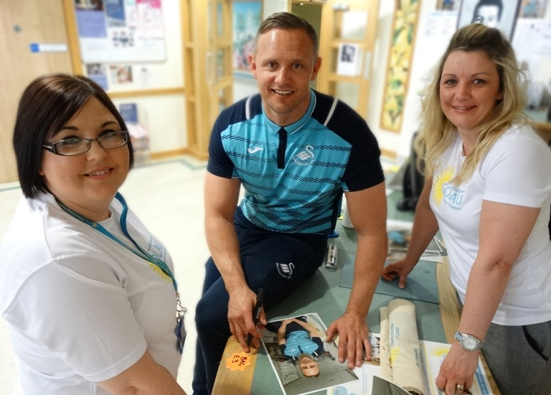
“It’s been my pleasure to come along today and meet everyone and do what I can to support Golau.

Lee Trundle with Jo Thompson and Michelle Barrett from the Golau Cancer Foundation.

“It has really helped me understand what the patients go through when they come here,” said Lee.

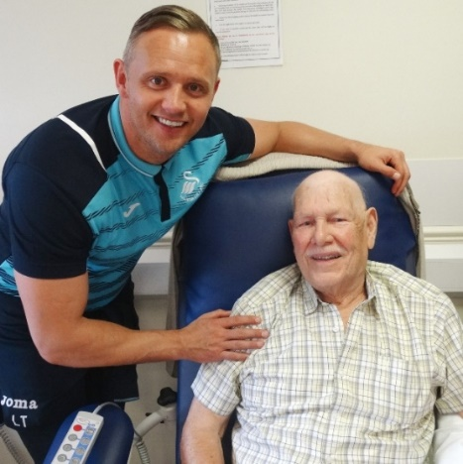
Lee chatted to patients while they were having chemotherapy and posed for pictures with staff before being given a close-up look at high-tech equipment by radiotherapy engineer Gary Mason.

Michelle added: “We are so lucky that we have fantastic support from the community for Golau but Lee coming here today has been another big boost for our work.”

Patient Brian Fishwick took the opportunity to talk football with Lee who has come out of retirement to enjoy a remarkable season scoring nine hat-tricks for Llanelli Town.

“It was good to meet him, great that Lee gave up his time to call in to see us,” he said.

Find out more about the charity and its work at www.golaucancerfoundation.wales.nhs.uk
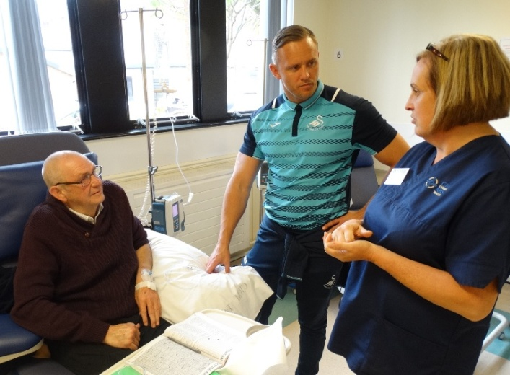
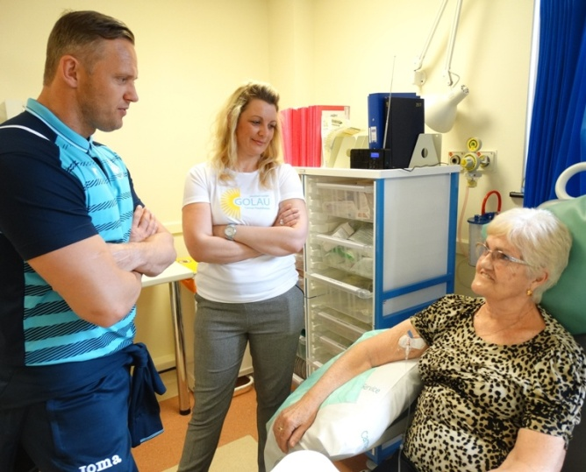

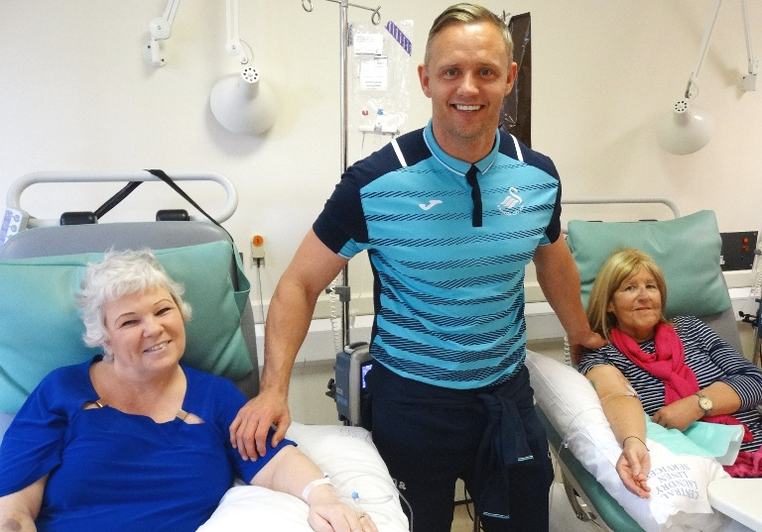

Source: Abertawe Bro Morgannwg University Health Board

