Lifesaving projects up for national awards
Friday, 26 May 2017
Two ABMU projects that could help save lives are in the running for national awards.
They are in the finals of this year’s UK Antibiotic Guardian Awards, taking place in London, next month.

In its second year, the awards recognise the achievements of organisations and individuals tackling antibiotic resistance – one of the most significant threats to patients’ safety in Europe.

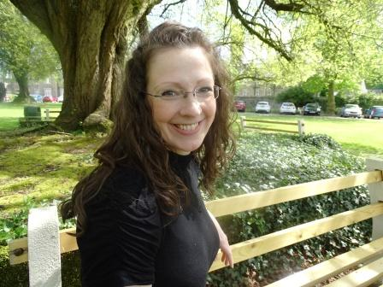
Primary Care Antimicrobial Pharmacist Avril Tucker (pictured right) explains:

“Every time we use antibiotics, bacteria adapts and can become resistant to them making the antibiotics less effective. Already, over 25,000 people die each year across Europe from infections resistant to antibiotics. If this carries on, soon we won’t have any effective antibiotics and even simple operations will become very dangerous.”

It isn’t possible to stop antibiotic resistance but we can slow it down by only using them when absolutely necessary.

The ABMU area is one of the highest prescribers of antibiotics in Wales, and the health board’s medicines management team have been working closely with other healthcare professionals looking at if and how usage can be reduced.

“Best practice guidelines tell doctors they don’t need to prescribe antibiotics for self-limiting infections. Previously, GPs may have prescribed antibiotics for these infections. But now evidence shows it’s best to allow the body’s own immune system to fight the infection, if the patient is otherwise fit and well. As the body can fight the infection itself, by not giving antibiotics we’re helping slow down the development of resistant bacteria,” said Avril.

The health board employs dedicated Antimicrobial Pharmacists who work with doctors to ensure they have the most up-to-date evidence on which antibiotic works best for which conditions. This means when doctors feel antibiotics are absolutely necessary they prescribe the most effective one for that condition, which is most likely to kill the infection without requiring further antibiotics and increasing antibiotic resistance.

Avril has been working on this with GPs in the Bridgend North area. Their work has resulted in a 6.91% reduction in the prescribing of antibiotics in the area – the Welsh national average is 4.17% - and being shortlisted in the staff engagement category of the Antibiotic Guardian Awards.

ABMU has also set up a dedicated team and campaign – the Big Fight - to help fight antibiotic resistance across the health board.

The Big Fight team has been raising awareness amongst the public about the life threatening risk of antibiotic resistance and how GPs will only prescribe antibiotics when absolutely necessary.
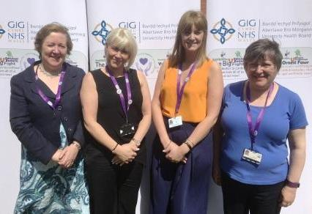
Picture: Big Right Team (l – r) Debra Woolley Christine Woods, Kellyann Edwards, Janice Price

Debra Woolley, Project lead and Specialist Antimicrobial Pharmacist explains:

“Coughs, colds and sore throats are caused by viruses and antibiotics have no effect on these. Many people ask for antibiotics for these conditions because they think they’ll make them better when they won’t.

“So we’re saving the public an unnecessary and often inconvenient trip to their GP by letting them know this in advance. The best thing to do is look after yourself and if you think you need professional advice speak to your local pharmacist – you don’t need to make an appointment – and they can advise you when to see a doctor.”

“It’s very important people realise by only taking antibiotics when absolutely necessary they are not only helping themselves but helping to slow down antibiotic resistance and save lives. Coughs and sore throats can be a pain and cause sleepless nights, but you’ll get better. Pneumonia on the other hand is a life-threatening infection. If you have it, you want antibiotics that will work, not that have been wasted on conditions they have no effect on.”

The work of the Big Fight team, and partners, has contributed to 13,917 fewer prescriptions for antibiotics being prescribed in the ABMU area, and seen the team shortlisted in the ‘stewardship’ category of the awards.

Judith Vincent, ABMU Clinical Director for Pharmacy said: “I’m very proud of what the teams have achieved working with others to change the social norm of antibiotics being used “just in case” to antibiotic use “only when needed” and of benefit to the individual. Being shortlisted in these awards provides further recognition of all their hard work.”

But this is just the beginning for the teams fighting antibiotic resistance. They’re keen to point out this is everyone’s fight and there’s more work to be done.

For further information visit www.abm.wales.nhs.uk/antibioticresistance
Source: Abertawe Bro Morgannwg University Health Board

