Midwives step up to take on pedometer challenge
Tuesday, 2 May 2017
Determined midwives from across ABMU are taking steps to get fitter while enjoying a spot of friendly rivalry with their colleagues.

A total of 128 staff who work in the community and at Princess of Wales, Neath Port Talbot and Singleton hospitals signed up for a two-week pedometer challenge to monitor how far they could walk.

Divided into 20 teams across the different sites, they are now eagerly awaiting the results to find out which group has clocked up the most miles.

As soon as Princess of Wales midwife Karen Rees heard about the Royal College of Midwives’ nationwide Caring for You Pedometer Challenge she knew her friends and colleagues would be up for a bit of very healthy competition.

Whether they are sporting their RCM pedometers or using phones apps and fitness devices everyone has been really enthusiastic, said Karen, who is collating the results from all the participants.
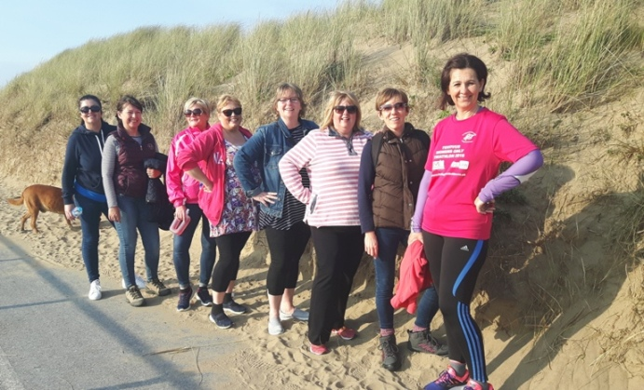
“It is going really well, it’s good to see so many people wanting to get involved.

“Obviously they are on their feet a lot during their working day but now they are putting in the steps when they are off duty too - we even had some staff who climbed Penyfan,” she said.

Karen Rees (third right) and her team mates head to the seafront to get their steps up. Pictured below are other midwifery staff from various teams who have also been taking part in the challenge.

Midwife Hayley Davies, of the Red Hot Chilli Steppers team, has been recording her team’s exploits on camera.

“Everyone is very determined. Some people are taking it more seriously than others but there is never any shortage of volunteers to go to the pharmacy or to take bloods to the lab now – we are all looking for ways to get out step up,” she said.
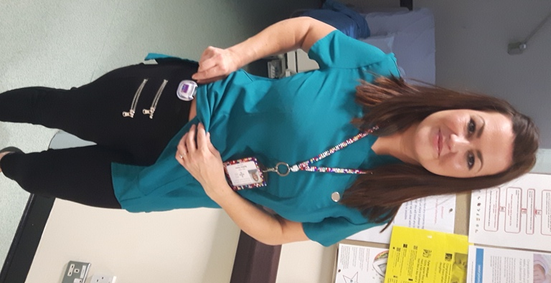
Hayley and her team-mates are among those who have been meeting up in their free time to fit in an extra bit of exercise.

“That has really has helped bring us all closer, we’re enjoying spending time together and we’re encouraging each other!”

The challenge was launched as a way of not only improving midwives’ moral and their fitness but also setting a good example to the mums they care for.

The team that records the most miles nationally will claim £100 for its RCM branch to use on a wellbeing initiative.

“But even if we don’t manage to win that award we have still had a marvellous time,” said Karen, who is also RCM health and safety representative for maternity.

The ABMU total will now be revealed at a midwives’ study day being held on Friday 5th May when the winners will be announced and small prizes will be handed out.
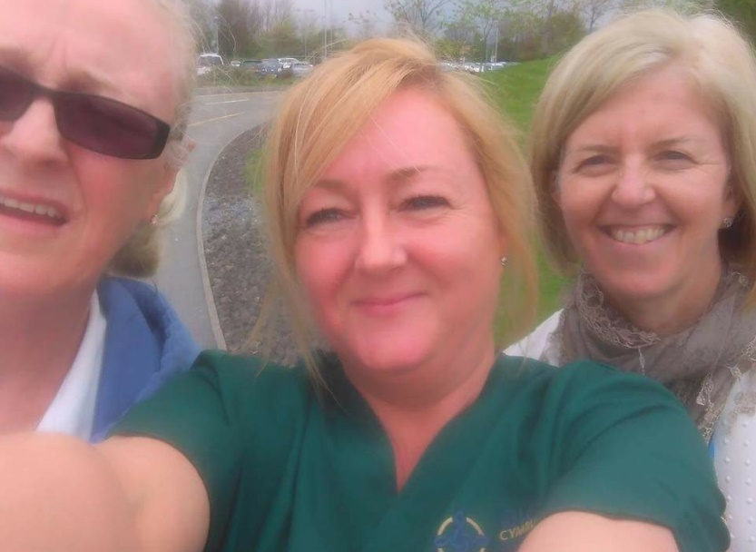
“This challenge has been another way of keeping up morale.”

“We already have an appreciation box where people can give details of someone who has done something above and beyond for another midwife – even if it’s just bringing someone who hasn’t had a break a cup of tea,” added Karen.

Source: Abertawe Bro Morgannwg University Health Board

