Morriston pair using pedal power to spread word about condition
Wednesday, 3 May 2017
Two members of Morriston Hospital’s cardiac team are saddling up for a marathon challenge to help raise awareness of heart valve disease.

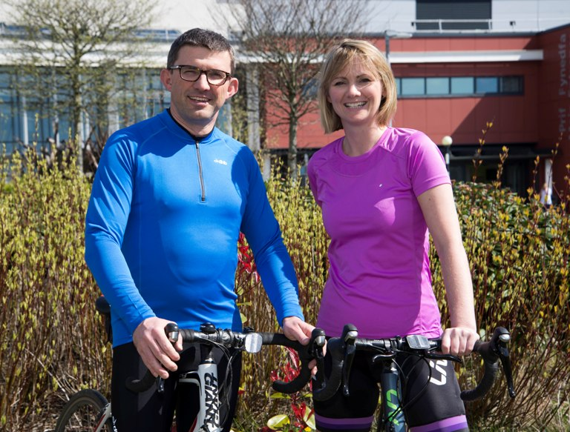
Consultant cardiologist Dave Smith and Anwen Jenkins, who is unit manager of the cardiac short stay and catheter labs, (pictured) are among healthcare staff and patients taking part in the bike ride from London to Paris later this month.

The ride has been organised by charity Heart Valve Voice and will see the intrepid riders not only ride to the French capital but also on to the stage of the main auditorium at the Palais des Congres, which is hosting EuroPCR, the world’s largest interventional cardiac meeting.

Dave said: “We will be promoting awareness of heart valve disease and treatment as well as Morriston’s leading role in Wales in providing heart valve treatments.”

He explained that heart valve disease is a condition associated with older people so it is a particular problem in Wales where 11.7 per cent of the population are over 85 compared to the UK average of 5 per cent.

“Yet we have poor public awareness, poor access to treatment and therefore long waiting lists and times. I’ll also be bringing my stethoscope along with me to highlight the importance of regular check-ups,” he added.

Anwen said: “Heart valve disease, most commonly aortic stenosis, is a life-limiting condition. We are embarking on this challenge as a demonstration of support for our patients and to bring attention to the increased demand for treatment. “

The pair say it is particularly appropriate that Morriston has representatives in such a high-profile event as the hospital’s cardiac unit celebrates its 20th anniversary this year.

Dave and Anwen have been in training to prepare for the event which also aims to celebrate the quality of life patients can have after treatment as well as pay tribute to the memory of those who have died of the disease.

The riders will be given a send-off from Guys’ & St Thomas’s Hospital in London on 15th May before heading towards Newhaven to catch a ferry to Dieppe. They are due to reach their destination on 17th May in time to deliver a presentation with Heart Valve Voice at the conference.

Source: Abertawe Bro Morgannwg University Health Board

