Morriston ward sister named RCN Nurse of the Year
Tuesday, 9 May 2017
A ward sister who has worked tirelessly to improve the care of people with learning disabilities not only in Morriston Hospital but across ABMU has been named RCN Nurse of the Year 2017.

Melanie Davies, sister on Morriston’s Ward G, was presented with the profession’s top accolade at a ceremony in London which also saw her winning the Learning and Disability Practice Award.
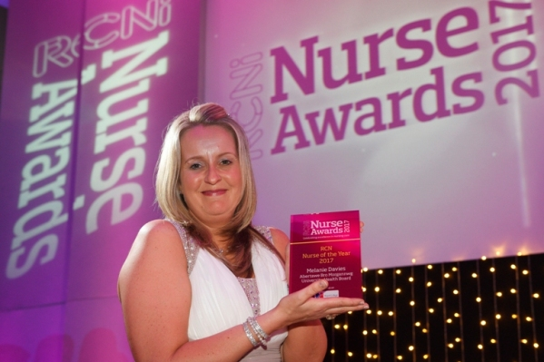
She said: “I am shocked, honoured and amazed - I just can't believe it. This is the highlight of my nursing career.

“I've got a fantastic team behind me and work with fantastic people but ultimately this award is for Paul Ridd and his family.”

Mr Ridd, who had learning disabilities, died at the hospital in 2009 after receiving very poor care. Since then Melanie has been committed to helping change the way vulnerable patients are looked after, working closely with his sister and brother, Jayne Nicholls and Jonathan Ridd.

“This is something we can give back to him and show how care has improved and now I just want to keep on going.

“We've done so much in the last few years and now we want to get the whole package of support out - maybe see a national mechanism in place,” she added.

Since joining the ward in 2010 Melanie has advised colleagues, developed information packs, delivered training and developed a network of champions, mostly in her own time.

She said: “I made a promise to Paul Ridd's family that no other patient or family would experience the poor care that he sadly received.”

In turn they praised Melanie for her work and the support she has given them professionally and as a volunteer for the foundation set up in their brother's name.

Jonathan Ridd said: “Melanie guides and inspires other NHS staff with her high standards and values. By following her example, the standard of care for patients with learning disabilities is increasing enormously throughout the hospital.

“Her outstanding communication skills enable her to connect with individuals and deliver clear information. As the brother of someone who had profound learning disabilities, I know this is essential.

“Her energy, enthusiasm and compassion are to be commended. She is an amazing lady, whose dedication to her patients is exceptional.
“If Paul had been nursed on Ward G today, we believe he would still be alive.”
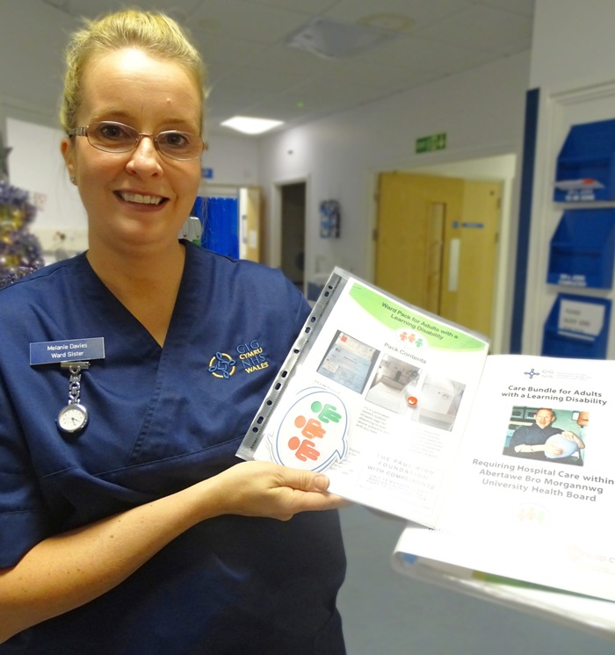
Melanie developed an information pack, with communication tools, magnets, stickers and advice, to make it easier for staff to meet the needs of people with learning disabilities.

Melanie with one of the packs which are now in use across ABMU.

She started delivering informal training sessions on wards to explain the packs and established herself as the hospital's go-to person for advice when a patient with a learning disability arrives on the ward.

“I built relationships and shared good practice ideas with staff whenever I could. If staff were stuck, they knew they could call me any time.”

The packs and the training have now been rolled out across the hospital and ABMU and are now used as the foundation for the care bundle developed as part of the Welsh Assembly's 1,000 Lives campaign.

There is now a network of 170 trained learning disabilities champions across the health board's four sites. Their names are on ward noticeboards, so that staff know who to turn to with any questions or issues about learning disabilities care.

Melanie now wants to work more closely with parents, carers and families and to see learning disabilities training made mandatory and she is involved in the ongoing development of an e-learning platform for learning disabilities training.

Tina Smyth, lead nurse for surgical specialties at Morriston, said: “We are so proud of Melanie. She has been a pioneer in changing attitudes and behaviours towards patients with learning disabilities from passive to passionate.

“Her own passion for patient-centred care and her willingness to go the extra mile is abundant.”

RCNi editorial advisory board chair Caroline Shuldham, who was on the judging panel, praised Melanie's empathy and determination.

“She has used personal and professional experience and persistence to make improvements to the care of people with learning disabilities.

“And she has done something many would not have - developed a collaborative relationship with the sister and brother of the patient who died, worked with them to improve care, and become a trustee of the charity they created in their brother's name. The panel were really impressed by her.”

She added that there has been a fall in complaints related to learning disabilities care since Melanie started her work.

There were rousing cheers as she was named Nurse of the Year and made her way to the stage, a journey made more difficult by a badly sprained ankle which meant she had to wear a supportive boot.
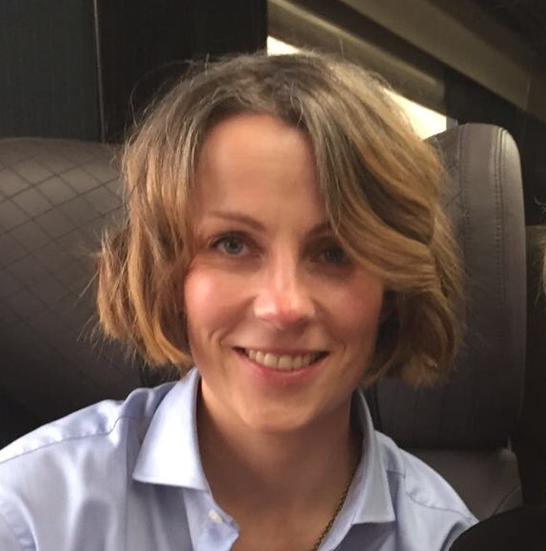
The annual RCNi Awards reward the innovation, talent and skill exhibited by the nursing profession and are keenly contested every year.

Missing out in on the Innovations in Your Specialty Award was ABMU’s other finalist, Macmillan sarcoma specialist nurse practitioner Joanne Vass (right) who also attended the ceremony held at the Westminster Park Plaza Hotel.

Source: Abertawe Bro Morgannwg University Health Board

