Olwen stars in Welsh Government nurse recruitment campaign
Tuesday, 9 May 2017
Our singing nurse Olwen Morgan has revealed another talent as one of the faces of the Welsh Government’s nurse recruitment campaign. With video.

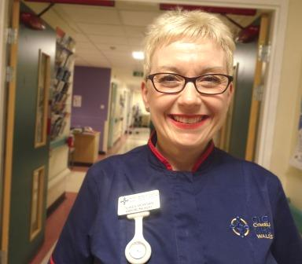
Neath Port Talbot Hospital’s senior matron appears in a new video and promotional images showing her at work and as an artist at her home in Llandovery.

Our video of Olwen performing Myfanwy in the Neath Port Talbot Hospital atrium during the 50th anniversary of the Aberfan disaster was seen around the world last October.

But while we all knew she could sing we had no idea Olwen was a talented artist too.

Her name was put forward for consideration for the new recruitment campaign by Neath Port Talbot Hospital Unit Nurse Director Lesley Jenkins.

Olwen was then picked and a production team arrived at Neath Port Talbot to film a sequence for the video that showed her interacting with colleagues and patients
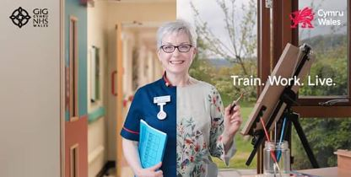
As the campaign also emphasises work-life balance, Olwen was asked about her hobbies.

“When I told them about my artwork, they asked if they could film me at home as well,” she said.

“It was my favourite subject in school. I love doing it. It’s the one thing that relaxes me.”

https://www.youtube.com/watch?v=Y6e6kFNdfJs

Source: Abertawe Bro Morgannwg University Health Board

