Pharmacy team scoop top award
Wednesday, 24 May 2017
Staff at Neath Port Talbot Hospital are celebrating after being named the Hospital Pharmacy Team of the Year at this year's prestigious Welsh Pharmacy Awards.
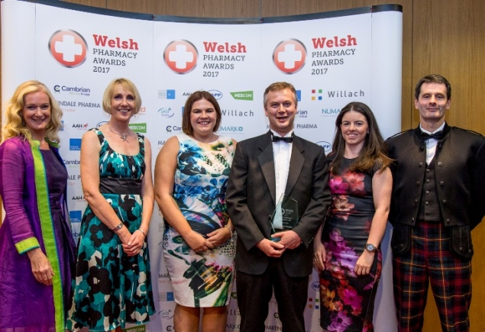
Paul Swithenbank, who leads the anticoagulation team made up of pharmacists, pharmacy technicians and clerical staff, was at the ceremony to receive the trophy.

“It is the first time we have entered something like this and the other shortlisted entries in our category were all very deserving so we are absolutely delighted to have won,” he said.

The team is responsible for providing an anticoagulation service to around 2,000 patients in the Neath Port Talbot area, mainly those who attend warfarin clinics.

Lead clinical pharmacist Paul said: “I’m very proud of the team. This award really recognises their dedication and the hard work they have put in.”

“Even though the service has been in existence for many years, over the past 18 months we have developed what we do and diversified the range of anticoagulation services we provide.

He explained that with the development of new group of blood thinning drugs, the team now works with patients to see if one of these would be more suitable for their care.

“We make sure they know their options and involve them in the choice. We want to go for the best drug for them because then patients are far more likely to take it.

“We then continue to monitor them and see that they are taking it as they should.”

Paul and his colleagues work closely with the domiciliary medicines management team to improve the way housebound patients are monitored and dealt with. They also involved with bridging patients – adapting their anticoagulation medication as necessary as a patient prepares for and recovers from surgery.

“We are doing a lot more now and this really encouraged us to enter the awards. We work closely with both secondary and primary care to put the patients at the centre of everything we do.”

Clinical director for integrated pharmacy Judith Vincent said: “Congratulations to Paul and the anticoagulation team, I am delighted at their success.

“They are constantly looking at ways they can improve and develop what is a very well-regarded and important service and thoroughly deserve this recognition.

“Their work is an example of the valuable role pharmacy staff across the health board play in looking after our patients every day.”
The ceremony was held at the Vale Resort near Cardiff and saw professionals from all aspects of the pharmaceutical industry in Wales gather for the presentation of the ten awards.

Source: Abertawe Bro Morgannwg University Health Board

