Pub regulars rally to support hospital neonatal unit
Friday, 26 May 2017
Kind-hearted regulars at a Swansea pub have helped provide a boost to support Singleton Hospital’s special care baby unit.

Fellow customers at the Wern Inn in Landore didn’t just raise a glass after their friend James Scott’s baby recovered from a traumatic start in life, they put their hands in their pockets.
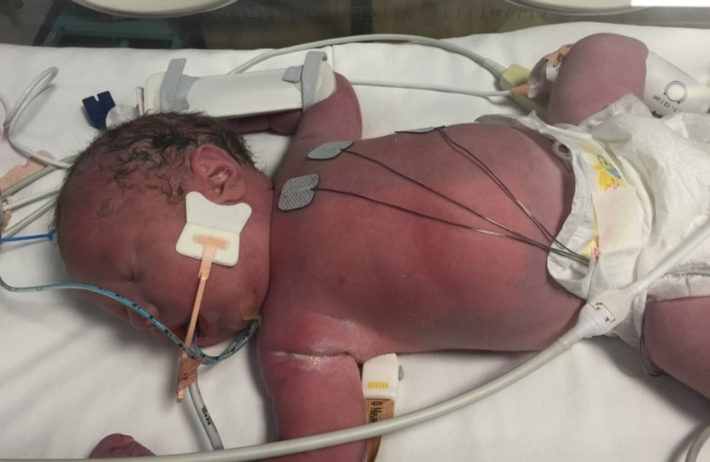
They held a series of fundraising dates, organised by former landlord Paul Kiley, which raised £1,800 for the neonatal unit which had looked after little Noah.

Now a healthy toddler about to celebrate his second birthday, Noah and his dad returned to the unit to hand over the money.

Noah was born at full term and a healthy weight but soon after he was delivered James and his wife Lisa noticed he was turning blue.

After they alerted staff, consultant neonatologist Joanna Webb diagnosed the life-threatening condition persistent pulmonary hypertension of the newborn (PPHN) which meant Noah had dangerously high blood pressure in his lungs and his body was starved of oxygen.

James said: “If it wasn’t for the quick thinking and expertise of the staff, especially Jo, Noah wouldn’t be with us today. Noah’s condition was spotted straight away and that’s what saved him. Noah was taken from us and we didn’t see him again for seven hours while they worked on him.”

After making a good recovery Noah only needed to spend a week in the special care baby unit but the care he received left a lasting impression not only on James and Lisa, who live in Treboeth with Noah and his seven-year-old brother Mitchell , but also on their friends at the pub.

“Lisa and I would like to thank the old landlord Paul, all the customers at the Wern and everyone else who supported the events and helped us reach that fantastic total,” he added.
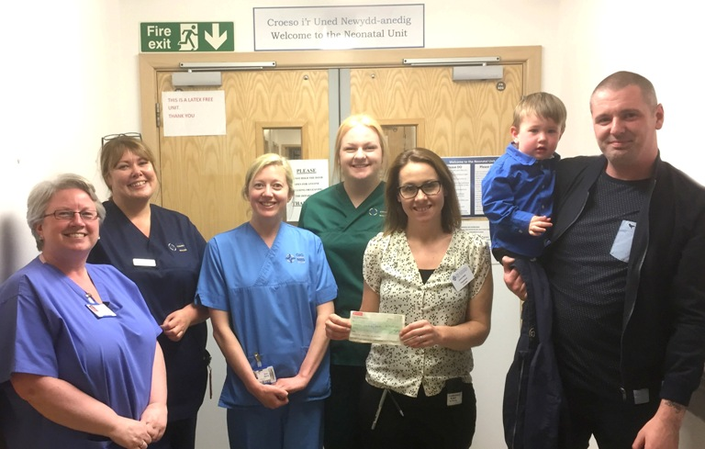
James and Noah Scott (right) with Dr Joanna Webb (third right) and neonatal unit staff at the presentation.

Receiving the cheque Dr Webb said: “We are incredibly grateful for the amazing amount of money raised by Noah’s family and friends.

“The fundraising support we receive enables us to continue to provide the best care we can and support the current families who are going through difficult times here on the neonatal unit.

“Noah has made an excellent recovery from his difficult start and we thoroughly enjoyed seeing him again.”
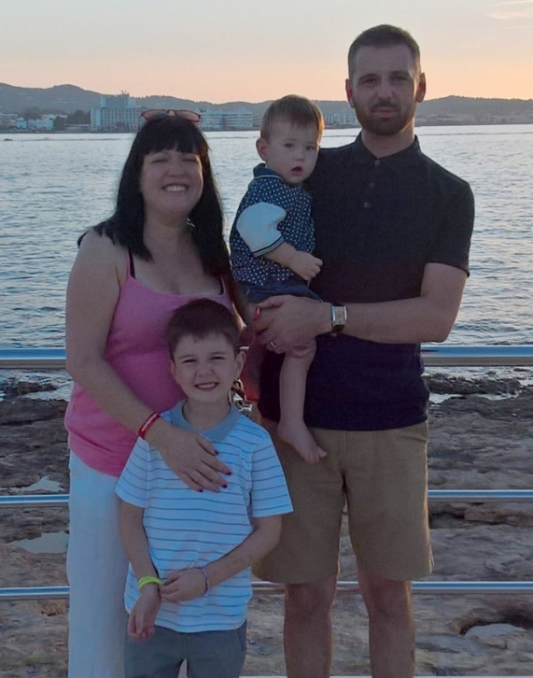
After his return to the unit James said: “We couldn’t thank them enough - that sum of money seems nothing compared with what they have done for us.

“The staff – everyone from the cleaners to the consultants - all do an absolutely fantastic job.

“Noah is now a real busy bee and into everything and we cherish every day we have with him.”

James and Lisa Scott with Noah and his big brother Mitchell.

Source: Abertawe Bro Morgannwg University Health Board

