Pupils get close-up guide to technology at heart of modern healthcare
Tuesday, 9 May 2017
From MRI scanning and radiotherapy to medical engineering and nuclear medicine, modern healthcare needs more than just doctors and nurses.
A group of Year 12 students from schools in the ABMU area were able to learn about some of these careers – and try out some of the technology - during a medical physics and clinical engineering visit to Swansea University and the Singleton campus.
The pupils were from four schools - Ystalyfera, Bishop Vaughan, St Joseph’s Port Talbot, and Morriston.
During their visit they learned about different areas of medical physics, getting hands-on demonstrations from clinical scientists and other staff at Singleton Hospital.
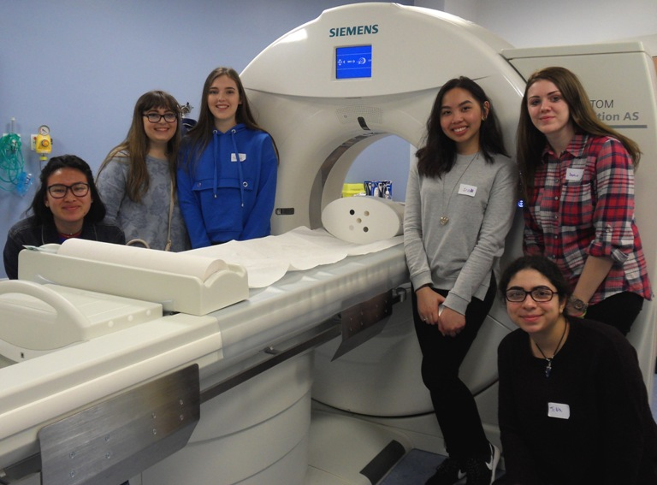
The visit was organised by the South West Wales Reaching Wider Partnership, which is based at Swansea University and works closely with ABMU. Reaching Wider is a programme which aims to widen access into higher education across the whole student age range through learning and activities.

Students who took part in the event get
a close-up look at a CT scanner.

Bishop Vaughan teacher Khudeza Siddika said: “This is a fantastic opportunity for our students. Many are keen to work in the health profession but assume that being a doctor or a nurse are the only options available.

“The event provideds valuable careers information to our students, both by showing the range of jobs available in the health sector, as well as offering a behind-the-scenes look at what those jobs entail.

“This experience is hugely important to our students as it allows them to access career-specific information from specialists and start making informed choices about their future."

Artjoms Smakovs, trainee clinical scientist in radiotherapy physics at Singleton, described what the pupils saw: “Our team was really excited to be able to provide access to the radiotherapy department where we work and to explain how radiation is used to destroy tumours and treat cancer.

“In other workshops, providers showed how diseases are diagnosed in nuclear medicine, MRI physicists talked about the bright future of MR imaging, clinical engineers explained how modern medical devices are used for diagnosing, aiding or treating patients while rehabilitation engineers showed how technology helps people with disabilities.

“I believe that an event like this can inspire future generations of engineers and scientists to consider a career in healthcare.”

Ruth Harding, clinical scientist from the same team, added: "It was a great opportunity to inspire local students to consider careers in the medical field they may not be aware of. I have found medical physics to be a very rewarding career and vocation and I want to share my enthusiasm for this job."

Rebecca Griffiths, of the Reaching Wider Partnership, said: “Students get the opportunity in talk directly to health professionals based at both Singleton and Morriston hospitals and they get to see facilities which are not normally open to the general public.

“It’s been brilliant to see more than 30 pupils take part in the visit. We hope we’ve helped to inspire the next generation of health professionals."

Source: Abertawe Bro Morgannwg University Health Board

