Sharon pears up with store to put fresh fruit on menu for colleagues
Monday, 22 May 2017
A health worker in Swansea is peachy keen when it comes to taking care of her colleagues.

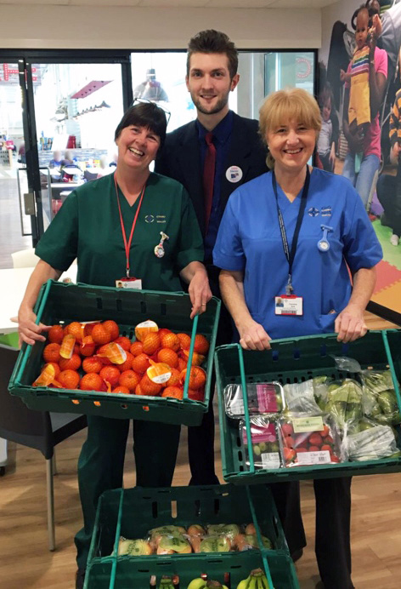
The city’s Acute Clinical Team provides treatment for patients in their own homes so they don’t have to go into hospital.

Sharon Taylor (left) and chronic condition nurse Caroline Kirk with Tesco’s Steve Carter

It’s made up of 40 staff including advanced practitioners, doctors, a consultant, senior nurses, nurses and healthcare support workers.

Now they are getting a helping hand to keep fit and healthy themselves thanks to team member Sharon Taylor.

Healthcare support worker Sharon has become the team’s wellbeing champion – and her first project, providing her colleagues with fresh fruit, has gone down a treat.

ABMU launched its Wellbeing Champion Network last year, with the aim of having at least one in each service area or department across the health board.

Champions can raise awareness of wellbeing initiatives within the organisation, and be a point of contact for colleagues who want to know more about the services that are available to them.

The champions also promote health campaigns and organise work-based health and wellbeing activities.

Sharon joined the network earlier this year and, after completing a course, has really got into the swing of it.

She said: “My manager asked if I would become wellbeing champion earlier in the year and I said I would because I was passionate about doing something for the team.

“I came up with a healthy eating initiative. It’s important to eat healthily, as this improves your wellbeing.

“The team are in and out throughout the day and don’t always have time for a proper lunch.

“I thought that if they had some fresh fruit they could grab a banana or whatever as they were passing.”

Sharon got in touch with Steve Carter, community champion in Tesco Llamsamlet, and asked if the store could supply free fruit every week for four weeks – which it agreed to do.

“They’ve been fantastic. I couldn’t pick up the fruit from them so they even arranged to have it delivered to us,” said Sharon.

“It’s the first thing I’ve done as our wellbeing champion and I’m over the moon with how well it has gone. I couldn’t believe the response, from Tesco and from the team.”

Swansea’s Acute Clinical Team is based in Bonymaen Clinic but does not see patients there, as it works entirely in the community.

It was formed a year ago with the merging of two separate teams and provides a rapid response to treat acutely unwell people at home so they don’t have to go into hospital.

If they have been in hospital and have improved but are still unwell, the team continues their treatment at home so they don’t have to stay in hospital any longer than necessary.
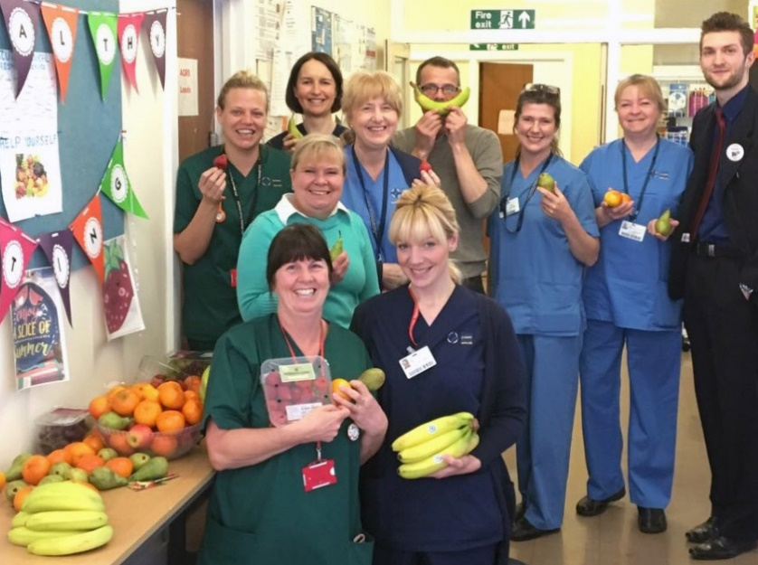
Opposite: Sharon Taylor, front left, with Swansea team colleagues and Tesco’s Steve Carter (right)

When clinical lead Sarah Davies decided to recruit a wellbeing champion, Sharon’s name was the first that came to mind.

“She is so interested in people’s wellbeing and always has a smile on her face. I thought she would relish it, and she has really taken it on board,” said Sarah.

“It has been lovely. Having fresh fruit on display has really brightened up people’s mood.

“Everyone in the team has remarked how nice it is that someone cares about them.”

Sharon said the fresh fruit initiative would be the first of many as she had plenty of other ideas. She added: “I’m hoping to get the next one off the ground very soon.”

Source: Abertawe Bro Morgannwg University Health Board

