SPA experience wins another top award for POWH anaesthetic team
Friday, 5 May 2017
The awards just keep on coming for a spa experience with a difference at Princess of Wales Hospital.
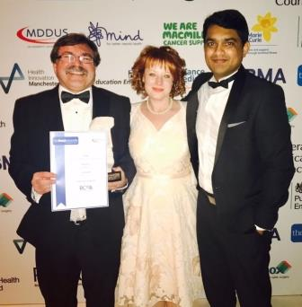
Soothing Patient Anxiety – SPA – takes the fear out of the operating theatre for patients with a learning disability who need dental work but cannot be treated in a traditional dentist’s surgery.

L-r: Paul Harris, Rose Edwards and Shakeel Moideen with the award

Instead they have it done under general anaesthetic in hospital – where the anaesthetic team has gone to extraordinary lengths to make sure they feel at ease.

That could be achieved by letting them play their favourite film, music or video game as they go to sleep.

Operating department practitioner Paul Harris has also sourced an array of props ranging from disco lights to children’s character toys.

The initiative has already won several awards, including the prestigious NHS Award last year, and been a finalist in others.

Now it has won the Anaesthesia Team of the Year Award in this year’s national BMJ Awards.

Paul, along with consultant anaesthetist Shakeel Moideen and recovery nurse Rose Edwards represented the POWH team at the awards ceremony held at the Park Plaza Westminster Bridge in London.

Speaking for the team, Paul said: “We are honoured to receive this prestigious award.

“It is testimony to fantastic teamwork between hospital staff, community teams and care providers.

“We are proud to have recognition for our innovative and unique approach to ensure our patients can reduce their anxieties and cope with fear of hospitals and an operating theatre.

“Making small but essential changes to our practices have been significant to our patients.
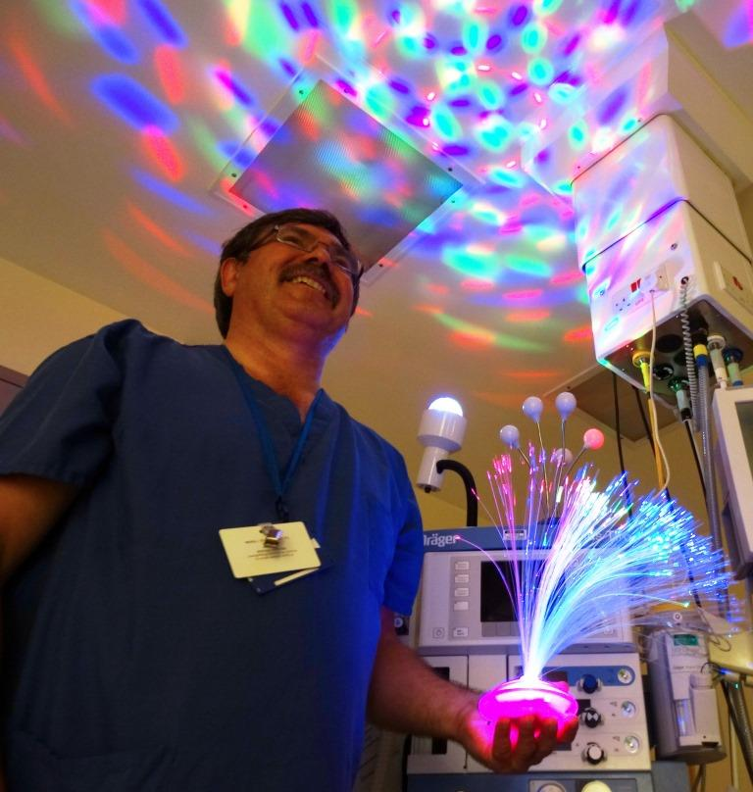
“We would like to inspire and encourage other departments and hospitals to adopt our approaches that we know mean so much to our patients and their carers.”

Paul with some of the lighting effects used as part of the SPA experience

Dr Liam Brennan, President of the Royal College of Anaesthetists, said: “Dr Moideen and the whole anaesthetic team at Princess of Wales are leading the way in patient-centred care.

“Anaesthetists play an important role in supporting patients before, during and after surgery.

“The SPA Experience programme shows how caring for each patient as an individual can improve outcomes.

“I congratulate the whole team on this well-deserved recognition and for the excellent care they continue to provide.

“They are role models as we continue to find new ways to improve the quality of anaesthetic care.”

Another ABMU initiative, Managing Antibiotics Wisely, was shortlisted in the clinical leadership team category of the BMJ Awards.

It involves reducing the use of antibiotics in babies at Singleton’s neonatal unit.

The project has seen a 43 per cent reduction in antibiotic use, sustained over 12 months, during which the unit recorded one of its lowest death and serious illness rates of recent years.

A video about the SPA experience can be seen here

Source: Abertawe Bro Morgannwg University Health Board

