Storytellers' visit is just what the doctor ordered at Morriston Hospital
Tuesday, 23 May 2017
There was a healthy dose of music and laughter when Starlight Children’s Foundation brought its annual Storytellers Tour to Morriston Hospital.

Starlight is a national charity that grants wishes for seriously and terminally ill children and provides entertainment in hospitals and hospices across the UK.

The Storytellers Tour saw four actors visit the hospital’s children’s wards to bring classic tales The Three Little Pigs, The Three Musketeers and The Princess and the Pea to life.

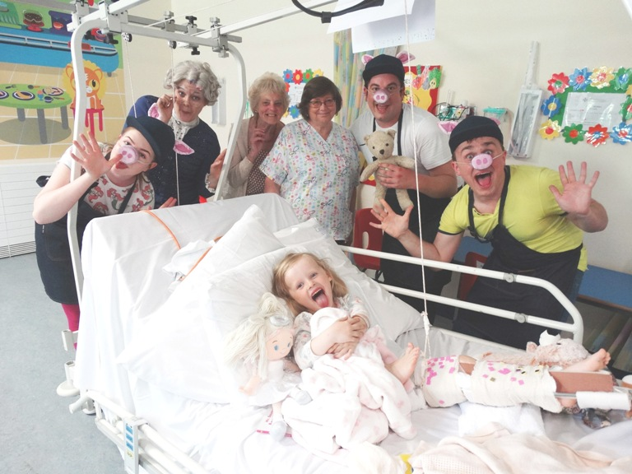
Now in its fourth year, the tour’s stories were produced exclusively for Starlight by The Panto Company which performed the fully interactive versions, aimed at getting young patients and their families to laugh and cheer.

Patient Sienna Hughes, aged 4, with (from left) Eden Lynch, Rachel McPhail, grandmother Eirlys Rees, play specialist Ann Jones, Oliver Wallaard and Hue Cox.

Morriston play specialist Ann Jones said: “We use play to help distract children from pain and anxiety they might be feeling and there’s nothing like a good story to capture a child’s imagination.

“The children are always very excited ahead of a visit from Starlight and we are so grateful to them for providing the opportunity for our young patients to forget their illness for a little bit and have some fun.”

During its eight-week long tour the actors have been visiting a bumper 92 children’s wards across the country, giving thousands of sick children the chance to escape their illness and enter the magical world of storytelling, all from the safety of the hospital ward.

Neil Swan, of Starlight Children’s Foundation, said: “We’re delighted to be able to bring storytelling and fun to poorly children and we hope that the stories were just what the doctor ordered!”

For more information visit www.starlight.org.uk
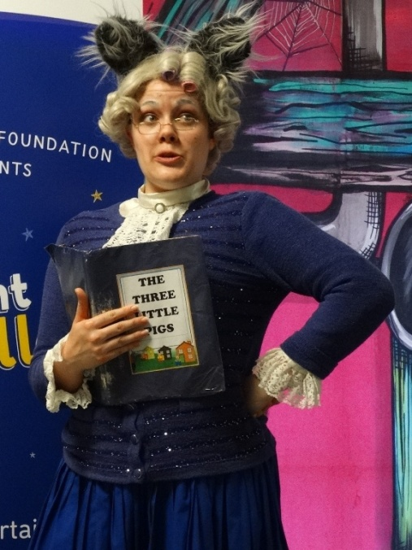
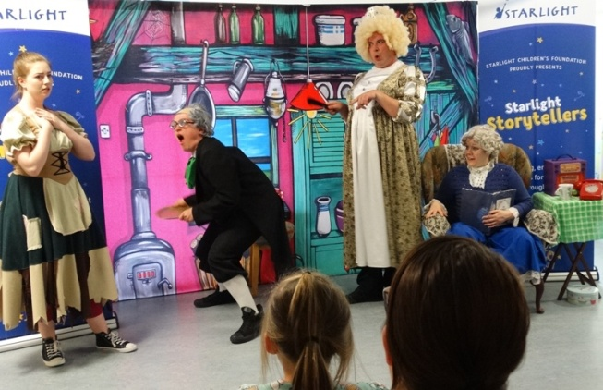

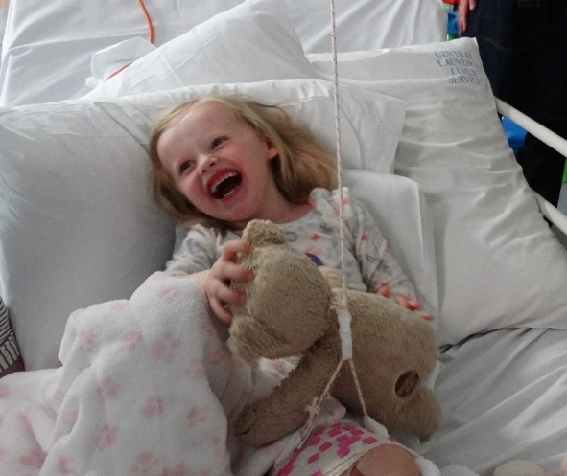

Source: Abertawe Bro Morgannwg University Health Board

