Widow helps fund research into disease that claimed husband's life
Tuesday, 16 May 2017
A Swansea widow has helped raise money for a research project into the incurable lung disease that claimed her husband’s life.

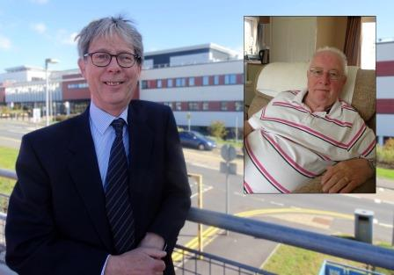
Keith James passed away in 2015 from idiopathic pulmonary fibrosis (IPF), which causes thousands of deaths in the UK every year.

Dr Kim Harrison and (inset) Keith James

He was a member of Dunvant Workingmen’s Club, which has supported Keith’s widow Glynis in raising money for research into the disease.

In December 2015, Glynis donated a cheque for more than £1,200 raised through a sponsored sky dive by club barmaid Kerry Bennett-Perman.

The club then held a series of fundraising events last year, culminating in a charity night in December. That raised a further £2,000.

Rather than have the money go to a national charity, Glynis wanted it spent on local research.

Consultant chest physician Dr Kim Harrison and his team at Morriston Hospital cared for Keith when he became ill.

Dr Harrison is collaborating on an IPF research project with Dr Melitta McNarry and Dr Mike Lewis of Swansea University’s College of Engineering.

The money raised by Glynis and the Dunvant club members has been donated to this research, which focuses on the effects of exercise on people with idiopathic pulmonary fibrosis.

Dr Harrison said: “Once again the generosity shown by Keith’s family and friends has been overwhelming.

“This donation is very welcome because it will help us carry out further studies.”

IPF causes scar tissue to form in the lungs but the cause is not yet known.

People with the disease have shortness of breath – at first with more strenuous activities like walking uphill but, as the condition worsens, with more everyday activities such as washing, dressing, eating and talking.

Dr Harrison said relatively few people had heard of IPF even though it was not uncommon. It was also becoming more prevalent, for reasons that were not yet understood.

“It kills about 5,000 people a year in the UK, making it roughly as common as cancer of the stomach or cancer of the bladder.

“IPF is difficult to diagnose as it presents in a subtle way with slowly increasing shortness of breath and a cough.
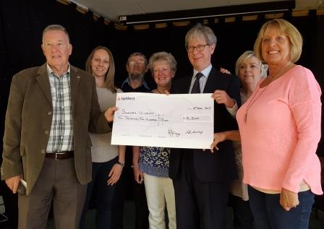
“For this reason it is often missed or mistaken for other lung diseases such as COPD.”

Reg Williams (left), who organised the fundraising night, and Glyns James (right) present the cheque to Dr Kim Harrison. Also pictured are Dr Melitta McNarry (second left) and Dunvant Workingmen’s Club members.

Dr Harrison said a correct diagnosis was important because IPF had a very poor prognosis, with an average survival of just three to four years.

Therefore people and their carers needed to have the correct information about the condition, and support in how to live with it.

“Another reason why a diagnosis is important is because treatments are now available that, although they won’t cure it, will slow down the disease progression and the decline in lung function.

“It must be emphasised that these treatments are only available to some people at certain stages of the disease, and not to all patients.

“More research needs to be done to find new and better treatments. But the outlook is certainly more optimistic than it was even five years ago.”

The Swansea research examines the effects of exercise on people with IPF – how the disease impairs normal physiology, in the way the lungs and heart interact with the muscles.

Dr Harrison added: “We need to understand what happens in the first place before can start to look for new treatments.”
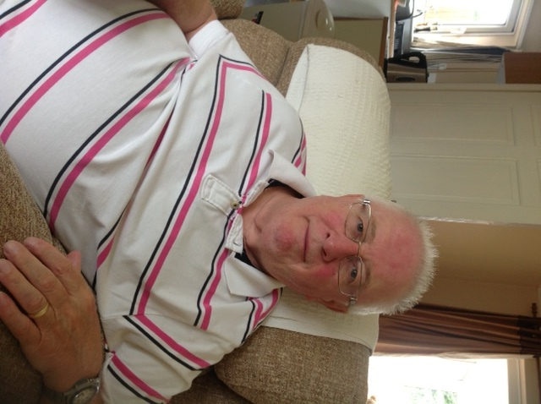
He set up the interstitial lung disease clinic at Morriston Hospital, which he runs with a group of specialist nurses for patients with a wide range of lung problems conditions including IPF.

Glynis is also giving £200 to a support group for people with IPF and their carers – which Dr Harrison and his team helped found and which meets monthly in Penuel Baptist Church Hall, Loughor.

Glynis said Keith (left) had suffered problems with his chest for some time before being diagnosed with IPF. “He was very brave about it, right up until the end.

“Nobody knows what causes it. That’s why research is so important, and I wanted the money to go to the research being done in this area.”

Source: Abertawe Bro Morgannwg University Health Board

