ABMU in running for three NHS Wales Awards
Thursday, 24 May 2018
ABMU Health Board is celebrating after three of its projects made the finals of this year’s NHS Wales Awards, announced today.
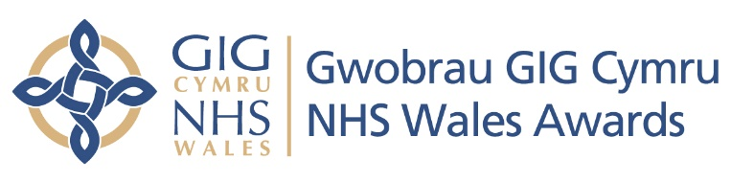
The health board is shortlisted in the Citizens at the Centre of Service Re-Design and Delivery category for its project “From marshmallows to magic: engaging the public to reduce antimicrobial resistance (AMR)” put forward by antimicrobial pharmacist Avril Tucker.

She used magic in a video to help illustrate why it’s so important antibiotics are only prescribed when absolutely necessary and if you’re prescribed them, that you take the full course.

A project entitled “Implementing and developing a new CT colonography advanced practice radiographer role to improve the patient experience, service provision and quality” is in the running for the Developing a Flexible and Sustainable Workforce category submitted by Louisa Edwards.

A collaboration between ABMU and Swansea University is also through to the next stage of the awards. The study of the local, national and international healthcare impact within diabetes submitted by Professor Jeffrey Stephens has been shortlisted in the Promoting Clinical Research and Application to Practice category.

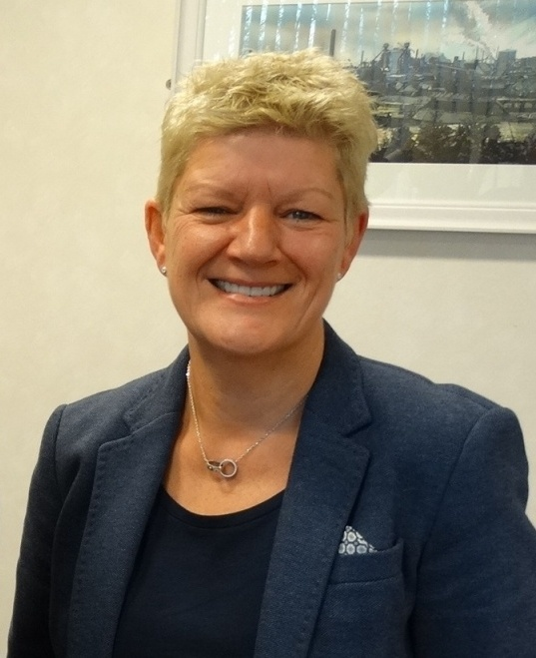
ABMU Chief Executive Tracy Myhill (left) said: "We are delighted to have three exciting projects among the shortlisted entries at this year's awards. The fact that each is so different really goes to demonstrate the breadth of knowledge and expertise of our dedicated staff.

"I wish them all every success in the next stage of the awards - ABMU is very proud of them!"

Now in its 11th year, the annual NHS Wales Awards celebrate the work of organisations and teams across Wales in delivering excellent care and the winners of the seven awards will be announced in a ceremony on 20th September.

The next stage of the awards will see judging panels visiting each finalist to find out more and see first-hand the benefits they’ve brought to patients.

For a full list of finalists please visit www.nhswalesawards.wales.nhs.uk.
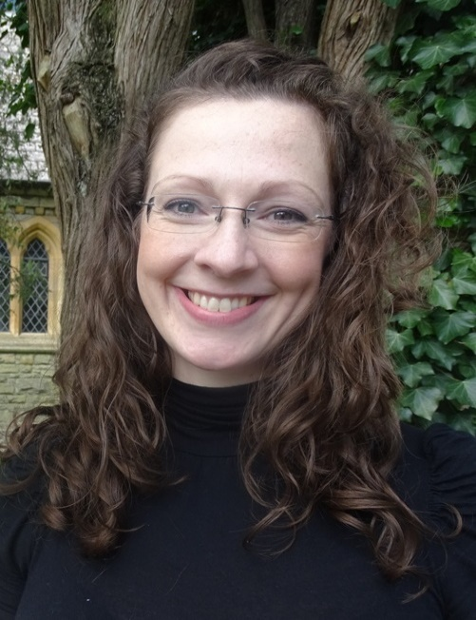
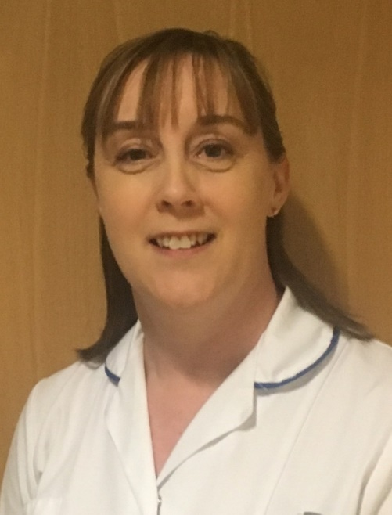
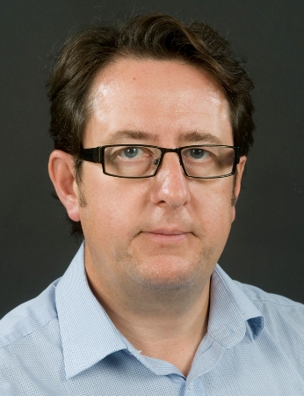

(From left) Avril Tucker, Louisa Edwards and Prof Jeffrey Stephens

Source: Abertawe Bro Morgannwg University Health Board

