Children's passports help ease the way during hospital journey
Monday, 14 May 2018
Children needing cleft surgery in Morriston Hospital are being given a passport to prepare them and their parents for the journey.

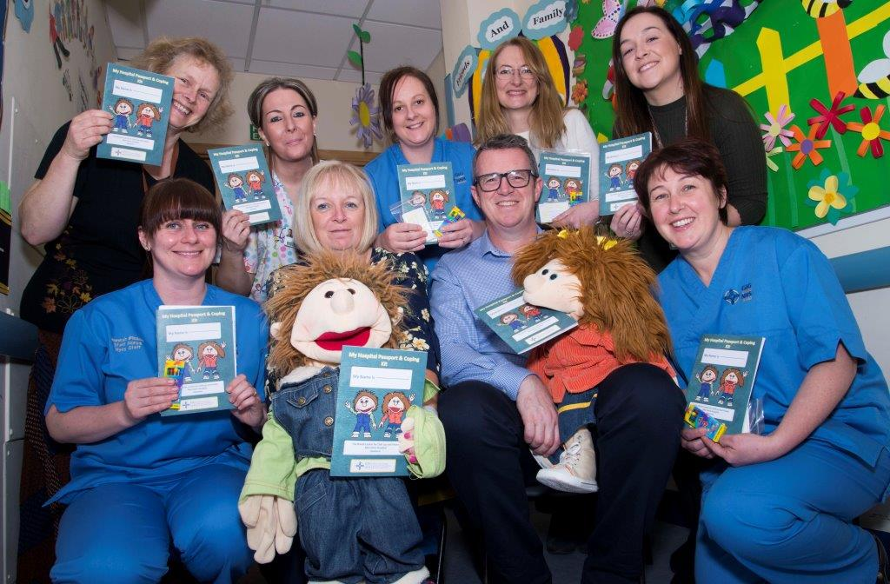
Psychologists at the hospital’s Welsh Centre for Cleft Lip and Palate have developed the passport and a series of bright ideas cards.

This ‘coping kit’ has been designed to help children and parents prepare for coming into hospital and deal with any anxieties they might have during their time there.

It was inspired by a similar initiative in Scotland.

Consultant clinical psychologist Vanessa Hammond explained: “Some children are very anxious about coming into hospital.

“They can find it difficult to cope with certain procedures, involving needles for example.

“Parents can also worry about how to talk to their child about going into hospital for an operation.

“We were working with a number of families to help them prepare for coming into hospital, and with nurses staff and play specialists on the children’s surgical ward to support children and families during their time there.

“We decided to develop the passport and bright ideas cards as a joint project, with us as psychologists working alongside the cleft team nurses, ward nurses and play specialists.

“The project has helped make sure we are all working together and that families are supported from the time they come to clinic right through coming into hospital.

“A really positive aspect is that we are working alongside parents and children to help them be actively involved in their care.”

The passport is an illustrated booklet which provides a fun structure for parents to work through with their child, reducing their worries and anxiety leading up to them coming into hospital.

It also provides activities and strategies that help children settle into the ward and manage difficult procedures.

The passport comes with a pack of bright ideas cards which use evidence- based strategies to help children cope with anxiety – such as looking around the ward and naming things they can see and hear.

Assistant psychologist Jessica Simmonds said: “We give the passport out a few weeks before surgery so parents have time to work through it with their child.

“As the children fill in the pages, they get to understand more about why they need to come to hospital and what they should expect on the ward.

“It helps them communicate their concerns with ward staff and explains the things they need to do before they can go home.

“It also allows them to make some decisions about certain procedures such as if they want to sit on their parent’s lap or look away, which evidence suggests can help reduce their anxiety.”

The passport cover features Boris and Doris, two puppets which Morriston Hospital play coordinator Lisa Morgan uses to explain to children what will happen during their stay in hospital.

Inside there are games such as colouring in the different coloured tops worn by ward staff.

Jessica said: “Boris and Doris introduce the hospital journey as an adventure and offer support along the way.

“They also remind children to use their bright ideas cards if they do start to feel a bit nervous.

“The children’s aim is to work their way through the passport.

“For everything they do they get stickers, stamps and plenty of praise from the nurses, play therapists, the surgeon, the anaesthetist and from us.

“And at the end they get a certificate to say they’ve completed their passport.”

The cleft team psychologists are now piloting the use of the coping kit and collecting feedback from youngsters and their parents as well as staff on the children’s surgical ward.

Dr Hammond said: “We have been using the passport for a few weeks now and feedback has been really positive.

“There has been a lot of interest from psychologists in other cleft teams around the UK as well as from other services in the hospital.”

Pictured above with Boris and Doris are: Top row l-r: Cleft lip and palate clinical nurse specialist Michele John, play coordinator Lisa Morgan, staff nurse Tracey Griffiths, consultant clinical psychologist Vanessa Hammond and assistant psychologist Jessica Simmonds. Bottom row l-r: Staff nurse Hannah Pinson, cleft lip and palate lead nurse Michaela Rowe, consultant cleft and maxillofacial surgeon David Drake and junior ward manager Kath Shaw.

Source: Abertawe Bro Morgannwg University Health Board

