Hats off to superhero George who kept a cool head when aunt became ill
Tuesday, 1 May 2018
He may only be three years old but that didn’t stop George Powell following his family’s tradition for caring when his aunt became suddenly ill.

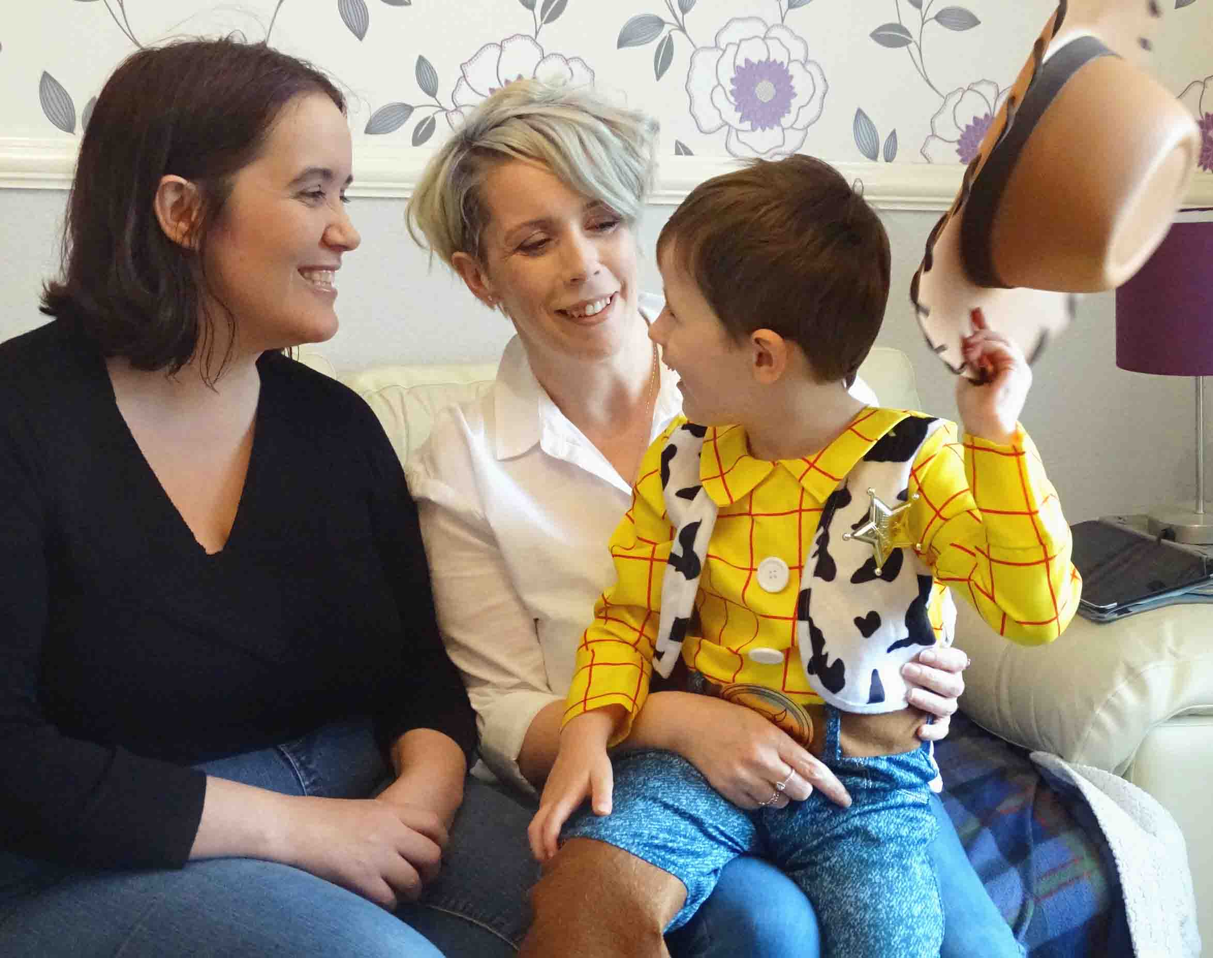
Toy Story and superhero fan George kept a cool head when Ruth Guy suffered an hemiplegic migraine, which mimics the symptoms of a stroke.

Toy Story fan George Powell with aunt Ruth (left) and mum Beverley

The Swansea youngster helped Ruth take her medication, tucked her into bed so she wouldn’t fall out, and then went to find his older cousin.

“He was a little superstar,” said Ruth, who lives in the Ravenhill area of the city and is a healthcare support worker in Fforestfach Medical Centre.

Ruth is a long-term sufferer of hemiplegic migraines, a rare and serious type of the condition which causes temporary paralysis of one side of the body.

One evening she was babysitting while her sister, George’s mum Beverley Guy, was on nursing duty in Morriston Hospital’s Emergency Department.

Ruth said: “I love looking after George. He sleeps next to me when he’s here and this night I had an attack while we were in bed.

“He was very good. He got me comfortable. It’s my left side that goes and he put my dodgy arm and leg on the pillow for me.

“He tucked me in so I didn’t fall out of bed. He even checked my head to see if it was all right.

“I carry a box of medication around with me everywhere. That was by the side of the bed and George got it for me.

“We opened the box together and he got my nasal spray and opened the little packet for me.

“After that he went to get Caitlin, my 14-year-old daughter who was in her bedroom.

“She said, ‘What do I do? George has done everything!’.”

Ruth said she had migraine attacks every week to 10 days so Caitlin was well used to helping her deal with them.
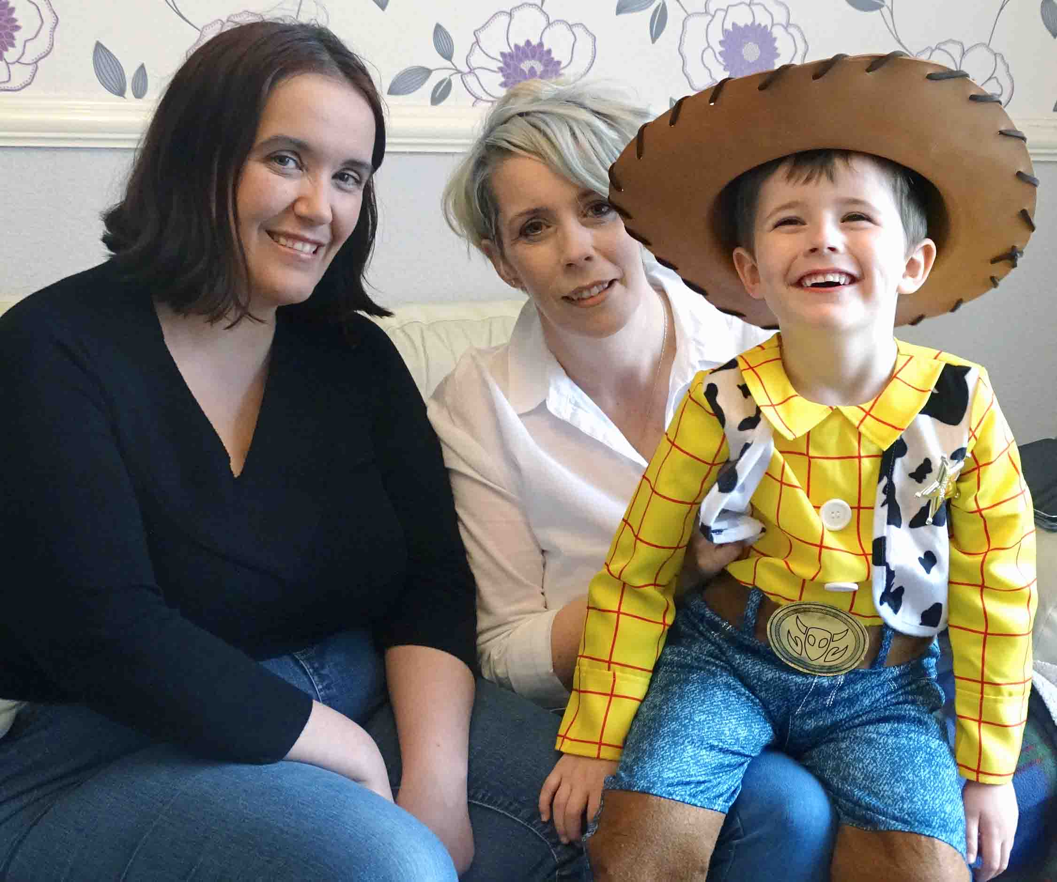
“I think George observed her doing it for me on occasions before and he just did what she did. He didn’t panic, he didn’t cry or get upset. He’s definitely his mammy’s son.”

The two sisters are not the only carers in the family – their mother, father, grandmother and aunt were all psychiatric nurses.

George is clearly following in their footsteps. He is a nursery pupil at Gendros School and attends Ty Hapus crèche in Fforestfach where he has been learning all about first aid.

Mum Beverley, from Cockett, said: “He’s got a certificate for looking after cuts and bruises and applying compression and a cold compress. In a couple of weeks they’ll be learning about the recovery position.

“He’s a clever little boy and very level-headed. He looks after his nan with her bad leg as well.

“My mum picks him up from school. She can’t carry his bag, walk with her stick and hold his hand, so he walks right by her side. He won’t run off because he knows she can’t run after him.”

Source: Abertawe Bro Morgannwg University Health Board

