New Mountain View Health Centre a hit with patients and staff
Tuesday, 1 May 2018
From a former house to a state-of-the-art new centre – a Swansea GP practice’s new home is a hit with patients and staff alike.

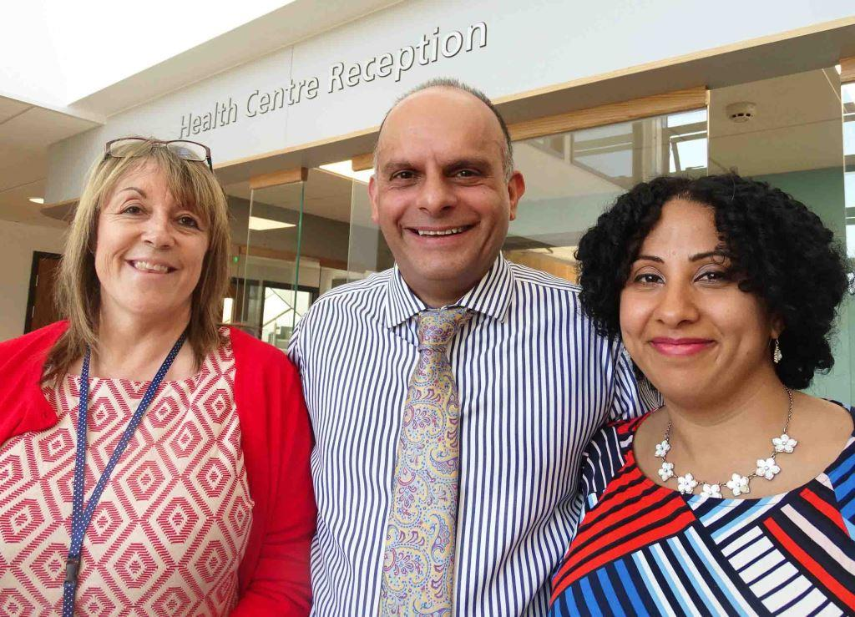
The opening of the £2 million, first-in-Wales complex marked the start of a new chapter for Mayhill Surgery.

L-r: Practice manager Julie Hayes and GPs Baljit Ghuman and Ameera Brett

Instead of having hardly enough space to move, doctors and staff are working out of a suite of bright, airy rooms with the very latest facilities.

It’s not only proving a popular move with existing patients but more of them have registered with the practice since the new centre opened.

Practice manager Julie Hayes said: “It’s much better. It has more space, and the staff are happier.

“It’s such a difference to what we came from, an old house with an extension on an extension. Where we are now, there’s plenty of room for everybody.

“We’ve already taken on quite a few patients. People are coming in to register because they live close by and they want to come where the new building is.

“It’s been good so far. We are looking at introducing new services and hopefully taking on more doctors.”

The integrated Mountain View Health Centre and Children’s Centre, which also includes a pharmacy, is the first of its kind in Wales.

It has been delivered in partnership by ABMU Health Board and Swansea Council.

ABMU has provided funding for the health centre, while the Welsh Government contributed £567,000 towards the family centre element.

The old GP surgery on Pen-y-Graig Road no longer met modern standards and was too small to allow for future expansion.

But the new health centre on Mayhill Road is almost twice its size, with four ground-floor consulting rooms and a further two on the first floor; two treatment rooms; a phlebotomy room; reception; waiting areas; offices; and associated staff rooms.

Dr Ameera Brett said: “I joined the practice last year so I’ve been lucky how quickly this has happened since then.

“Some of the rooms in the old surgery were very small, the doors were thin, people in the waiting room would often tell us they had heard everything.

“It was difficult protecting confidentiality and dignity. But there was nothing we could have done. We tried our best but some patients are deaf so you have to speak up.

“Also, the examination areas were all squashed. So we made do with what we had.

“But now patients come in, they have a proper space, they have dignity, they are treated in a special way and it builds a really good relationship.”

Dr Baljit Ghuman spent 21 years in the old surgery and said the move to the new location had been a long time coming.

“My room was next to the reception desk. I had one window but it overlooked nothing. The heating didn’t work. Staff had their coats on.

“Here it’s much quieter. It’s not as stressful. Everyone was on top of each other there as well, so it was difficult for us.

“The people up here are great. They deserve something. We hope this will give them some inspiration, some drive and self-belief as well.”

ABMU Chairman Professor Andrew Davies said: “This state-of-the-art facility is exactly what the community needs and deserves.

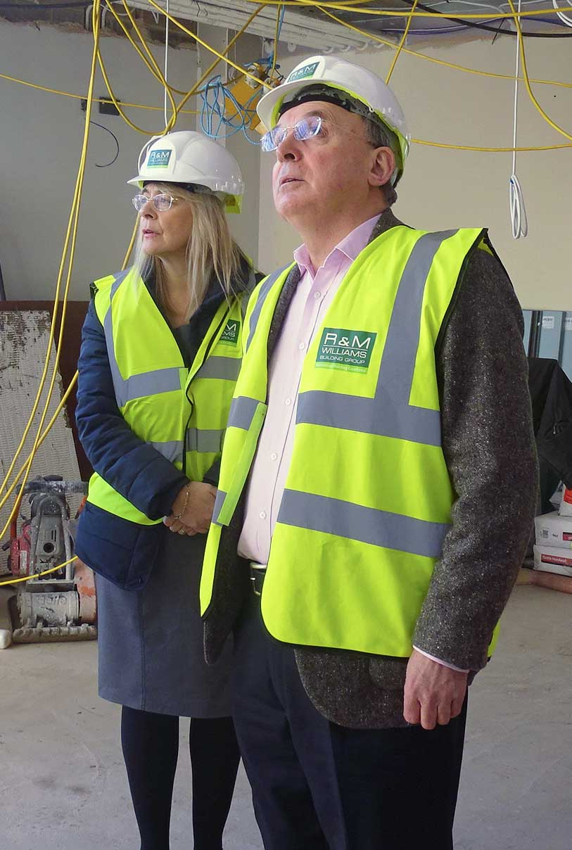
“It is a model of what we can provide in other parts of the health board, and exactly the sort of approach we’re using for the planned wellbeing centre in Swansea city centre.”

The new centre was still some way from completion when ABMU Chairman Andrew Davies and head of primary care for Swansea Sharon Miller had a look around in February

Professor Davies said the life expectancy for people born in deprived communities such as Mayhill could be as much as 10-15 years shorter than those born in more affluent areas.

“That is a huge difference. So providing quality services for communities such as Mayhill is exactly what we need to narrow that gap.”

ABMU’s head of primary care for Swansea, Sharon Miller, said: “This is something we’ve wanted to do for a long time.

“It has been a collaboration with partners to benefit the wider community.

“There’s a lot of evidence that if you co-locate children’s services with primary community services it can have much wider benefits, particularly in early years.

“We hope to expand services here. We want to bring as many services as we can closer to people’s homes, into their community, and try to design those services with patients.
“You do need modern facilities to enable that to happen. But it’s certainly part of our plans in a number of areas as well as in Mayhill.”

Source: Abertawe Bro Morgannwg University Health Board

