September start for £9.7 million upgrade of Singleton neonatal unit
Friday, 4 May 2018
Work on a £9.7 million upgrade of a Swansea centre that cares for sick and premature babies is due to start this September.
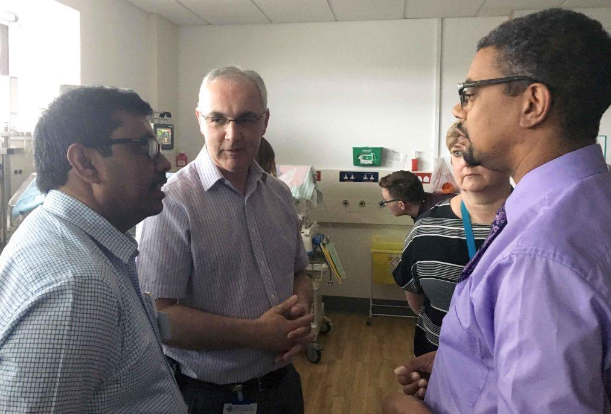
The transformation of Singleton Hospital’s neonatal unit will take 18 months to complete and will be phased to avoid disruption.

Cabinet Secretary for Health Vaughan Gething with consultants Sujoy Banerjee and Geraint Morris, along with Singleton Hospital Service Director Jan Worthing

Cabinet Secretary for Health Vaughan Gething visited the unit to make the announcement and to meet staff, along with parents whose babies were being looked after there.

Singleton has one of three neonatal intensive care units in South Wales, alongside Cardiff and Newport.

It is also one of only two neonatal Deanery training units in Wales – the other being in Cardiff’s University Hospital of Wales.

Over the years it has developed a reputation for innovation and quality improvement – such as leading the UK in the fight against antibiotic resistance in newborn babies, for which it won an NHS Wales Award.

Singleton also supports training medical students from Swansea University Medical School.

The unit provides all three recognised levels of care – special care, high dependency care and intensive care.

Consultant neonatologist Geraint Morris said: “Most of our work is to provide care for babies born prematurely.

“But we also look after babies who are full term and may have had a brain injury or problems with infection or other acute illnesses at or shortly after birth.

“We have a neonatal intensive care unit here. It cares for high-risk babies and critically ill babies from all over South West Wales.

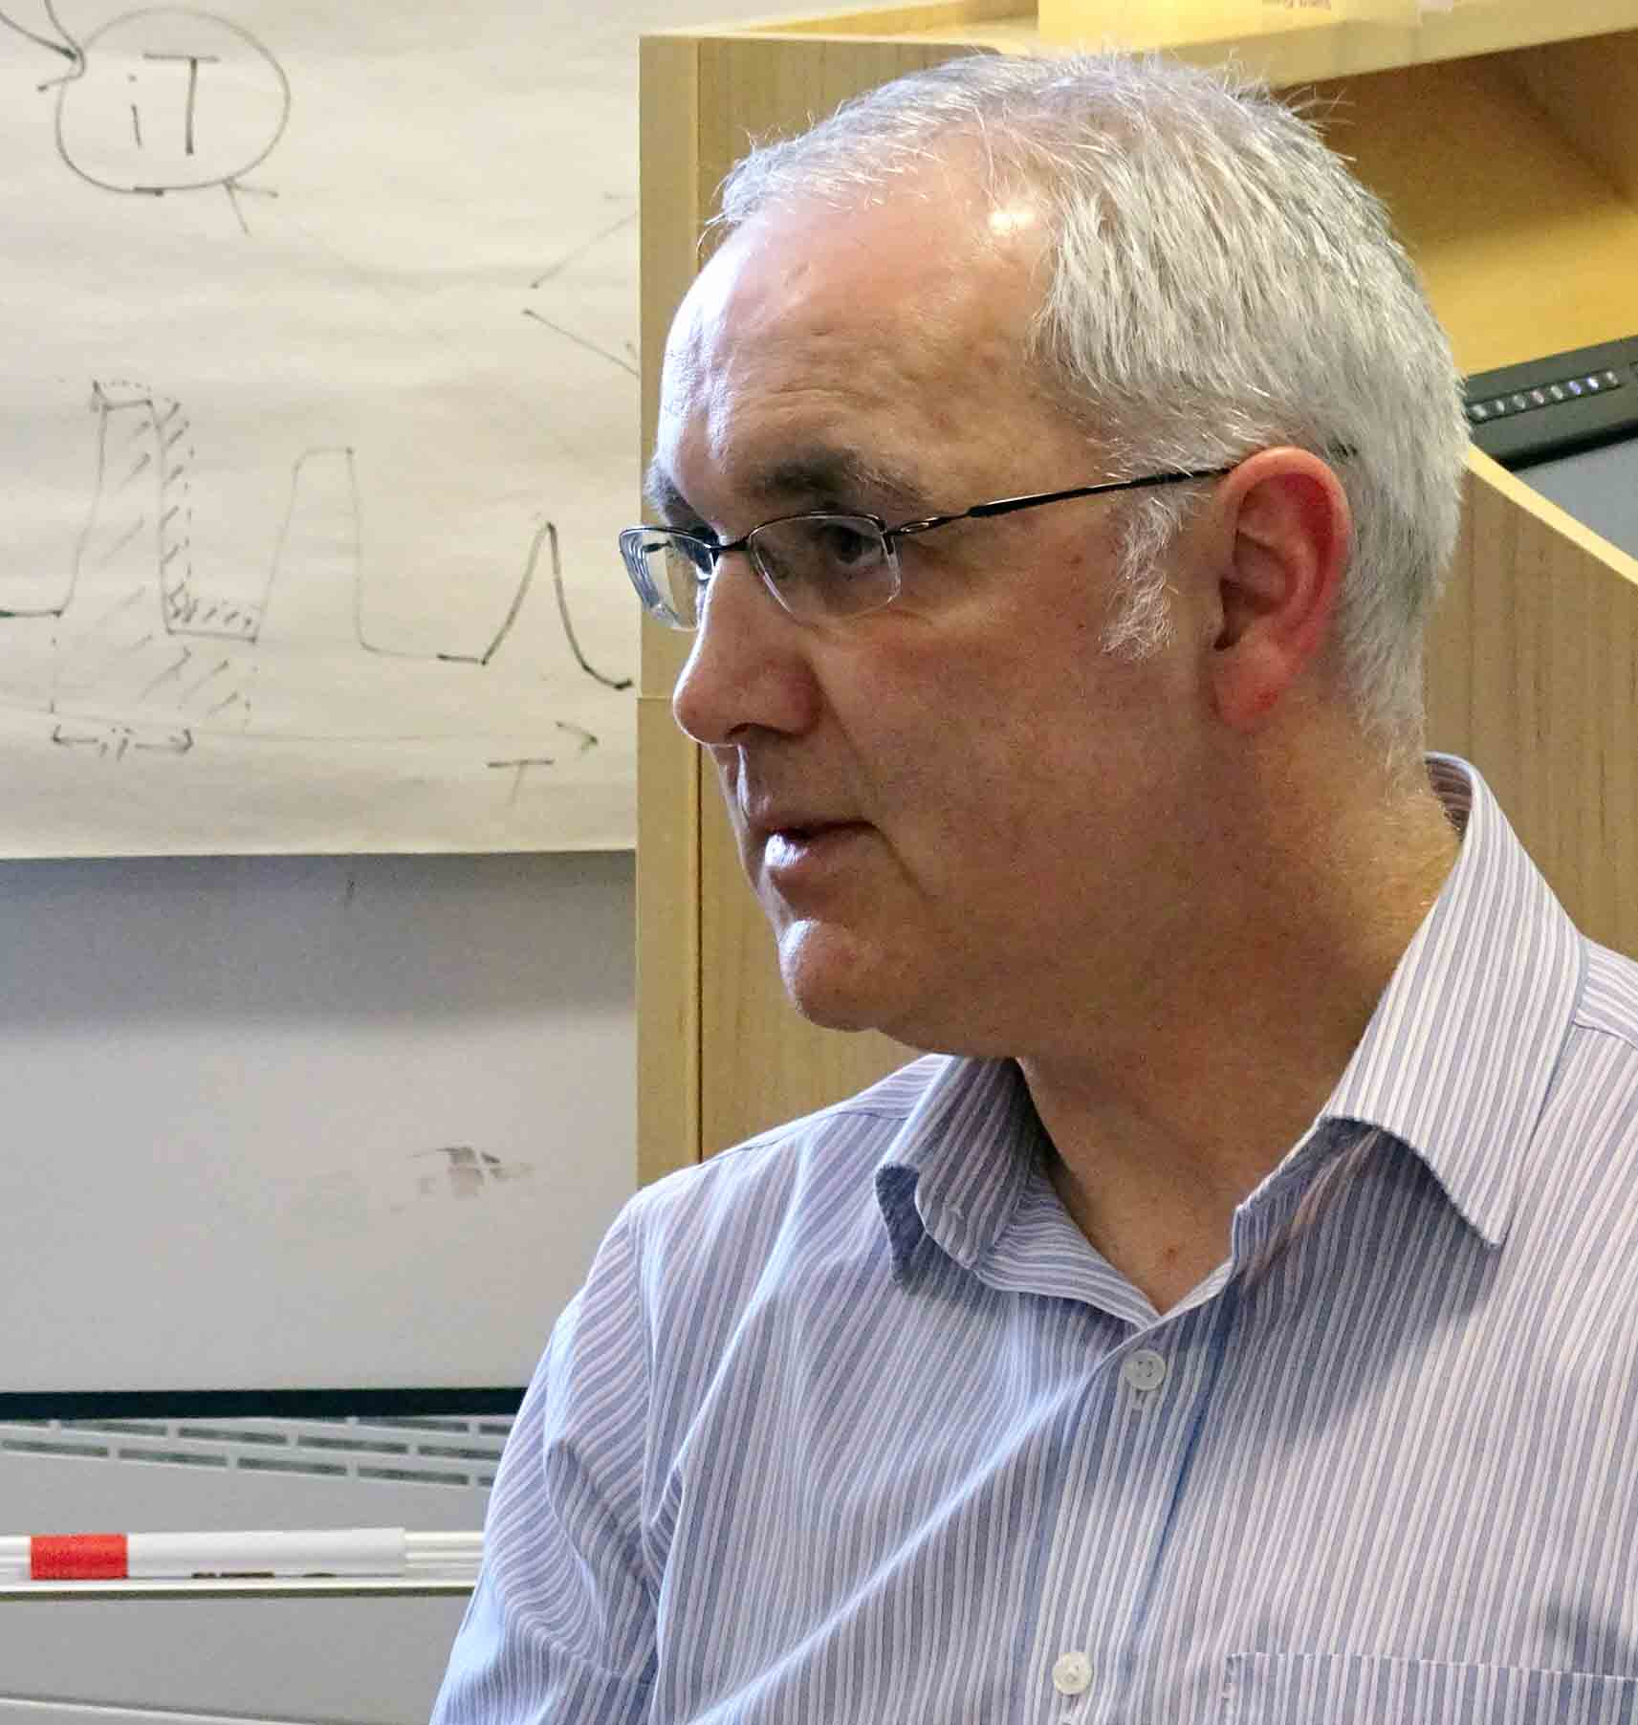
“We are a regional referral unit so we provide intensive care when babies are critically ill.

“We receive referrals from the whole of southwest Wales, from an area right up to Gwynedd, all the way over to east of Bridgend.

“So everything southwest of that line will tend to come to us for intensive care.”

Mr Morris (right) said around 450 babies were admitted to the Singleton unit every year and the number was growing steadily.

“Babies born at the extremes of prematurity are doing better now than they used to. But the rate of premature birth is also going up steadily.

“If a pregnant woman presents with a problem at, for example, 27-28 weeks of pregnancy, perhaps many years ago the possibility of having a Caesarean section would not have been considered.

“But because the outcome of premature birth is that much better now, that baby is one who it would be worth having a Caesarean section for.

“In other words that baby’s chances of survival now are a lot greater than they used to be.”

A major feature of the redevelopment will be the creation of a seven-bed transitional care unit. This is for babies who require more than normal postnatal care but do not require admission to the neonatal unit.

It will include overnight accommodation for mums, with single rooms and ensuite facilities.

Dr Morris said: “It’s very common for babies needing a higher level of care than they can receive on the ward to be admitted to a neonatal unit.

“That has major disadvantages for both the relationship between the mother and the baby and the inconvenience to the parents.

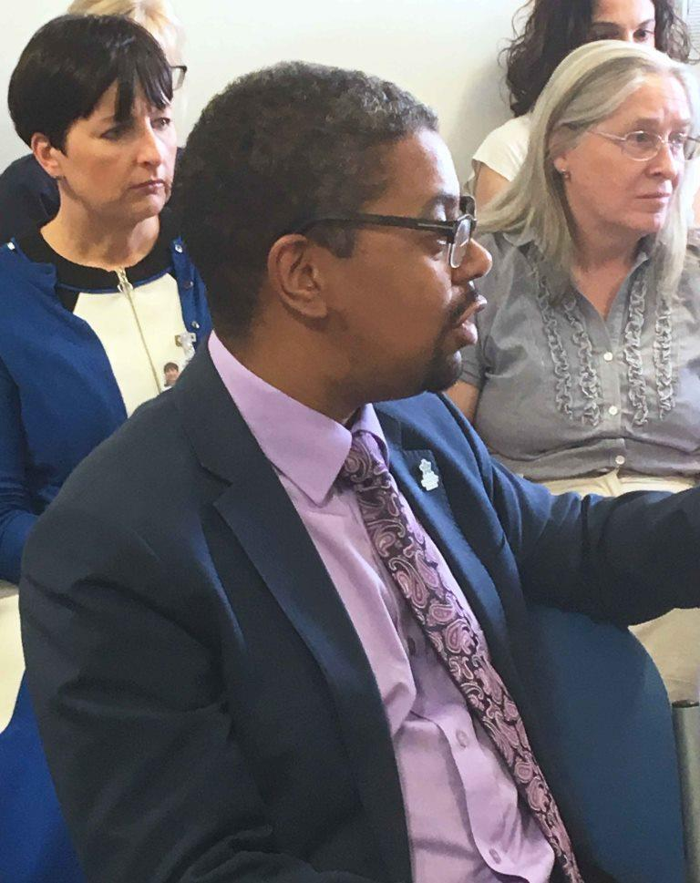
“From our point of view, the main disadvantage is the interruption of the normal establishment of breast feeding. Breast feeding has many health benefits, both to babies and their mothers.

“The idea of the transitional care unit is to provide a category in between the postnatal ward and the neonatal unit.

“This will allow babies to have additional medical care while their mothers remain with them.”

During his visit, Mr Gething met staff including children’s services group manager Samantha Williams (left) and consultant neonatologist Jean Matthes

Other main features of the £9.7 million upgrade are:

• Providing a permanent 12-cot special care baby unit;
• Increasing the neonatal high dependency Unit capacity by two cots and special care baby unit capacity by one cot;
• Allowing space to expand the high dependency unit; and
• Providing space for nine additional special care cots.

At the moment the unit is located on one floor. However, following the redevelopment, special care and transitional care will be on one floor and high dependency and intensive care on the floor above.

ABMU children’s services group manager Samantha Williams said: “Releasing space in high dependency and intensive care means we will be able to look after more babies who are at a critical care level.

“If we’re full and cannot take any more babies, they have to go elsewhere in Wales and sometimes to England.

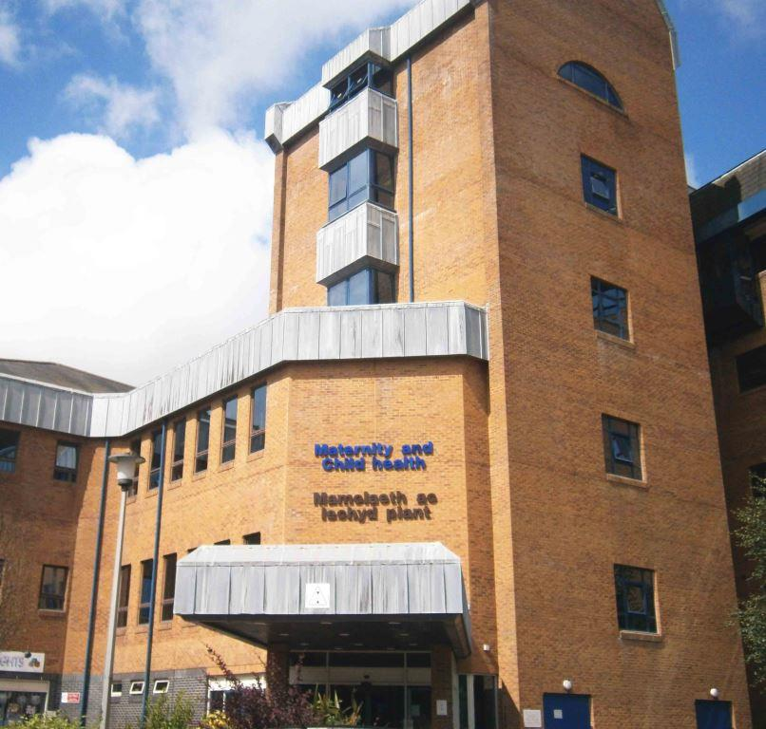
“The investment means that, instead of having to travel out of the area, they will be able to stay locally.”

During his visit to Singleton, Mr Gething said the investment was building on excellence and ensuring future capacity.

He added: “I’ve yet again been really impressed not just by the environment and the calm nature of the staff but also the tremendous gratitude parents have for the unbelievable care and assistance they receive here.”

Source: Abertawe Bro Morgannwg University Health Board

