Sony donation to Haematology Day Unit
Thursday, 24 May 2018
Haematology Day Unit patients at Singleton Hospital have recently had their hospital stay greatly improved by a generous high-tech donation.

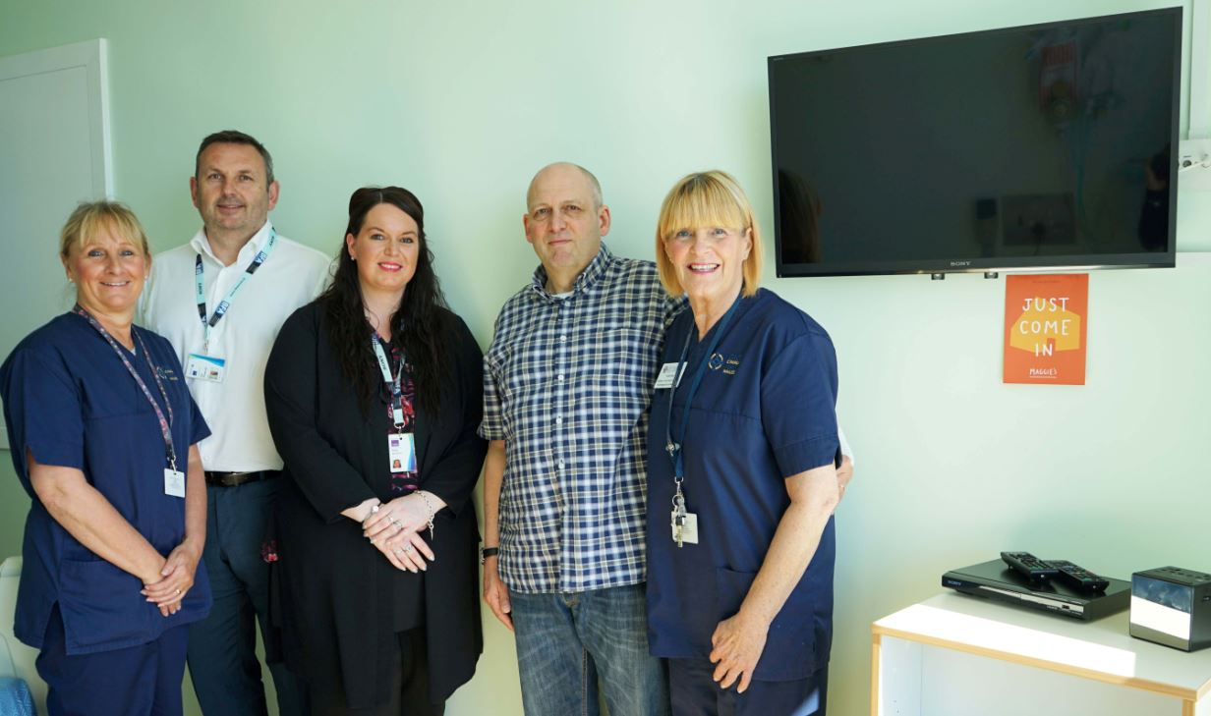
Sony UK Technology Centre in Bridgend donated four wide-screen HD televisions, four digital alarm clocks and four CD players to the Bone Marrow Transplant Unit to help patients pass their time in hospital.

Pictured (l-r) Deputy day unit manager Barbara Williams, Ian Prescott and Kelly Hurford CSR Team at Sony, patient Mark Hyett and day unit Manager Lynda Bray.

Unit manager Lynda Bray said: “Patients have commented on the positive impact these donations have had on their morale and general well-being.

“A huge credit and grateful thanks are extended to Mark Hyett who made the initial contact with Sony. Mark himself was a patient at the Bone Marrow Transplant Unit and had an inpatient stay of nearly three weeks. When he received the stem cell transplant he wanted to say thanks to staff for the care he had received and recognised what a difference these donations would make

“The staff on the Haematology Day Unit gratefully appreciate this thoughtful and kind gesture that has been extended to their patients.”

Source: Abertawe Bro Morgannwg University Health Board

