Surgeon Tom on his way to the USA after being awarded travel scholarship
Thursday, 3 May 2018
A surgeon and researcher at Morriston Hospital will fly to the USA this summer after being awarded a prestigious scholarship.

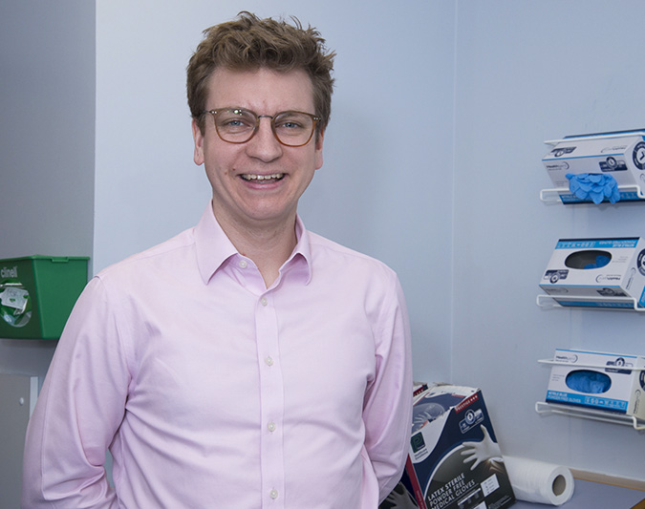
Plastic surgery registrar Tom Dobbs successfully applied for the 2018 Jill and Herbert Hunt Travelling Scholarship.

This supports travel abroad for clinical study or research for graduates of the Oxford University Medical School.

Tom is on the Welsh Clinical Academic Training Fellowship, which has fully-funded the PhD he is working on at the moment.

He has been supported to make the most of this experience by his academic supervisor Professor Iain Whitaker and plastic surgery programme director Tom Bragg.

The PhD is linked to PROMs – Patient Reported Outcome Measures – which assess the patient’s own perspective of their condition and treatment through the use of questionnaires.

Tom explained: “They’ve become much more important in the healthcare field in recent years.

“In England they’ve been collecting PROMs data for hip and knee replacements, varicose veins and groin hernias for several years.

“Those conditions are routinely collated but there’s now a feeling we should be doing a lot more across the range of conditions that patients experience.”

Tom’s PhD is based around PROMs for facial skin cancer. The world expert in plastic surgery PROMS is Andrea Pusic, who was recruited by Harvard University to set up a new outcomes unit.

Tom said: “The scholarship means I can travel to see this new unit and build bridges with her and co-founder Dr Chris Gibbons. I’m planning to go in August for around four weeks.

“It’s a great learning opportunity, working with the best in the field. I think it will help with my future development in terms of what I go on to do after my PhD and continuing my research in the field.

“From a more global point of view it will really help push forward our general involvement in PROMs, being part of developing new PROMs and hopefully developing a special PROMs centre here in Wales, looking at patient outcome measures.

“So it’s a great opportunity not only for me but also in the use of PROMs in healthcare in Wales and beyond.”

Source: Abertawe Bro Morgannwg University Health Board

