Charities help create new quiet room for surgical patients
Friday, 3 November 2017
Surgical patients and their families at Morriston Hospital now have their own dedicated quiet room away from the ward to deal with sensitive or distressing news.

Staff on Ward G were concerned that there was nowhere really suitable where families could go after receiving a difficult diagnosis or after bereavement.

Pancreaticobiliary nurse specialist Kathy Dykes said: “Previously we were having these discussions in the ward itself or sister’s office. We were faced with noise and interruptions which I am sure added to an already stressful and traumatic experience.

“We felt our patients deserved a designated appropriate, non-clinical and comfortable area where their diagnosis and treatment could be discussed.”

But now, thanks to donations from two local charities the Regional Pancreaticobiliary Cancer Surgery Unit, which is based at Morriston, along with colorectal and urology teams have their own quiet room.

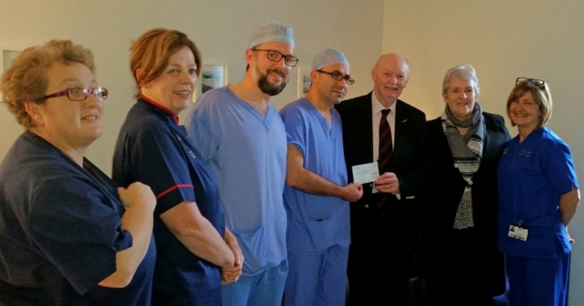
Pictured (from left) Ward G sister Nadine Jones, surgical specialties matron Jayne Morris, pancreatic surgeons Guy Shingler and Professor Bilal Al-Sarireh, fundraisers Ieuan Hughes, Janice Davies and pancreaticobiliary nurse specialist Kathy Dykes

The former office, at the end of Wards G and H has been decorated and furnished to provide a calming and far less clinical area.

Ieuan Hughes and Janice Davies from Kidwelly-based Apel Canser Ail Gyfle/Second Chance Cancer Appeal visited the hospital to see the room and hand over £2,000 towards the project.

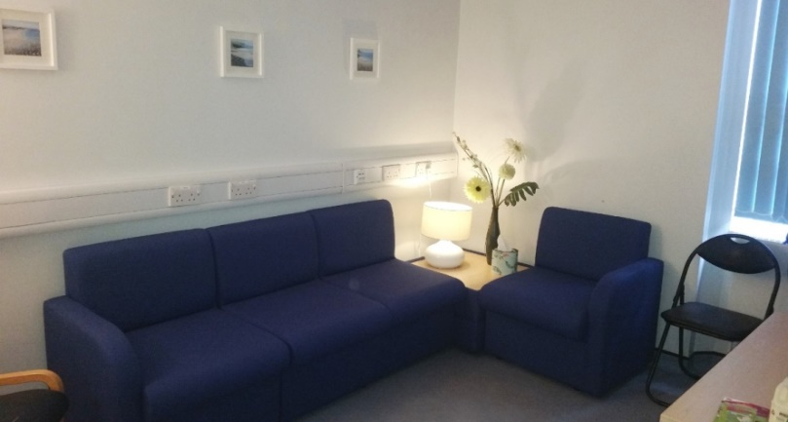
Janice said: “The room is marvellous and we are delighted to have been able to help towards providing it.

“We are a small charity, dedicated to raising money for cancer patients.

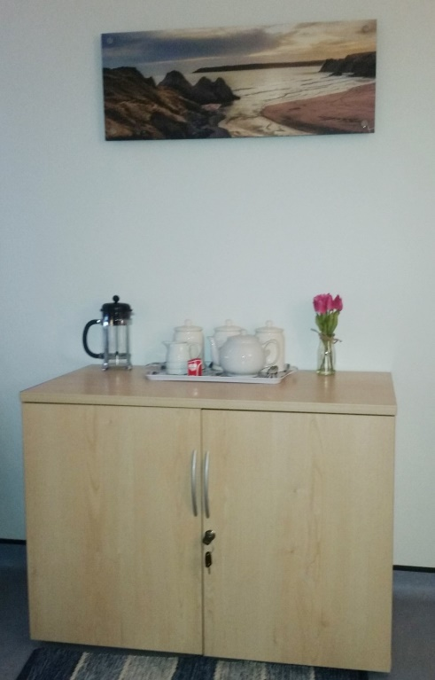
"We hold three events during the year, including a golf tournament at Glyn Abbey Golf Club, and would like to thank the community for all the support they have given us.”

How the room looks now

Kathy added: “Without this kind and generous donation from Second Chance we would not have been able to furnish this room as we have. We are extremely grateful for this and their previous donations to the Regional Pancreaticobiliary Cancer Surgery Unit. Their contributions are always gratefully received and make a real difference.

“I really believe the room will be of enormous benefit to our patients, their loved ones and the staff who care for them.”

Cash for the room was also provided by the Mark Vale Bowel Cancer Appeal charity committee, based in the Swansea Valley.

Mark was also given a close-up look at the room when he presented £5,000 to urology nurse specialist Cath Dixon and colorectal nurse specialist Mandy Wright.

Part of this donation was used towards creating the room with the remainder going towards equipment for Ward V where Mark was nursed following his own bowel surgery.

The money was raised at various events including a duck race, a horse racing night and an auction as well as donations from shops in Ystradgynlais, Cor Meibion Gyrlais and Celtic Energy.

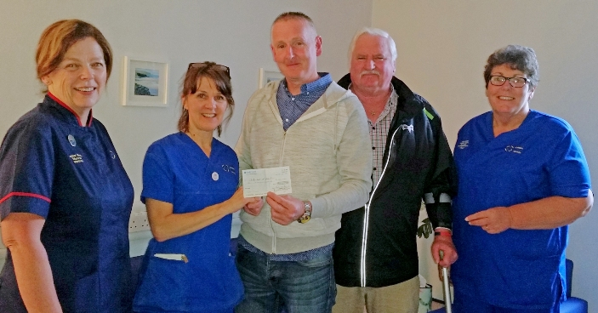
Pictured (from left) surgical specialities matron Jayne Morris, colorectal nurse specialist Mandy Wright, fundraisers Mark Vale and Mike George with urology nurse specialist Cath Dixon.

Cath Dixon said: “Thanks so much to Mark and to everybody who supported his appeal. This is a wonderful gesture and it is very much appreciated.

"The money will allow us to continue to offer our very best care to other patients like Mark when they need us.”

Source: Abertawe Bro Morgannwg University Health Board

