Congratulations to our EuroMillion winners!
Wednesday, 8 November 2017
Many congratulations to a syndicate of catering staff at Neath Port Talbot Hospital who have scooped over £25 million in the EuroMillions jackpot.

They hit the £25,476,778.30 jackpot on Friday night. The six ladies will each get an incredible £4,246,129.72 .The 'Catering Girls' have been playing the syndicate for six years.

Julie Saunders, Doreen Thompson, Louise Ward, Jean Cairns, Sian Jones and Julie Amphlett made the announcement at a media event held by Camelot.

We'd like to wish the ladies all the best for the future!

Picture courtesy of Athena Pictures
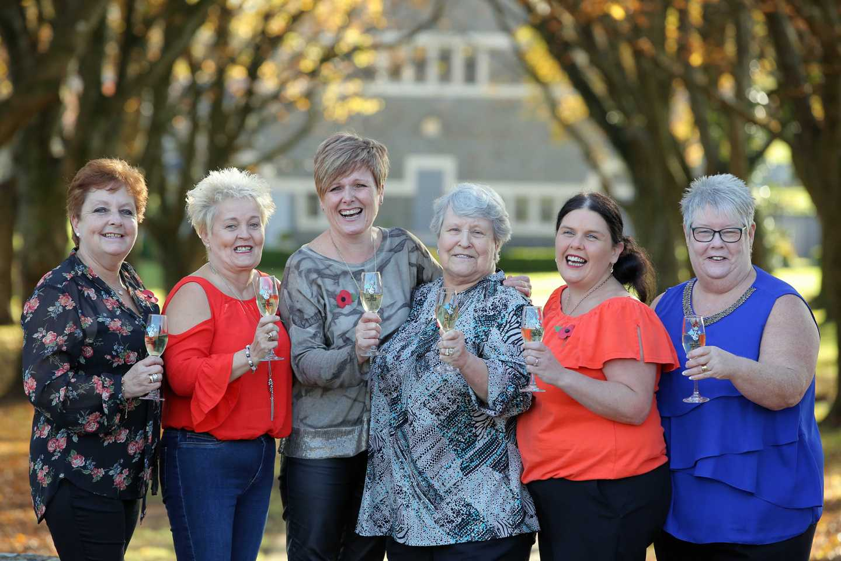

Source: Abertawe Bro Morgannwg University Health Board

