Dance moves will help protect older people from falls
Friday, 17 November 2017
Dance moves will be used to help protect older people from falling with the launch of a first-in-Wales programme within ABMU.
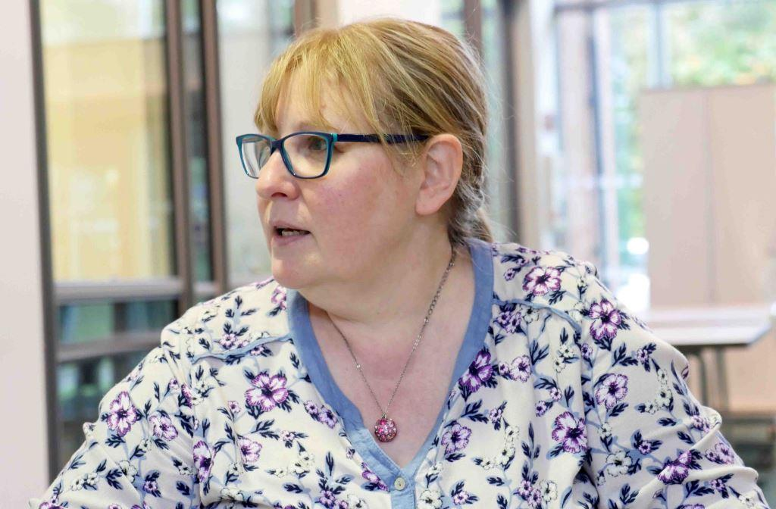
The health board is working with arts charity Aesop and National Dance Company Wales to hold a series of workshops for people at risk of falls or who have previously fallen and may have been admitted to hospital.

Pictured: local dance coordinator Alyson Pugh

It’s part of a £2.3 million expansion of the national Dance to Health initiative following pilots in three areas of England last year.

More than 60 programmes will be delivered in England and Wales over the next two years – with ABMU the only health board in Wales involved.

Falls are extremely traumatic for older people and costs the NHS nationally around £2.3 billion a year.

Dance to Health is a pioneering nationwide programme run by Aesop with health and social care partners, combining evidence-based physiotherapy with the energy and creativity of dance.

ABMU’s arts in health coordinator Prue Thimbleby said: “We know falls are a massive problem and we know too that dance can make a real difference.

“We are working very closely with National Dance Company Wales, who are providing the high-quality dance input.

“They have appointed five dancers to work on the project and the dancers are receiving detailed training in falls prevention exercise programmes.

“Aesop has also appointed a local dance coordinator, Alyson Pugh from Swansea, who will have an honorary contract with ABMU and be part of the health board’s arts team.”

Prue said the process of recruiting older people who might benefit from the Dance to Health programme had started.

It’s open to anyone who has fallen, is worried about falling, or just wants to stay steady on their feet and improve their health and fitness by strengthening muscles and improving flexibility.

The aim is to start three dance groups after Christmas and another three soon after that. Each will last six months but the idea is for patients to then join maintenance groups so they continue to benefit.

Alyson said: “There has been a great response from communities who want to pull together to support older people and prevent them from falling – it is really heart-warming.

“There is going to be a significant strand of volunteering – we’ll have volunteers involved in the groups to support them.

“We’re also making connections and partnerships with third sector organisations like Age Cymru.”

Funding for the national expansion is coming from a number of sources, including the Big Lottery Fund, along with contributions from each of the health and social care partners taking part.

ABMU’s contribution is £30,000. Prue said: “Most of that came from charitable funds and in return we will be getting at least £200,000 worth of activity so it is a very positive investment.”

Aesop chief executive and founder Tim Joss said: “Our vision is for older people everywhere to have easy access to Dance to Health.

“With the wonderful dance partners and health partners on board, we are taking a major step towards realising that vision.”

If you think you could benefit from Dance to Health, contact Alyson on 01993 870155 or email AlysonPugh@ae-sop.org.
You can find out more about Dance to Health here.
Source: Abertawe Bro Morgannwg University Health Board

