Farmer’s bonfire warning after fireball injuries
Thursday, 16 November 2017
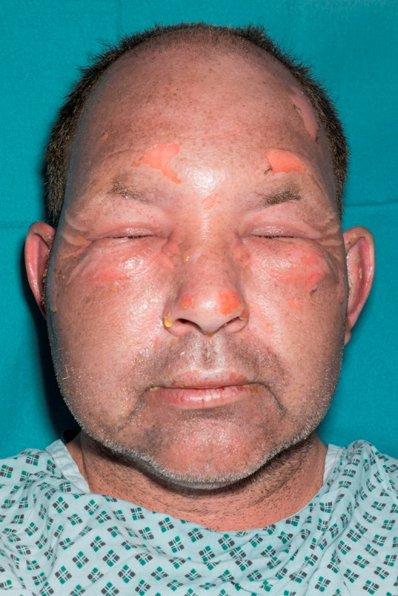
A dairy farmer is urging other agricultural workers to take care when starting bonfires after he suffered horrific burns to his face and hands.
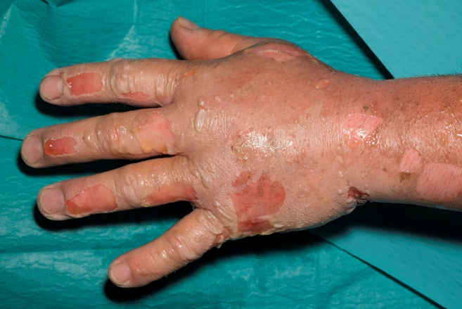
Rheinallt Jones accidentally used petrol on a bonfire at his farm in Llandyfaelog near Kidwelly in August 2016. He needed expert care at the Welsh Centre for Burns and Plastic Surgery and was so badly hurt he was unable to do manual work for three months.
He was one of 20,000 adults injured by accelerants used on barbecues, garden fires and bonfires last year - this accounted for 11 per cent of hospital admissions for burns in the UK.
Rushing to get a bonfire started, Mr Jones picked up a tin of tractor diesel to use on the fire, not realising it had been contaminated with traces of old petrol.
Mr Jones, aged 49, explained: “I threw this on the bonfire and lit it, causing a fire ball that went up as quick as a flash.
“My life flashed in front of my eyes as the fire ball knocked me off my feet. It was extremely frightening.”
Rheinallt Jones immediately after the accident.
Mr Jones’s clothes did not ignite but the intense flash of heat was enough to cause ten per cent superficial flash burns to his face, arms and hands resulting in severe blistering and swelling.
He managed to get himself to a cattle water trough and splashed water on to the burns for 10 minutes before turning a hose pipe on himself for another 10 minutes.
After being taken to Glangwili Hospital in Carmarthen he was transferred to the burns centre at Morriston and fortunately his burns healed without requiring surgery.
Menna Davies, clinical specialist physiotherapist at the burns centre, said Mr Jones’s quick thinking straight after the blast had helped his recovery.
She said: “Following the correct procedure by undertaking immediate and appropriate first aid can reduce the chances of scarring or in extreme circumstances save lives.”
The British Burns Association recommends the following three stage of first aid:
• Cool the burn with cool running water for 20 minutes to reduce the heat and reduce damage to surrounding tissue;
• Call for help; and,
• Cover the burn with cling film which protects the burn from infection while stopping the wound from drying out.
She added: “Fortunately the long-term scarring following effective first aid, pain relief, dressings, rehabilitation and scar management was minimal. However, due to the time taken for the skin to heal and become less fragile, he was unable to return to manual work for three months.”

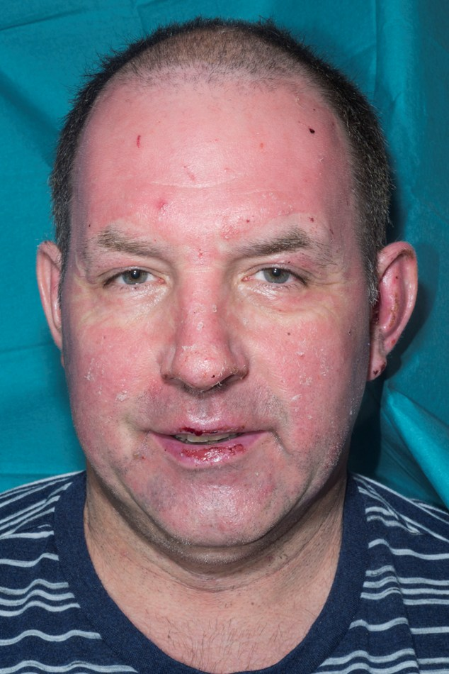
Now he is hoping to alert other farmers who legally use bonfires throughout the year to clear brash and plant waste to the dangers.
He said: “I felt foolish at the time as this was an accident that could have easily been prevented.
“I could have avoided this if I had taken more time, used a wick or stick to light the bonfire and used straw, paper and firelighters as recommended by the Health and Safety Executive.”

On the road to recovery – Rheinallt Jones (left and below right) six weeks after the accident.
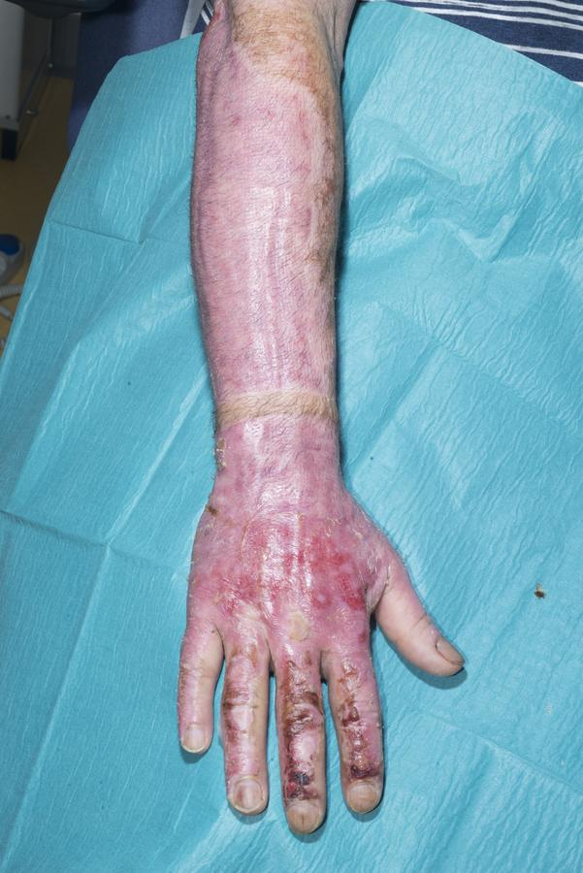
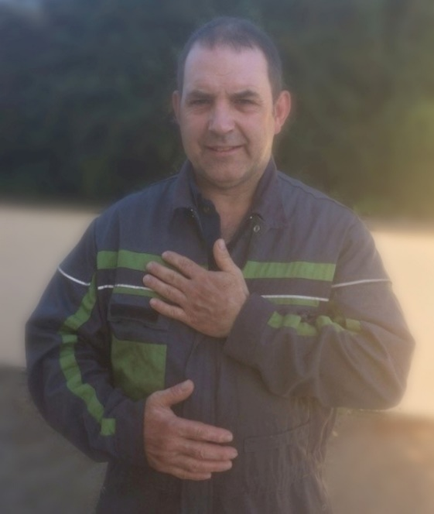
Many people may not realise just how dangerous using an accelerant can be.
Petrol evaporates quickly when exposed to air which is why petrol and other flammable fuels and chemicals should always be stored in an airtight container in a purpose-built Control of Substances Hazardous to Health (COSHH) cabinet. This will prevent the build-up of explosive gases and protect the contents from accidental exposure to sources of heat.
Because of the risks of causing serious personal injury if petrol is stored or used in an unsafe way the safe storage of petrol is covered by the Petroleum (Consolidation) Regulations 2014.
When you pour petrol on a bonfire the fuel begins to evaporate. As a rule if you can smell it, you are effectively standing in an invisible cloud of potentially flammable gas.
Once the concentration of gas in the air reaches a certain level lighting a match or introducing other sources of heat will cause an explosion, as Mr Jones discovered.
To stay safe remember:
• Never use any flammable fuel to start a fire not even diesel or oil;
• Firelighters work out a good deal cheaper than car fuel and are very effective and most importantly safe;
• An empty container that previously held petrol may also be unsafe because of the fumes which can remain in the container; and,
• Keep the cap of the container securely fastened, and follow the same advice as for storing petrol.
It took around 12 months for Mr Jones’s skin to become robust enough for him to return to heavy manual work.

Rheinallt Jones back at work on his farm after recovering from his injuries.
He said: “I was unable to do any manual farm work for three months as my skin was so fragile and I’d cut myself easily by handling different equipment.
“I have had to wear factor 50 sun cream and gloves in order to perform most jobs. It has taken this long for my skin to harden up to stop using gloves.
“I have learnt from my mistakes the hard way and I would like others to take way the message to stop using accelerants on bonfires and avoid causing harm to yourself and others.”

Source: Abertawe Bro Morgannwg University Health Board

