Helping people lead a full life following diabetes diagnosis
Monday, 13 November 2017
Being diagnosed with diabetes will come as a shock to anyone and for many people it means medication – and lifestyle changes.
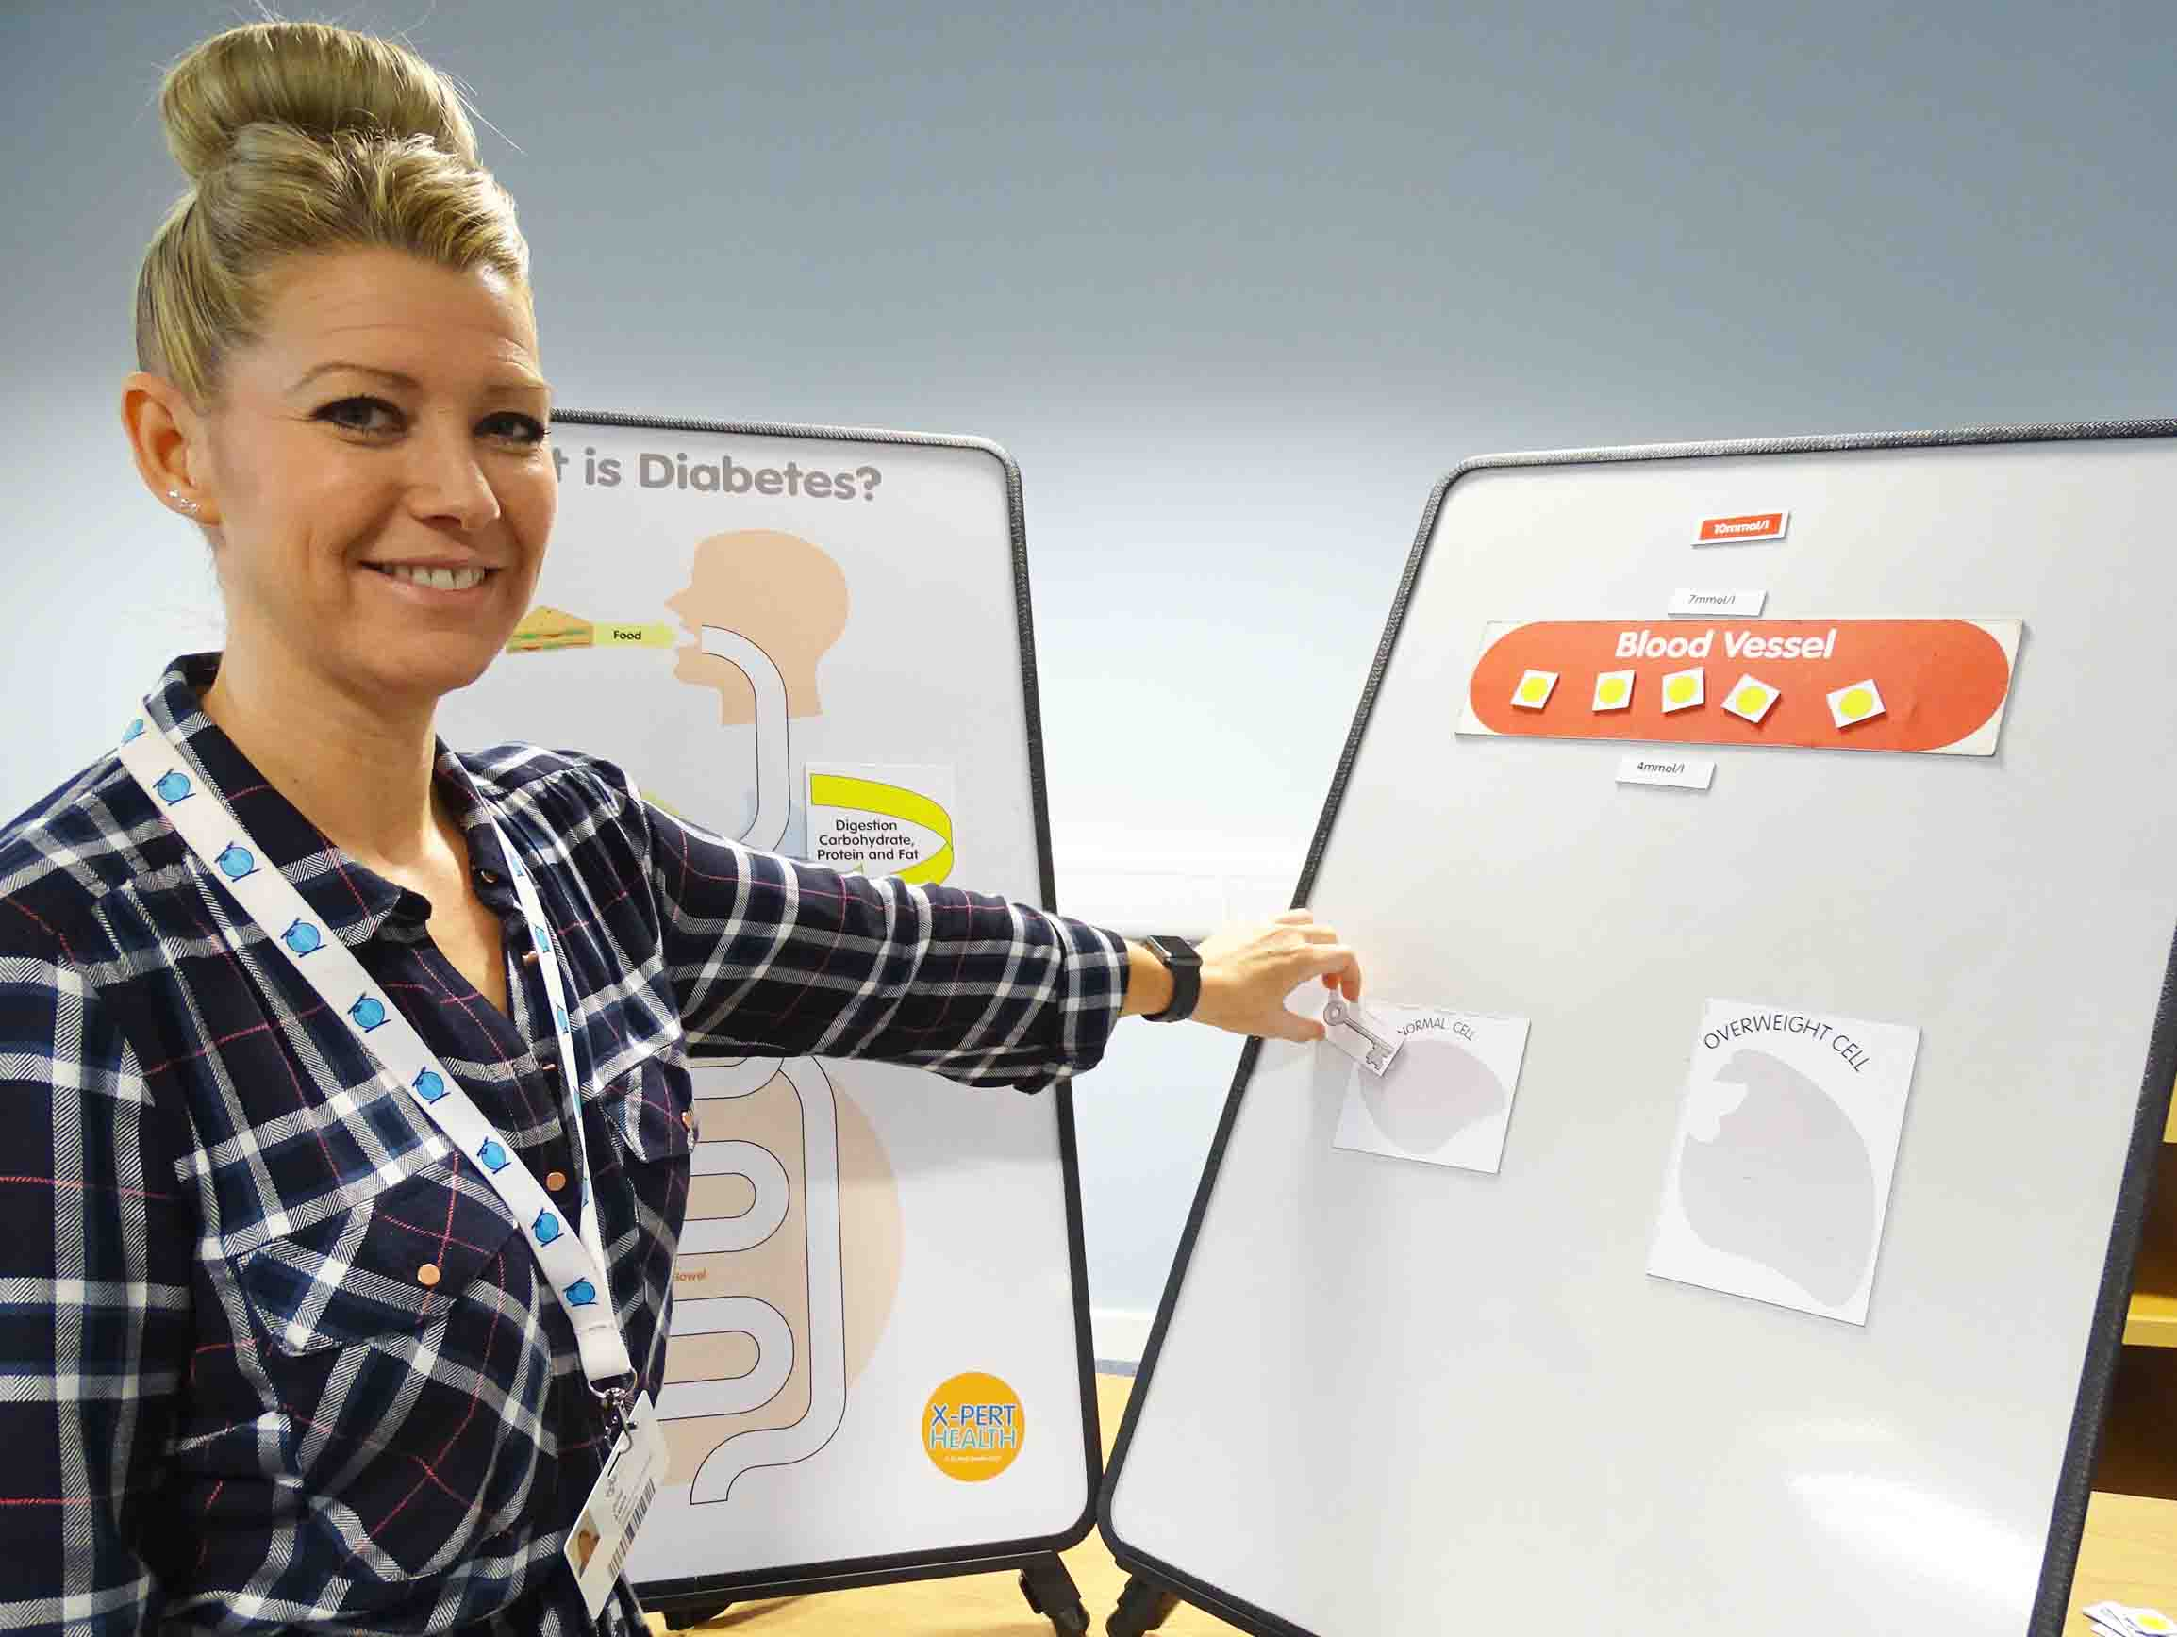
November is Diabetes Awareness Month and staff across ABMU will be playing their part to promote it.
(Left: Community specialist dietitian Julie Lunn delivering an Introduction to Diabetes course at Port Talbot Resource Centre)
Every year the birthday of Frederick Banting, the scientist who co-discovered insulin as a treatment for diabetes, is celebrated with World Diabetes Day on Tuesday, 14th November.
This year’s theme is Women and Diabetes. Diabetes teams and midwives across ABMU will promote World Diabetes Day by setting up displays and information stands in diabetes centres and antenatal clinics.
But there are also specialist courses available year-round for people with type 2 diabetes to give them all the information they could need to self-manage their condition and lead a full life.
Diabetes is a lifelong condition that causes a person’s blood sugar, or glucose, level to become too high.
Insulin, a hormone produced by the pancreas, controls the amount of glucose in the blood.
There are two main types of diabetes – type 1, where the pancreas doesn’t produce any insulin, and type 2, where the pancreas doesn’t produce enough insulin or the body’s cells don’t react to it.
People with type 1 need regular insulin injections to maintain normal glucose levels and have to look after their health carefully.
Those with type 2 may eventually need medication. It is possible to prevent it developing through lifestyle changes, which may also help control symptoms following diagnosis:
• Eating a healthy diet;
• Losing weight if you are overweight, then maintaining a healthy weight;
• Stopping smoking if you are a smoker;
• Drinking alcohol in moderation; and
• Taking plenty of regular exercise.
National guidelines recommend a structured education programme is offered to adults to type 2 diabetes – or their family or carers if appropriate – around the time of diagnosis.
So this year ABMU made it easier for people to access it by offering two programmes, both of which patients can join without a referral.
ABMU Deputy Head of Nutrition and Dietetics Carol Brock said: “The programmes can be attended by people who are newly diagnosed or who are living with diabetes but want more information to manage their condition.
“We offer a six-week programme called X-Pert or one-off group sessions across Swansea, Neath Port Talbot and Bridgend.
“These sessions are delivered by healthcare professionals in a relaxed, informal environment.”
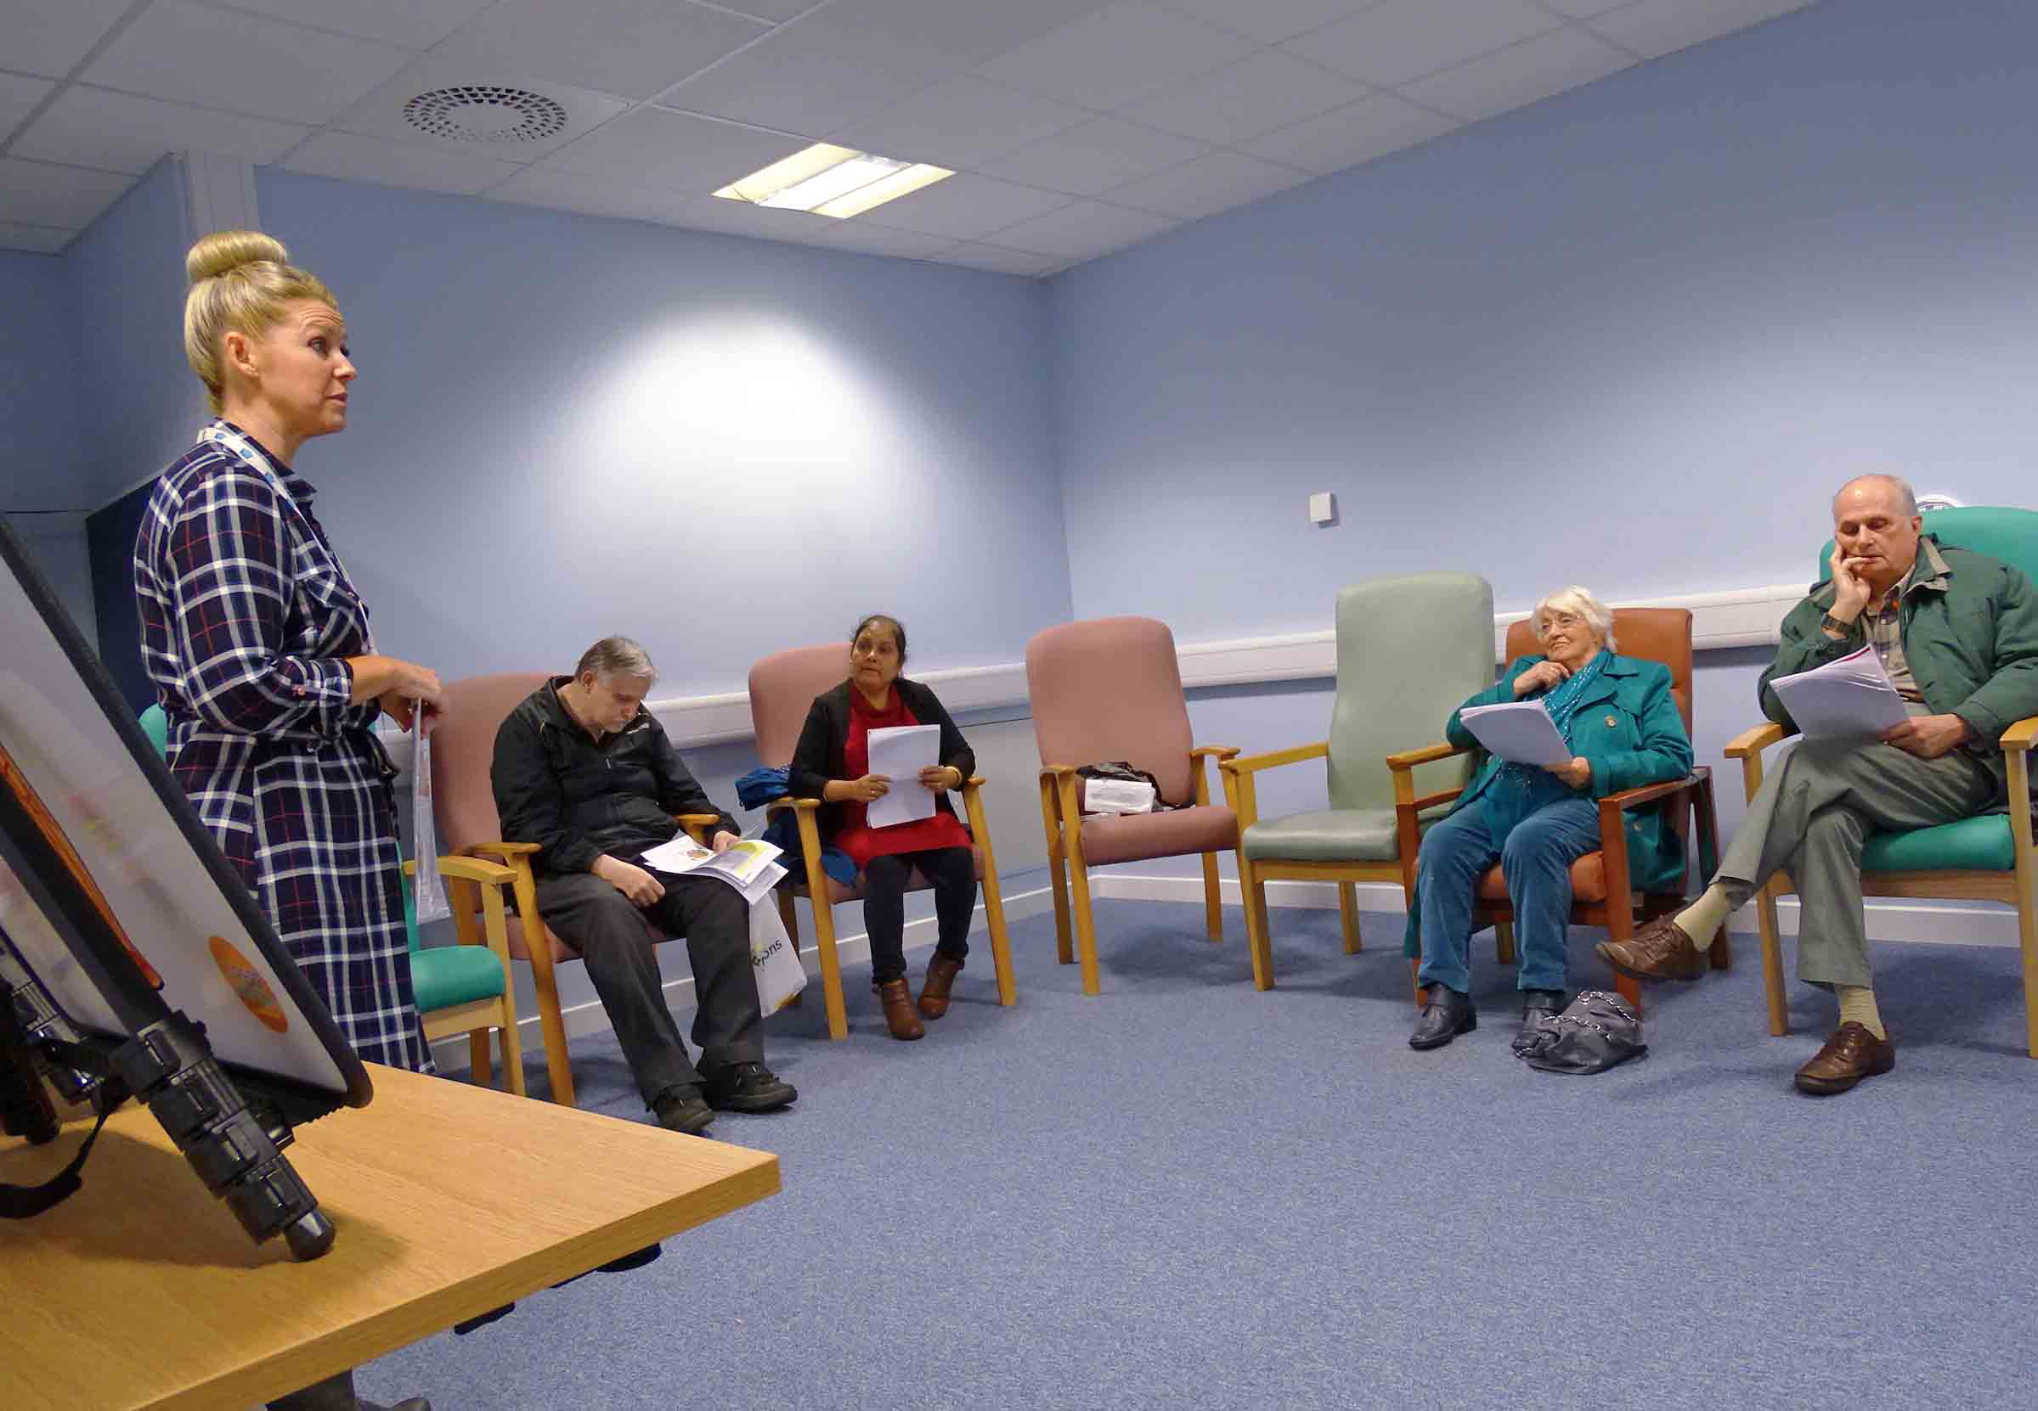
Topics covered by the interactive X-Pert course include what diabetes is, food including carbohydrates and food labels, what can go wrong with diabetes and how to prevent it happening, and understanding test results.
The one-day Introduction to Diabetes includes what diabetes is about, understanding test results, what you can eat, and dispelling myths.
Eddie Jenkins, aged 62, from Port Talbot, attended the X-Pert course and said he found it to be very beneficial.
“It was a great help. It was organised in such a way I found it easy to understand everything – it was broken down into sections.”
Eddie was diagnosed in April. He had been feeling unwell and tended to become tired in the afternoon. His doctor sent him for blood tests and the type 2 diabetes was confirmed.
Eddie had put on weight since retiring two years ago. However, while waiting for the X-Pert course to start he took up an offer from his GP to work with a personal trainer, doing exercises and circuit training.
He has lost weight and, as a result, is now within the recommended blood glucose level.
“Now I’m doing voluntary work, I’ve joined a walking club and been on a camera course. Sometimes you’re in charge of your own destiny.
“I’d really recommend the X-Pert course, and if you get the chance of a personal trainer then I would take that up too.”
Ann Thomas from Maesteg was found to have type 2 diabetes after a routine eye test a year ago.

Ann, aged 60, said the diagnosis came as a shock as she had led a healthy lifestyle, went to the gym and enjoyed walking.

While she had been overweight, she had lost weight before her diagnosis and more since then. Ann is now controlling her diabetes through diet and exercise rather than medication.

Ann has attended several courses, including X-Pert – which, she said, was very thorough and covered everything related to diabetes.

“It was very informative and there were question and answer sessions. It was very well laid out and we were told everything we needed to know.

“You do need it, to be honest. With diabetes you need all the information you can get.

“It’s such a volatile condition, you have to know what to look for and how to react in terms of diet and exercise.”

If you have type 2 diabetes and want to book a place on an X-Pert or Introduction to Diabetes course, you can contact the central booking point on 01639 862928 between 9am and 4pm Monday to Friday.
Alternatively you can email: ABM.DiabetesEducationReferrals@wales.nhs.uk
Check out our website’s diabetes page for more information.

A new video about diabetes can be seen below:

Source: Abertawe Bro Morgannwg University Health Board

