Monster mash at Morriston ALAC
Friday, 3 November 2017
There were high spirits at Morriston Hospital when it opened its doors to a crowd of witches, werewolves and mummies (and daddies).

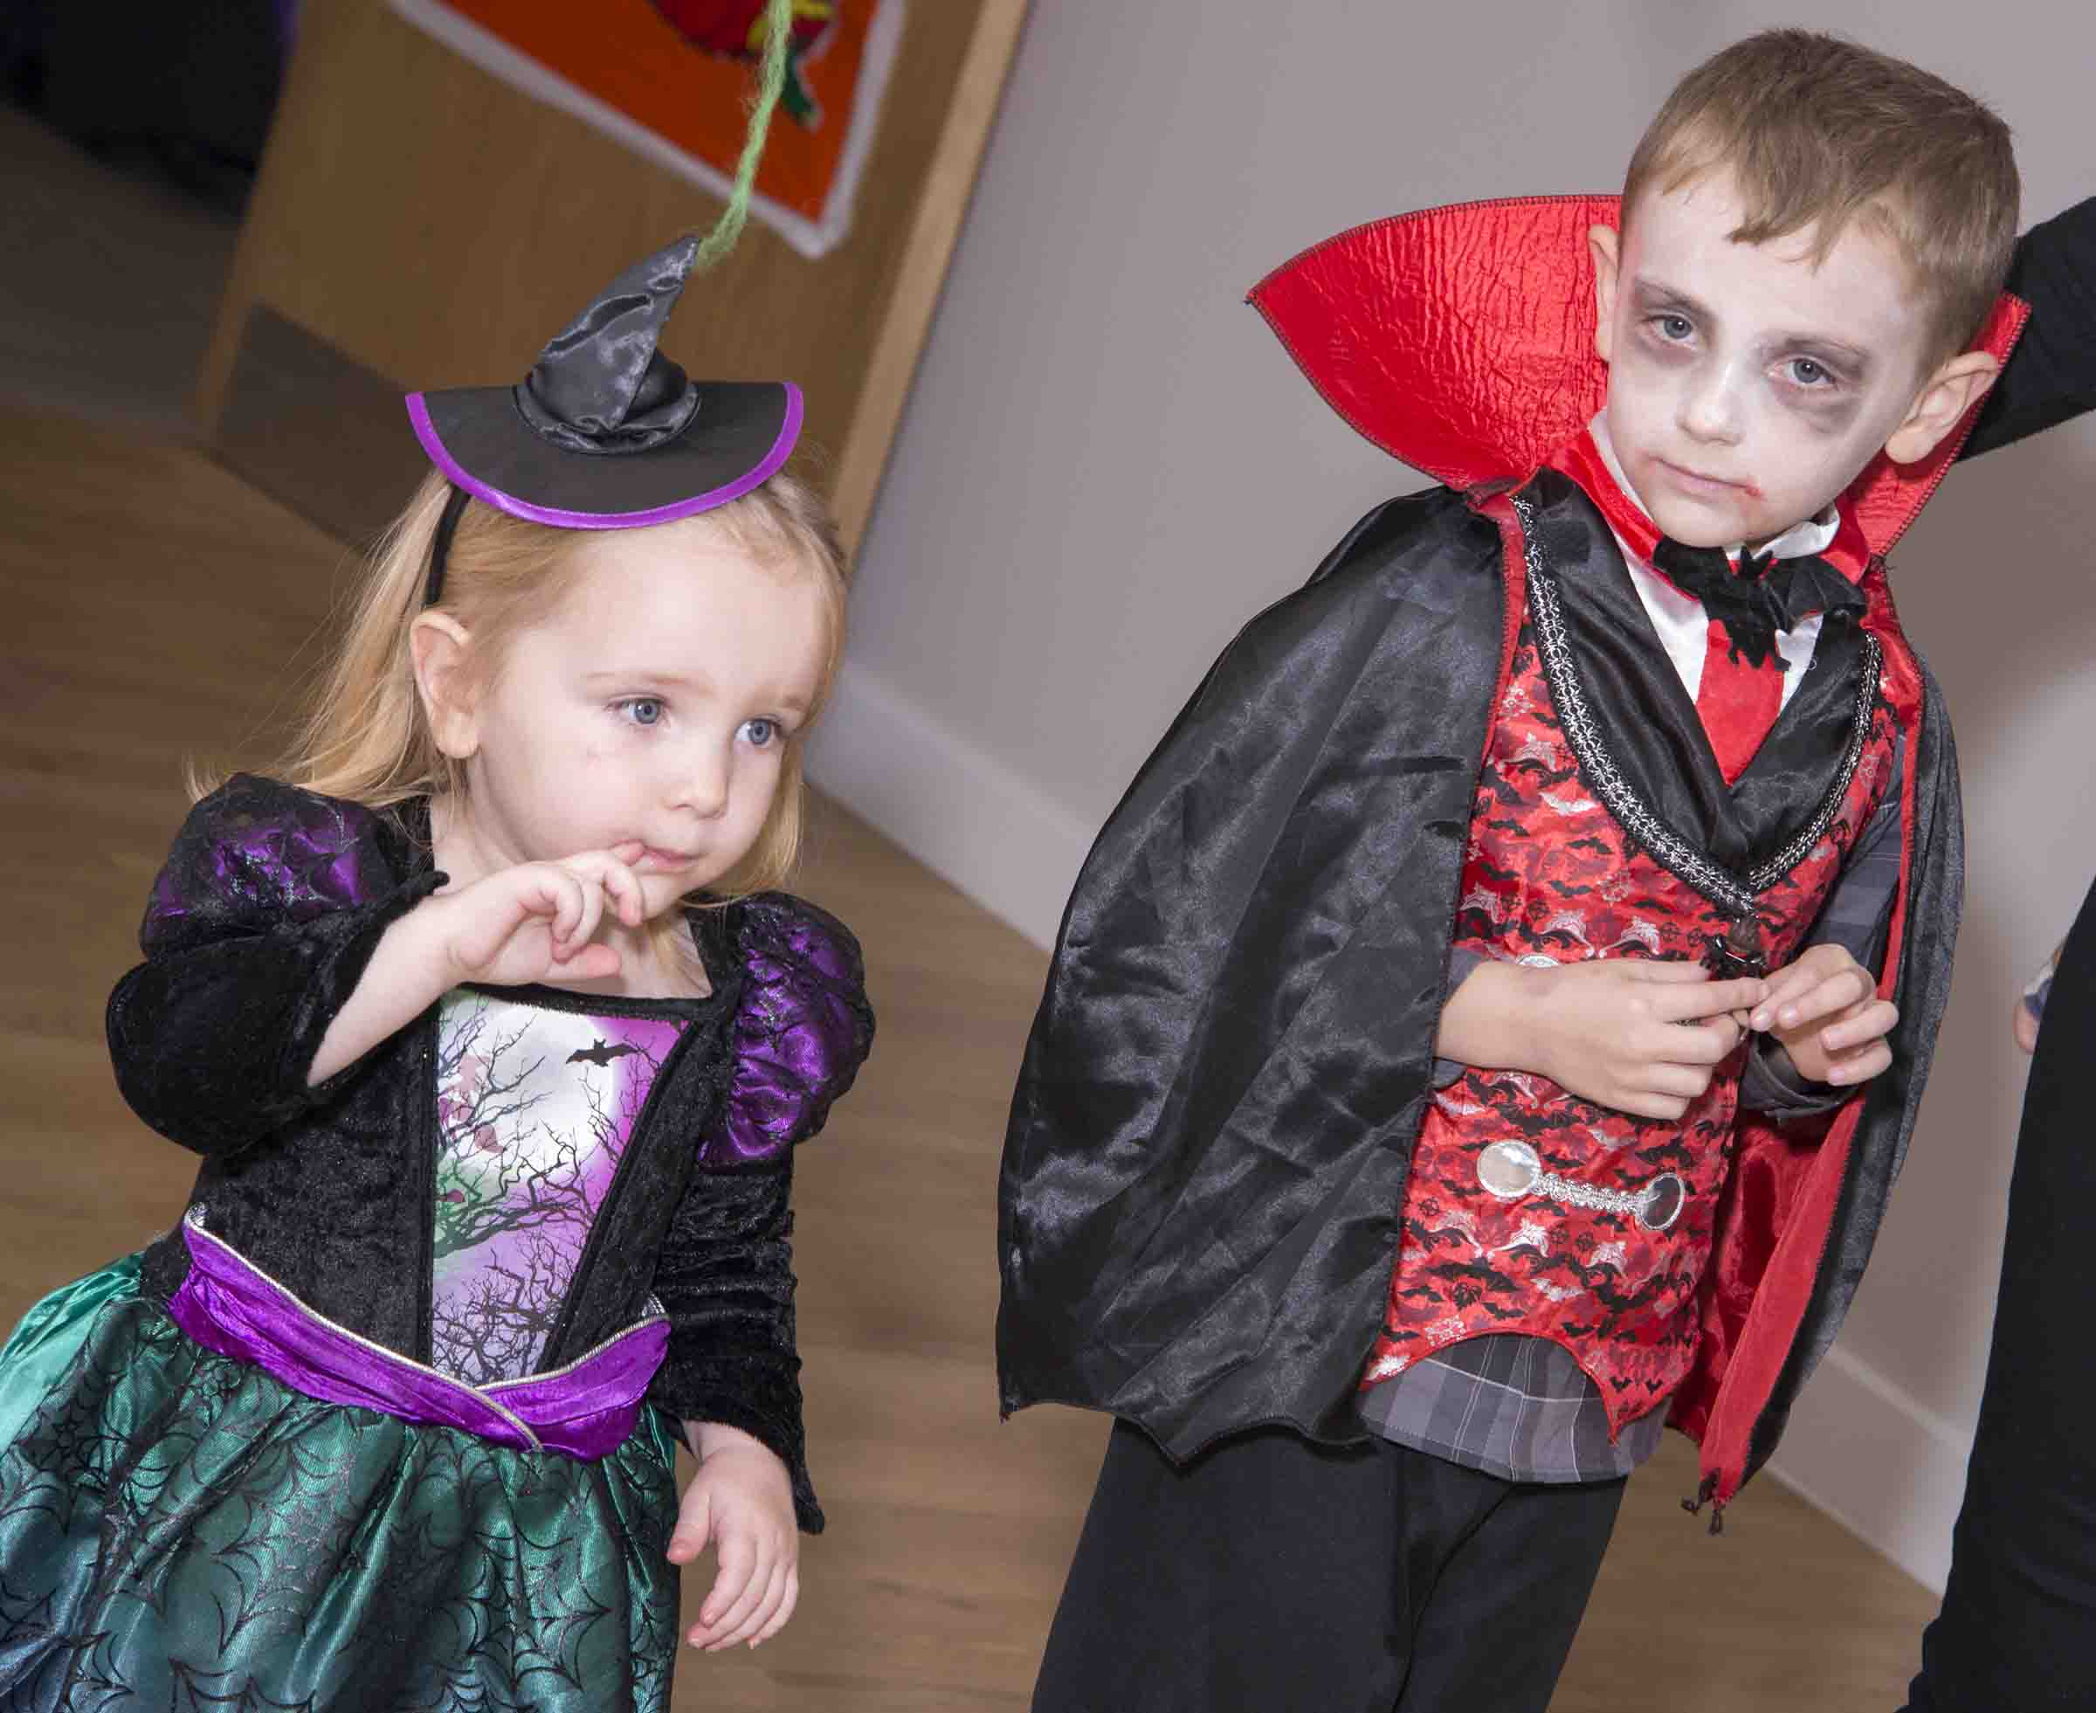
The bubble tunnel may have gone but an altogether more sinister tunnel opened up in the Artificial Limb and Appliance Centre where staff put on a Halloween Disco for children using the service.

A number of clinical rooms were completely transformed into Spooky Ghettos. Children were able to have their faces painted and braved the Tunnel of Doom.

Left: Vampire Charlie Bunkham and sister Alice get into the Halloween party spirit

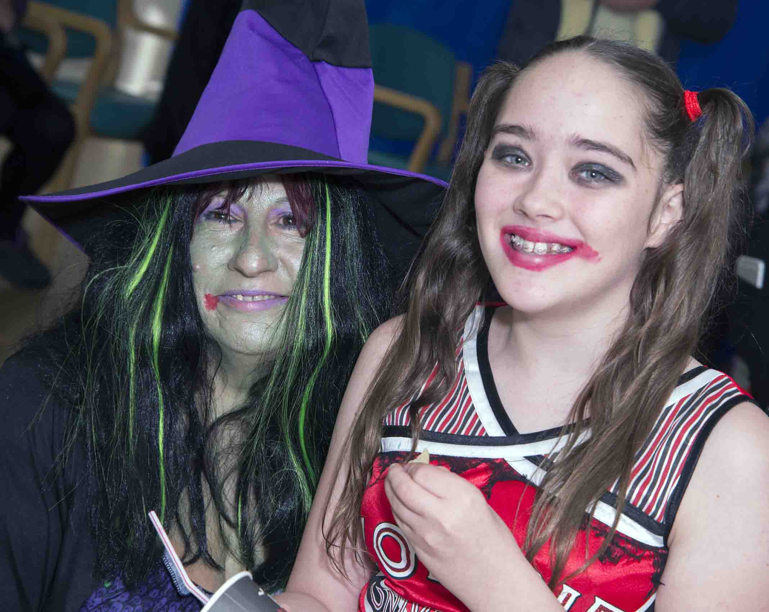
Right: She's behind you! "Witch" Deborah Perry with Madison Bromham

The building rocked to Thriller and other classics and everyone thoroughly enjoyed the event.

Local DJ Steve Thomas of DJ FLO & Tropicana Promotions was kind enough to offer his time and services for free after ALAC staff put out an appeal.

ALAC advanced practitioner occupational therapist Deborah Perry, who was transformed into a green-skinned witch for the occasion, said: "The kids and their families had the most amazing time.

"We would all like to thank Steve so much for all his hard work and for making our Halloween Disco so very special."

Below left: DJ Steve Thomas leads some spooky youngsters an un-merry dance; below right: the witch puts in another appearance

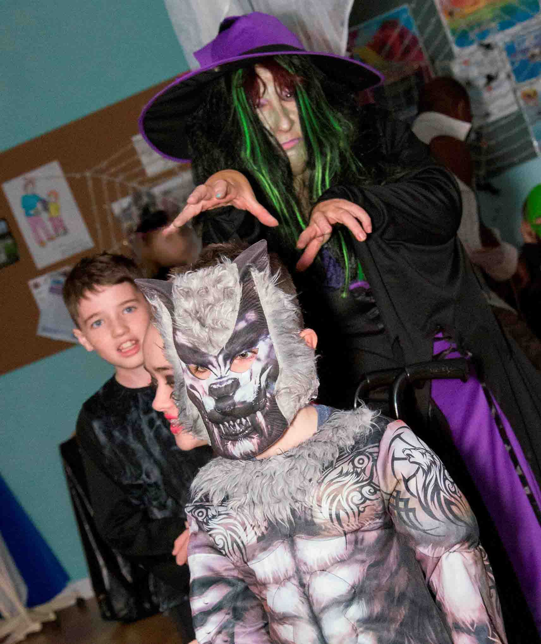
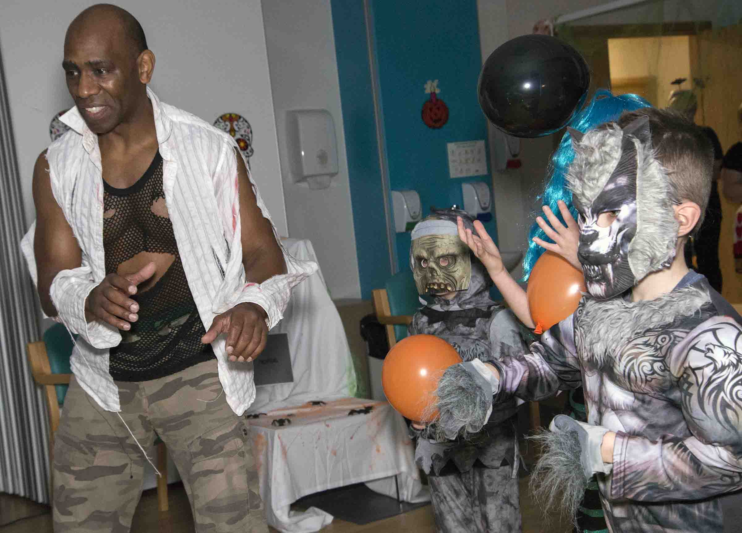

Source: Abertawe Bro Morgannwg University Health Board

