Neath Port Talbot first South Wales hospital to offer NHS prostate procedure
Tuesday, 14 November 2017
Neath Port Talbot Hospital has become the first in South Wales to offer an NHS surgical alternative to men suffering from an enlarged prostate.

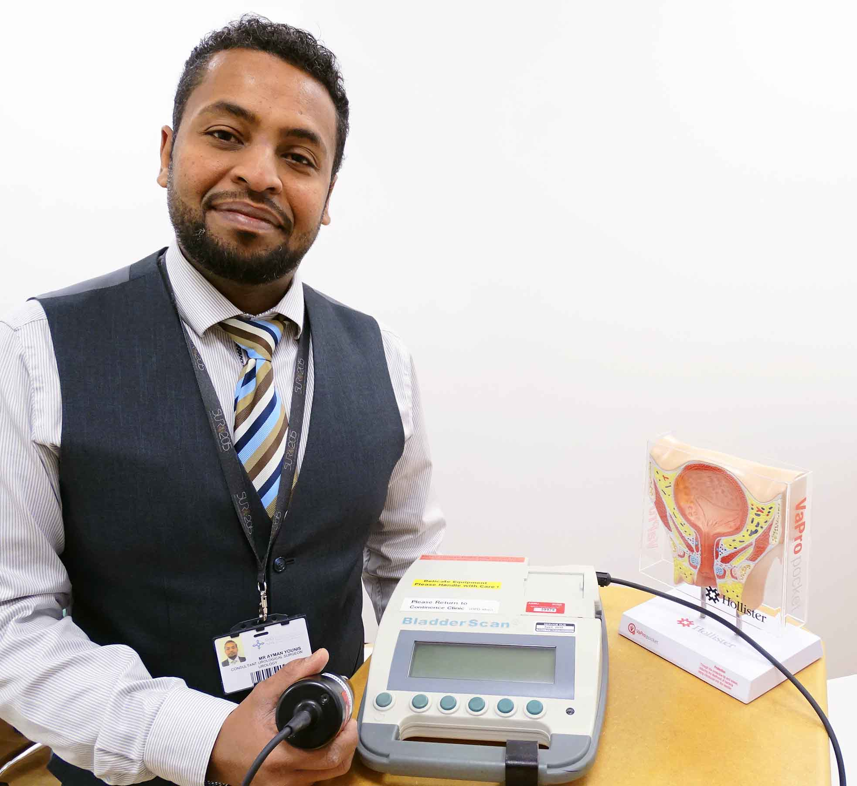
Traditionally, if medication didn’t work the next stage would have been a trans-urethral resection of the prostate (TURP), an operation to remove part of it.

This would have been carried out under general anaesthetic, requiring a hospital bed for one or two nights, and may have caused complications.

Also, surgery could have been postponed due to bed pressure for more urgent cancer cases – leading to longer waiting lists.

However, consultant urological surgeon Ayman Younis (pictured) is the first in South Wales to be trained to carry out UroLift on the NHS.

UroLift is a minimally intrusive procedure which can be done on a day-case basis under general or local anaesthetic – with no hospital admission needed and without the same risk of complications as TURP.

The prostate is a small gland located at the base of the bladder.

Benign Prostate Enlargement is common in men aged over 50. It can put pressure on the bladder and urethra – the tube through which urine flows – causing difficulties passing water.

Mr Younis, who is based in the main urology department at Morriston Hospital, said: “Patients usually start on medication. If this doesn’t control their symptoms, there are surgical options.

“Although TURP is successful in the vast majority of cases, for some there is a risk of complications, including bleeding, infection, erectile dysfunction and incontinence.

“TURP also requires admission to hospital for one or two nights. Because of the pressure on beds for cancer work, the procedure can then get postponed as cancer obviously takes priority.”

UroLift was pioneered in the US. It was introduced in Europe some years ago but has only recently become available on the NHS in parts of the UK.

It involves inserting tiny implants which lift and hold the two lobes (sections) of the prostate apart – similar to drawing apart two curtains with ties.

Mr Younis said: “It’s a simple and quick procedure which doesn’t require hospital admission. More importantly, there is no risk of incontinence or sexual dysfunction.

“We will offer UroLift from this month to suitable patients, though we will carry it out under general anaesthetic until we have become used to it.

“Patients will need to stay here for two or three hours, just to make sure they are okay after the anaesthetic. After that they will be able to go home, in most cases without a catheter.

“As the procedure becomes more established we will do it under local anaesthetic and that will be even quicker.”

Mr Younis said UroLift was available on the NHS in North Wales and a few centres in England. But Neath Port Talbot Hospital was now the first to offer it on the NHS in South Wales.

At the moment, he said, there were around 100 men on the waiting list for TURP. However, as many as eight could have UroLift in a single clinical session.

Mr Younis added: “At a certain point we might run out of patients.

“That is good for the waiting list but, more importantly, good for the patients. There is no risk, no delay, and it frees us up to do other work.”

Source: Abertawe Bro Morgannwg University Health Board

