Pioneering panel dedicated to shaping healthcare for next generation
Monday, 13 November 2017
A ground-breaking group dedicated to improving health care for youngsters across South Wales is hard at work helping to make a difference.
ABMyouth is the first youth health advisory panel in Wales and its members, all aged between 14 and 24, are passionate about shaping services for children and young people.

Supported by ABMU Health Board and Neath Port Talbot Children’s Rights Unit, the 15-strong panel was set up to give young people a voice about things that affect them
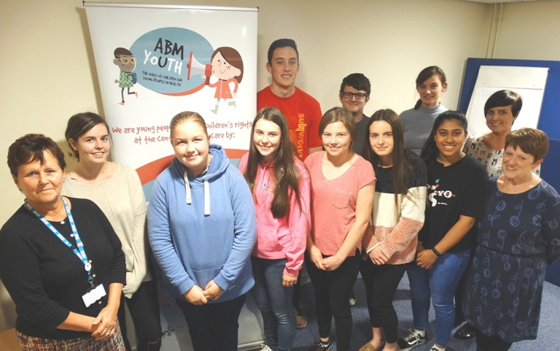
Members of ABMyouth with (left) paediatric patient experience nurse Janette Williams, project coordinator for the Children’s Rights Unit Jannine Smith (second right) and head of nursing, women and child health Eirlys Thomas (right).

Chair Sophie Millar, a 23-year-old medical student, said: “Our team is made up of young people who all bring unique skills and qualities - we have members who have experience of being patients, others volunteer with St John Ambulance and many plan to become nurses, pharmacists and doctors.

“While everyone comes from a different background, the thing we all have in common is a passion for making health services meet the real needs of today’s children and young people.”

The panel aims to highlight different issues and provide valuable feedback to health leaders from a young persons’ perspective.

ABMU’s head of nursing, women and child health Eirlys Thomas has been instrumental in establishing the panel along with paediatric patient experience nurse Janette Williams.

ABMyouth was originally launched in March at the same time as the health board’s pioneering Children’s Rights Charter which sets out the basic rights children and young people can expect when they use health services.

Eirlys said: “We are so proud that ABMU really is setting the agenda when it comes to children and young people.

“Not only is the panel the first of its kind, but we are the first health organisation in the UK to create a Children’s Rights Charter.

“But we can’t make positive changes or improve our care unless we find out what young people really think of us, that is why this panel is so vital.
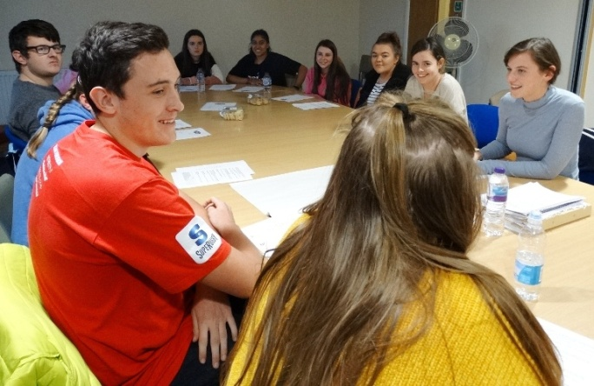
“It has given them a voice and a chance to engage with decision makers. We will now be looking to its members to guide us and tell us what they need.”

Sophie Millar (right) chairs the latest meeting of ABMyouth at Neath Port Talbot Hospital.

Since the group was formed its members have received guidance from Jannine Smith, the project coordinator for the Children’s Rights Unit, but now they set their own agenda as they develop a work plan of projects. Among the first of these was choosing the panel’s name and creating an eye-catching logo.

Now they are turning their attention to developing a questionnaire specifically for younger hospital patients, interviewing patients about their personal experiences and continuing to take part in 15 Steps Challenges. These see them giving staff a child’s-eye view of what they encounter when they first walk – 15 steps – onto a hospital ward.

Sophie added: “ABMU has committed to putting children rights at the heart of its work and it is a pleasure to work with such a forward-thinking health board.

“Being part of ABMyouth is an opportunity for me to be an advocate for young people in the area that I grew up in.”

Like Sophie, Abi Price, aged 17, of Port Talbot, got involved because she is hoping to become a doctor while Aisha Peerbaccus, also 17, of Bridgend, is aiming for a career in mental health.

However, 17-year-old Amber Perry’s motivation for joining was her own experience as a patient with type 1 diabetes.

She said: “I wanted to have a say in making the service better. I am looking forward to raising awareness of services and changing how people feel about them.”
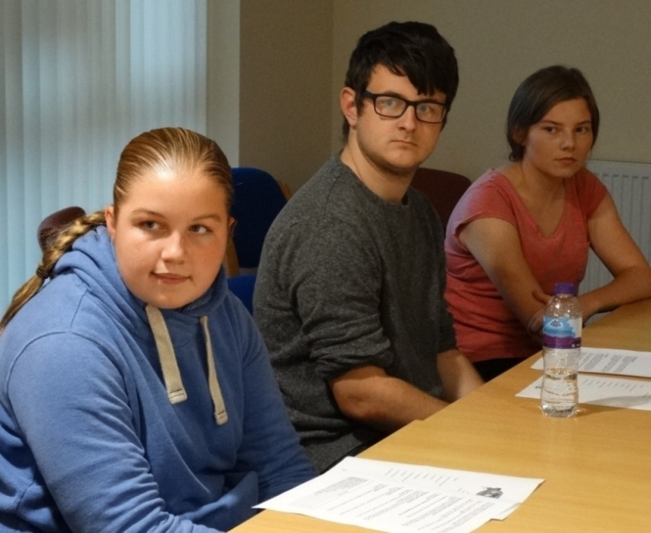
ABMyouth panel members Abi Price, Nathaniel Lewis and Sheona Thomas.

Her colleague Sheona Thomas, aged 18, said: “Initially I joined because I wanted to be a nurse and I thought this would give me an opportunity to see what goes on and how you can help children. It has given me a real insight into healthcare for young people.”

The panel now meets monthly at venues across ABMU and has just signed up a further three recruits to champion children’s opinions and, like the rest of the panel, they will be juggling membership with their education.

Sheona added: “But I feel the least we can do is give up a few hours to help improve services. Good health care for children is definitely worth two hours of my time.”

To find out more about ABMU’s Children’s Rights Charter click here

Source: Abertawe Bro Morgannwg University Health Board

