Staff say thank you to Neath Hospitals League of Friends
Wednesday, 15 November 2017
Staff at Neath Port Talbot Hospital have held a thank-you event for a group of hardworking fundraisers.
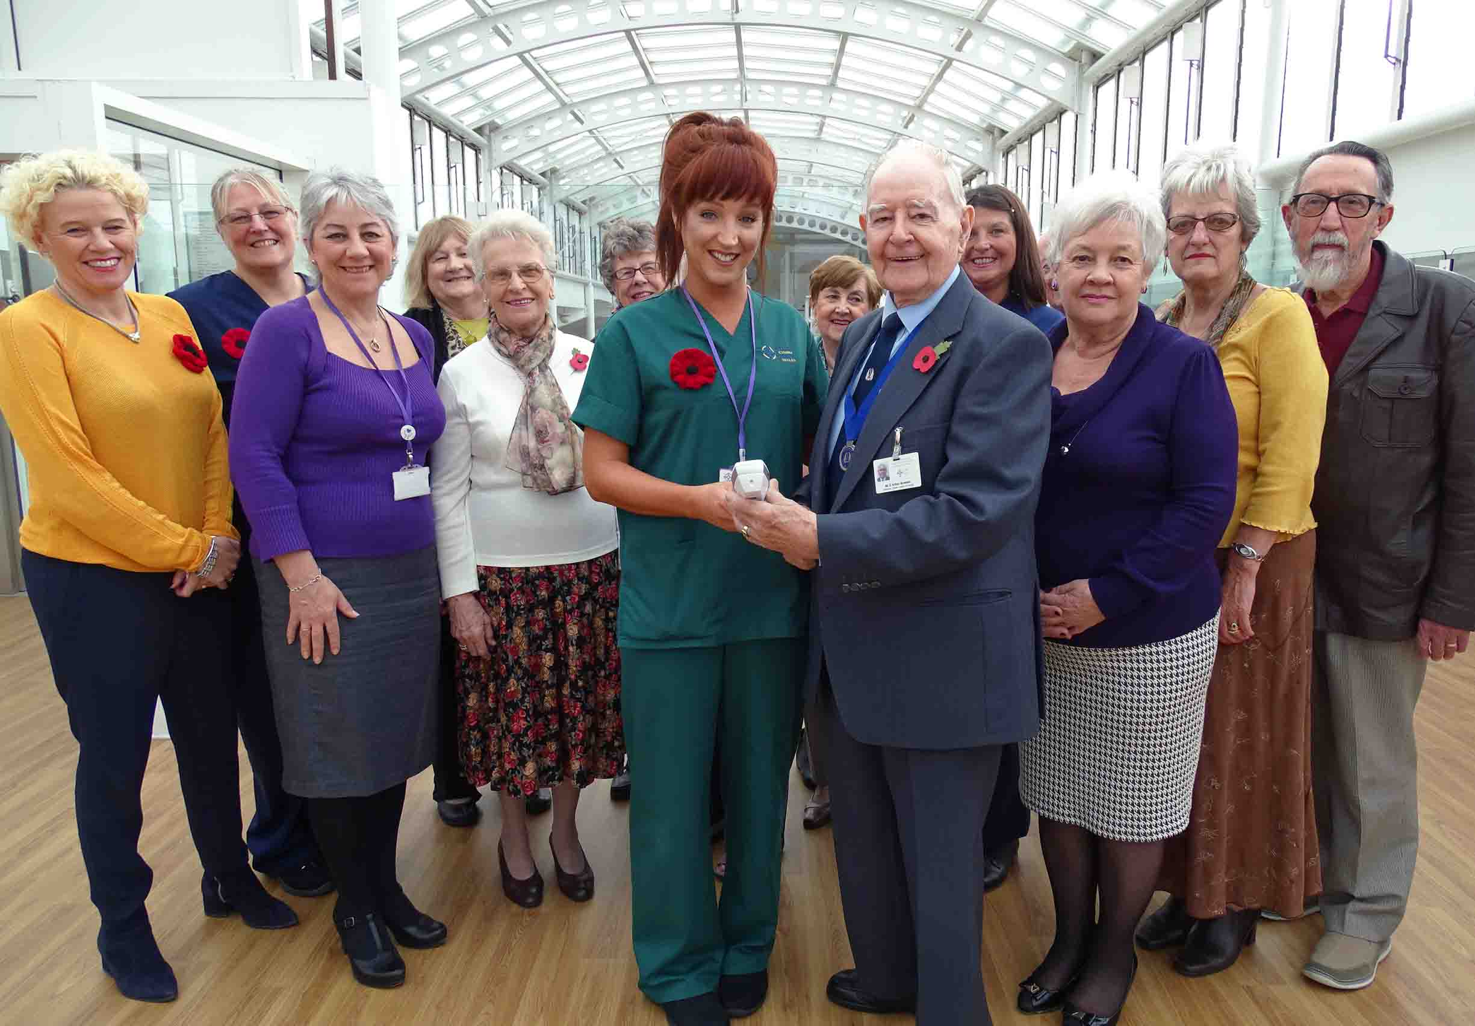
During the last year, Neath Hospitals League of Friends have paid for a variety of equipment worth around £50,000.

Group members, including chairman Arthur Bowden (pictured front with healthcare support worker Michelle Macbeth holding an Accuvein device), join Neath Port Talbot Hospital staff

Representatives of the group visited Neath Port Talbot Hospital where they were thanked for their support, which stretches back decades.

While they were there they were given a demonstration of one piece of kit – known as an Accuvein – which they purchased for the hospital.

It’s a handheld device which allows clinicians to instantly identify veins which may not otherwise have been easily located.

Neath Port Talbot Hospital Unit Director Claire Birchall paid tribute to the ongoing work of the League of Friends, which was formed in 1963.

“It’s great to celebrate another year of working closely with our colleagues in Neath Hospitals League of Friends.

“We are so grateful for their ongoing support and commitment, which provides such a wonderful contribution to the patients, relatives, visitors and staff in Neath Port Talbot Hospital.”

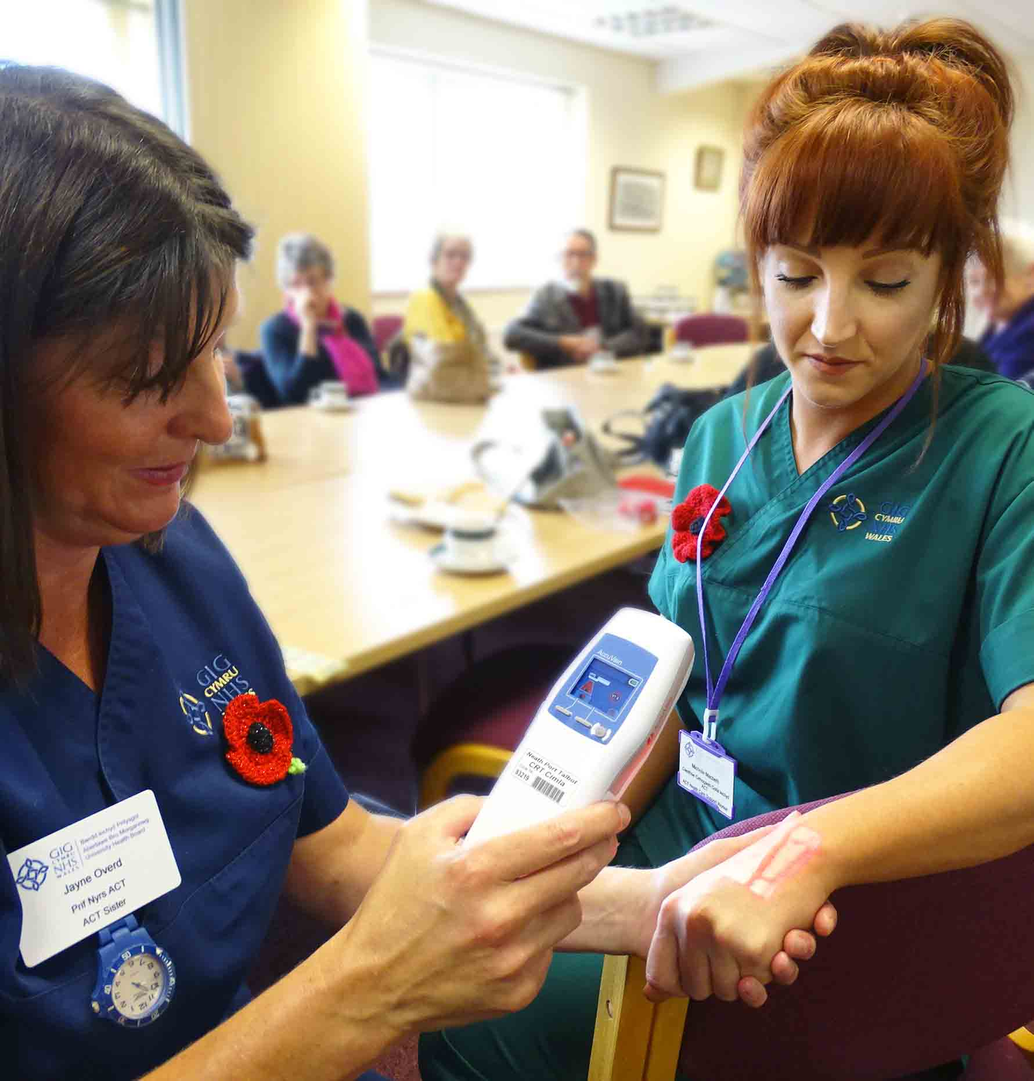
Among the guests was Neath Hospitals League of Friends chairman Arthur Bowden, who first got involved with the group in 1969.

Right: Sister Jayne Overd demonstrates the Accuvein device on healthcare support worker Michelle Macbeth (and below in close-up)

Mr Bowden said: “We must have made close on £2 million in that time.

“We usually put in around £25,000-£30,000 a year but for the last two years, thanks to a large donation we received, we have been able to put in £50,000 a year.”

The group has committees in Neath town centre, Skewen, Bryncoch, Glynneath, Cadoxton and Crynant which hold regular fundraising events.
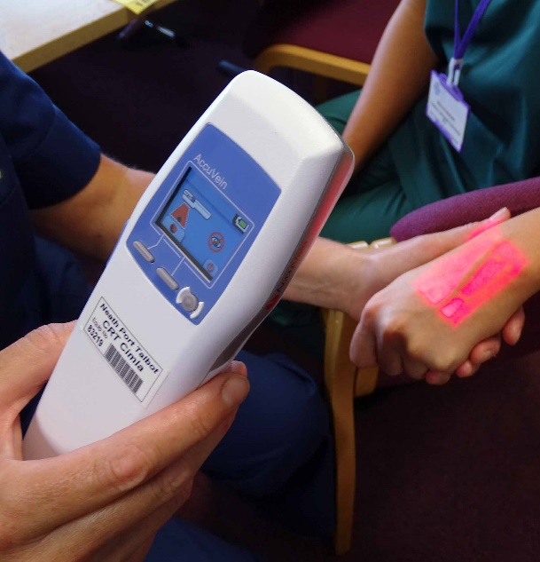
Volunteers also have regular collections in Neath Port Talbot Hospital.

Mr Bowden said Neath Port Talbot received the lion’s share of the money but the group also supported Tonna Hospital.

The most recent large contribution was to support Tonna’s Forget Me Not garden, where day patients can sit and enjoy the outdoors.

Mr Bowden said: “We also buy a parcel of items for every patient who is in Tonna at Christmas.”

Mr Bowden said the group was looking for new members and anyone interested should call the secretary, Howard Davies, on 01639 636001.

Source: Abertawe Bro Morgannwg University Health Board

