Vaughan Gething visits project offering hope to patients with Irritable Bowel Syndrome
Friday, 24 November 2017
Health Secretary Vaughan Gething has been finding out how a change of diet has transformed the lives of people suffering from Irritable Bowel Syndrome (IBS).

IBS affects up to one in five people and can cause stomach cramps, bloating and diarrhoea or constipation.

ABMU prescribing support dietitian Debbie Thomas is working with five Bridgend GP surgeries on a pilot project involving the low FODMAP diet, which identifies foods believed to trigger the symptoms.
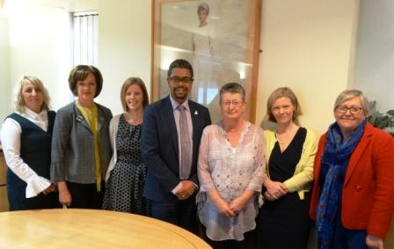
Pictured l–r: Alex Gibbons, locality head of medicines management; Debbie Thomas, prescribing support dietitian, patient Patricia Jones; Welsh Health Secretary Vaughan Gething; patient Lorraine Hornso-Pedersen; ABMU Vice Chair Emma Woollett and Director of Therapies Chris Morrell.

The results have been remarkable, with more than three-quarters of patients who stick to the diet reporting their IBS has eased or even disappeared completely.

IBS affects 15-20 per cent of people, which equates to around 21,000 in the Bridgend area alone – and 450,000 across Wales.

They are often prescribed medication to control the symptoms. Some may previously have been sent for a colonoscopy or endoscopy.

Debbie said: “Often patients go through these unpleasant procedures only to be told it’s ‘just’ IBS. But there’s no ‘just’ about it, IBS is very debilitating and embarrassing so people don’t really talk about it.

“It can have a really serious effect on their lives.

“Traditionally, GPs may refer the patient to a dietitian and they would be given advice such as looking at the regularity of their food, making sure they drink plenty of fluid and adjusting fibre. But, unfortunately that has only limited success.”

In the pilot project GPs refer appropriate patients to Debbie, who sees them in their local surgery usually within two weeks.

Usually only two appointments are necessary. The first is the elimination stage, which involves taking out all high-FODMAP foods.

The second, arranged after their symptoms improve, is the reintroduction phase to identify which foods cause the problem.

“This gives patients the choice to avoid trigger foods completely or eat them in small amounts – with the confidence that any symptoms will improve once they remove them from their diet again.”

Since starting the pilot in early 2015, Debbie has seen around 250 patients. Not all of them decided to try the diet, but 75 per cent of those who did have seen dramatic improvements.

Debbie has also introduced a second, even more successful pilot for ABMU staff after being inundated with requests.

Many of Deb’s patients wanted to come along during the Health Secretary’s visit to share their experiences.

Lorraine Hornso-Pedersen, from Bridgend, has had IBS for over 29 years.

She said: “My IBS was so bad I had to finish work. I never thought there would be an end to it. I thought I’d be ill for life. Now I’m on stage two of the diet and my life has been turned around.”

Patricia Jones, from Swansea, works for ABMU and has had such severe IBS for 11 the last years she would go days without food.

She told the Minister: “When I saw the diet on the staff intranet I thought ‘Oh My God’, there might be a way to stop this. Get me on that diet!

“Not long after starting on the diet my stomach was amazing; my medication was reduced and now for the first time in years I have three meals a day.”

Both Lorraine and Patricia agreed they’ve got their lives back, something they can’t put a price on.

Meeting with staff and patients, Health Secretary Vaughan Gething said: “IBS is a debilitating condition which can disrupt a person’s everyday life. Those suffering from IBS may often miss work or school, which could lead to a change in working hours, working from home or not working at all.

“Today has given me the chance to learn more about the pilot study at Abertawe Bro Morgannwg, which is unique in Wales, and I’m pleased to hear the project has shown encouraging results so far.

“I’m eager to see how this project progresses and I’m confident this type of service can improve the quality of life for those suffering with IBS across Wales; reduce waiting times for gastroenterology, lessen the need for invasive procedures and help ease the burden on GPs.”

Following the success of the pilot project, ABMU are now looking at how they can provide the service to even more patients.

Source: Abertawe Bro Morgannwg University Health Board

