Watch out – there’s art about at hospital thanks to patients’ hard work
Wednesday, 29 November 2017
Keep your eyes peeled if you are walking around the corridors of Neath Port Talbot Hospital... you may spot something unexpected.

Over the past few weeks tiny artistic creations have been popping up all over the site, often in unlikely settings.
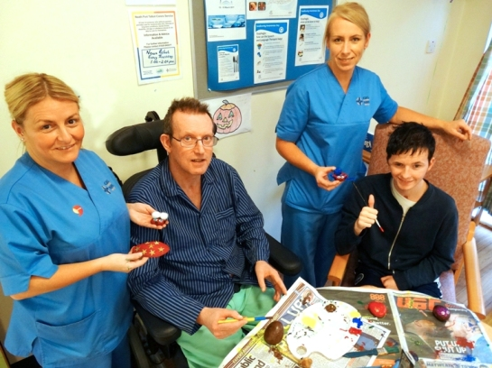
The little keepsakes are the handiwork of patients in the Neuro-Rehabilitation Unit who have been getting creative as part of a new project.

Staff nurses Helen Sandry and Zoe Evans with patients Edward Williams and Nathan Davies and some of the artwork they plan to abandon round the hospital.

It was the idea of staff nurse Helen Sandry who was inspired by a nationwide initiative called Art Abandonment which encourages people to leave pieces of their art work behind for someone else to find.

She said: “On World Mental Health Awareness Day last month I spotted a placard that someone had left by the hospital grounds saying ‘Stay strong, keep smiling’.

“We have always done craft activities with our patients but usually they have been linked to a theme like Halloween or Christmas.

"But when I saw this it made me think we could do something similar and use the hospital site to let people see what we have been making.”

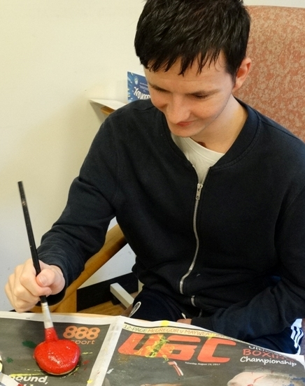
Using anything from pebbles to pine cones as a basis, the unit’s patients have been busy coming up with interesting
items.

“We guide them but they have been coming up with some wonderful ideas. Once they are finished we have been putting them all over the hospital, to make people smile,” said Helen.

Teenager Nathan Davies (right) said: “I really enjoy it and like making them all look a bit different.”

Each piece has been left with a brief note explaining that it is a piece of free art and the finder is welcome to take it, pass it on or just leave it for someone else to enjoy.

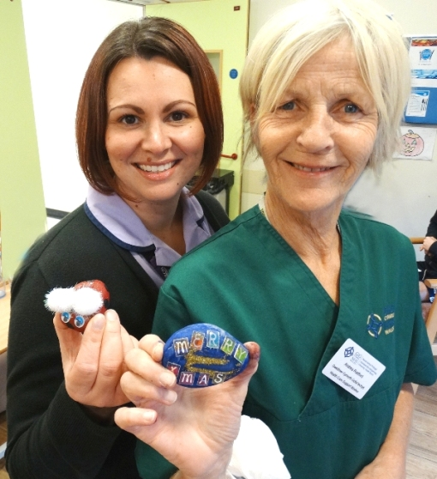
Neuro Rehab Unit ward clerk Joanna Lewis and healthcare support worker Andrea Radford with some of the creations.

“So far everything we have left has gone so we are busy coming up with more but we would love to know what people think of them and where they are now,” added Helen.

If you have spotted any of the art around the hospital you can let staff know what you think of it via Facebook

Source: Abertawe Bro Morgannwg University Health Board

