Youth panel share their passion for healthcare with Vaughan Gething
Wednesday, 22 November 2017
Welsh Health Secretary Vaughan Gething chose Universal Children’s Day to find out more about the unique way ABMU is seeking to develop and improve its services for young people.

He came to Neath Port Talbot Hospital to meet the members of ABMyouth, the first youth health advisory panel in Wales, and hear for himself how they plan to make a difference for youngsters.

The group was set up at the same time as the health board’s pioneering Children’s Rights Charter and aims to highlight different issues and provide valuable feedback to health leaders from a young persons’ perspective.

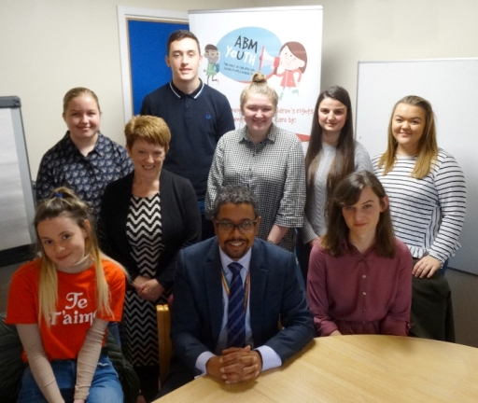
Their mission attracted the attention of Mr Gething who was eager to find out more about the panel which has members aged between 14 and 24 and reports directly to ABMU’s executive board.

Cabinet Secretary for Health Vaughan Gething with ABMU’s Eirlys Thomas and ABMyouth panel members Cerys Isaac, Abi Price, Ben Heywood, vice-chair Catrin Davies, Rudina Koko, chair Sophie Millar and Caitlyn Young.

He said: “I’m really interested in how you think you can best understand and listen to young people and then inform other people about what they want.”

ABMyouth chair Sophie Millar outlined the group’s immediate priorities including increasing awareness of the Children’s Rights Charter and holding talks with CAMHS, Child and Adolescent Mental Health Services.

The panel also took the opportunity to question Mr Gething about how healthcare in Wales compares with the rest of the UK, what the biggest difference he feels he has made to children and young people and about the challenges of his role.

“It’s not always easy but it is really rewarding to make changes and to make a difference,” he said.

“There is not just one answer for every person. It’s about how we recognise people’s needs individually and how we address those needs.”

Sophie said she was delighted Mr Gething had agreed to meet the panel, which is also supported by Neath Port Talbot Children’s Rights Unit, and that he would be taking a keen interest in its progress in future.

Sophie said: “ABMU has done a brilliant job of listening to children and young people and taking their views to a level where adults are seeking to make changes and today took this one step further.

“Meeting the Cabinet Secretary for Health for Wales puts young people and their opinions on a national level. Hopefully it’s a step forward and a good example of the way the Assembly wants to listen to children and young people for the future.

“Today has been a good way of making sure that we are the link between adults and the children who need help.”

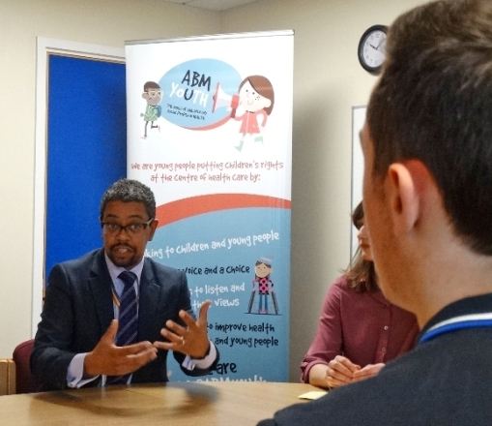
Vaughan Gething discussing healthcare with members of the ABMyouth.

Mr Gething was welcomed to the hospital by ABMU’s head of nursing, women and child health Eirlys Thomas whose work to create the Children’s Rights Charter and establish the youth panel led to her being honoured at last week’s RCN Wales Nurse of the Year Awards.

He told her he was now eager to see her share her experience and knowledge of promoting children’s rights with other health boards.

She said: “We are so pleased the Health Secretary chose Universal Children’s Day to come and find out more about our work here.

“The awareness day aims at highlighting and championing the welfare of children and young people and that is just what we hope ABMyouth will do too.

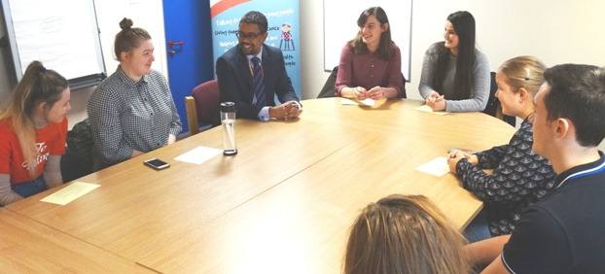
“We are very proud of the progress we have made but we know there is more to do and are eager to have the guidance of the youth panel members as we improve and develop our services for the future.”

Cabinet Secretary for Health Vaughan Gething with members of ABMyouth at Neath Port Talbot Hospital.

Source: Abertawe Bro Morgannwg University Health Board

