ABMU patient care honoured at RCN In Wales Awards
Thursday, 22 November 2018
Dedication to improving patient care has seen four ABMU nurses recognised at a national awards ceremony.

Alison Lewis and Hannah Rowlands triumphed in their categories at the RCN in Wales Nurse of the Year Awards, while Jonathan Gapper and Andrea Donald were runners-up.

Alison picked up the Innovation in Nursing Award for her work in improving care for patients with chronic obstructive pulmonary disease (COPD).

Hannah, who works at Princess of Wales Hospital, was named Health Care Support Worker of the Year for bringing her fresh ideas to improving patient experience in Ward 14.

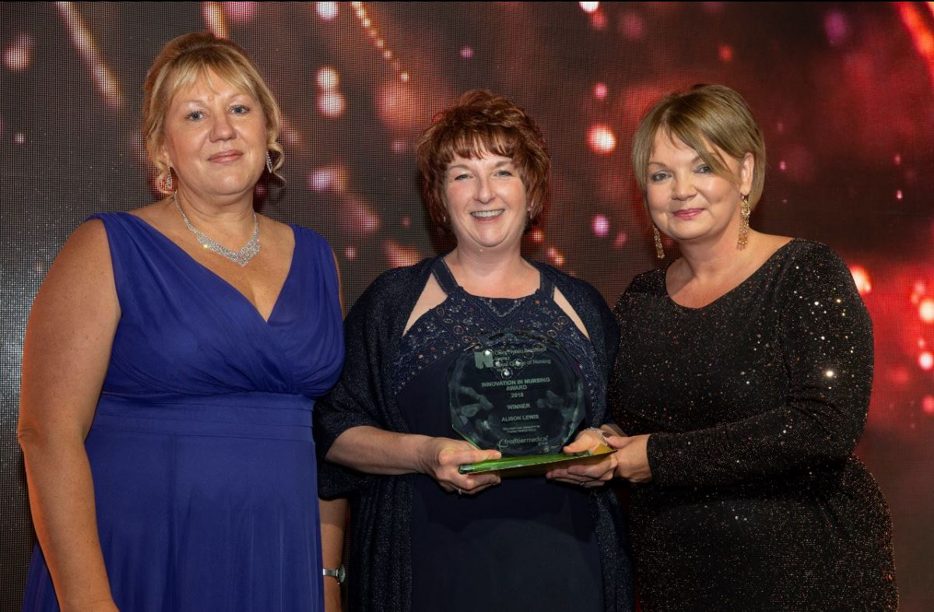
Alison’s innovation helped to improve the outcome of care of patients across Bridgend.

With support from her team, she introduced a self-management service for patients with COPD.

Left: Alison recieving her award

This teaches self-management skills to patients in their own homes to improve their quality of life, and reduce their risk of going into hospital.
They now accept referrals from GPs and practice nurses.
Alison said: “We have been delighted by the enthusiasm and willingness to work in new ways we have experienced when working with the GP practices in Bridgend.

“This has allowed us to work together to improve patient care.
“I was delighted and surprised to win the RCN Wales award. It was wonderful to have recognition for this project and also raise the profile of this distressing disease.

“None of this would have been possible without my amazing team, Jade Bazylkiewicz and Edward Davies.”

Support worker Hannah has only been in post just over a year.

But she was acknowledged for her eye for fresh ideas in improving patients’ stay in hospital.
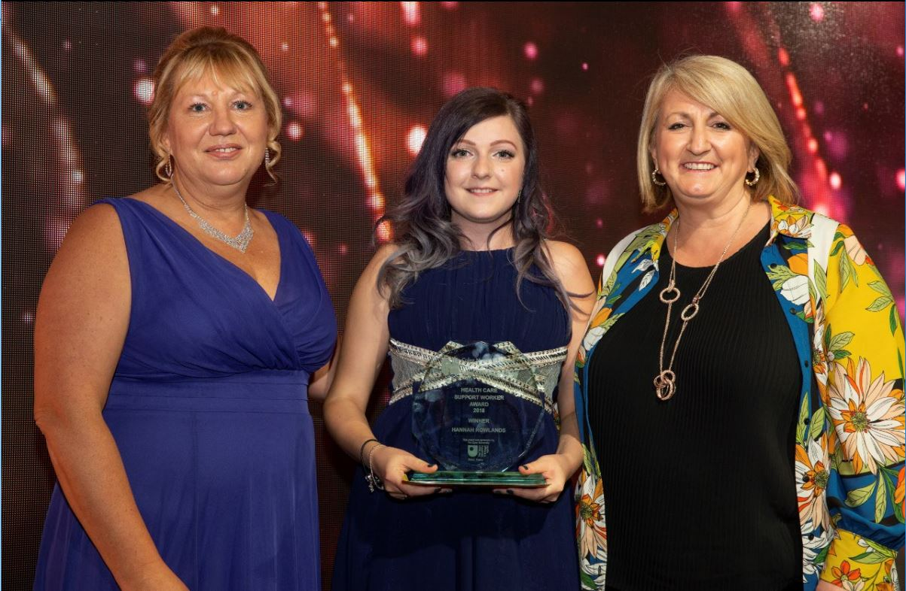
When she joined Ward 14 at POWH, a mental health ward, she noticed the patient leaflets lacked a lot of essential information.

Right: Hannah receiving her award

So she developed a new leaflet which included visiting times, telephone numbers, meal times, information on their rights as well as activities and a map of the ward.

She also came up with a food ordering system, which gave patients more of a say in what they ate.

Hannah also leads on the quality improvement programme and many fundraising events in the ward.

She said: “I would like to thank all my colleges on ward 14 and all of POWH’s quality improvement team for their support and enthusiasm in helping me develop the information leaflet, and much more.”

Jonathan, from the Psychiatric Intensive Care Unit (PICU) at Princess of Wales Hospital was runner up for the Mental Health and learning Disabilities Nurse of the Year award.

This was for his optimism and ability to support both patients and colleagues.

Jonathan has worked with colleagues to develop a transfer of care document. He has also taken an active leadership role in helping colleagues to complete the documents for patients at the end of their time on a ward.

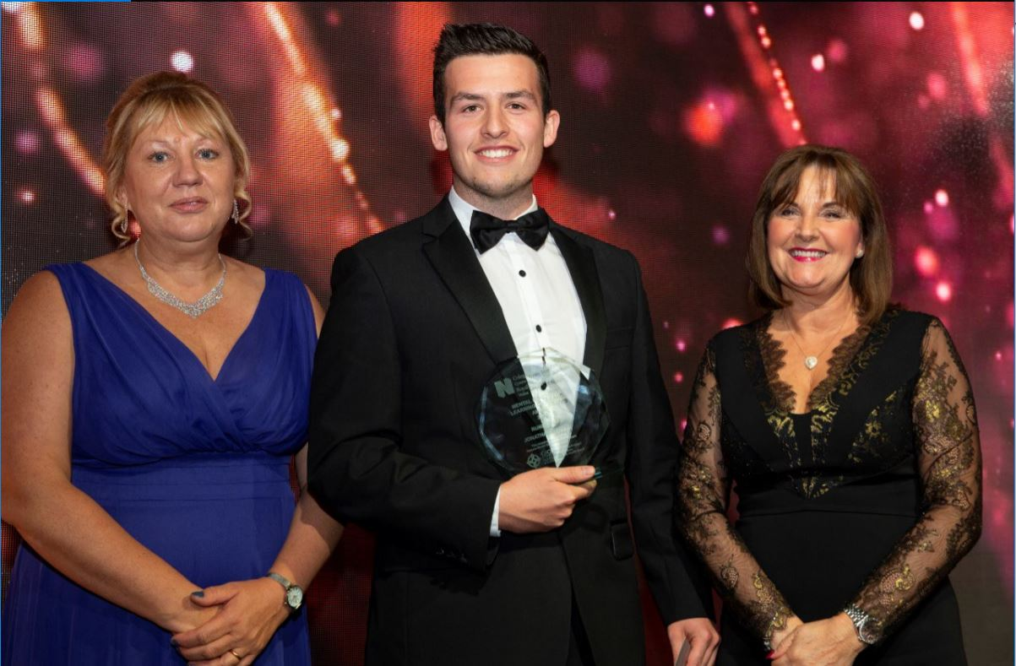
Left: Jonathan receiving his award

The document is completed with the patients to increase insight to their mental health, wellbeing needs and recovery.

Jonathan said: “I was overwhelmed by my initial nomination and never believed I would make the shortlist.

“I felt completely humbled to be part of an inspiring event and share a room with incredible individuals.

“Being runner-up for the award is certainly the pinnacle of my career to date.

“I am lucky enough to be part of fantastic team at PICU and this would not have been possible without their support.”

Andrea, health support worker at Gorseinon Hospital took runner up for the Health Support Worker of the Year.
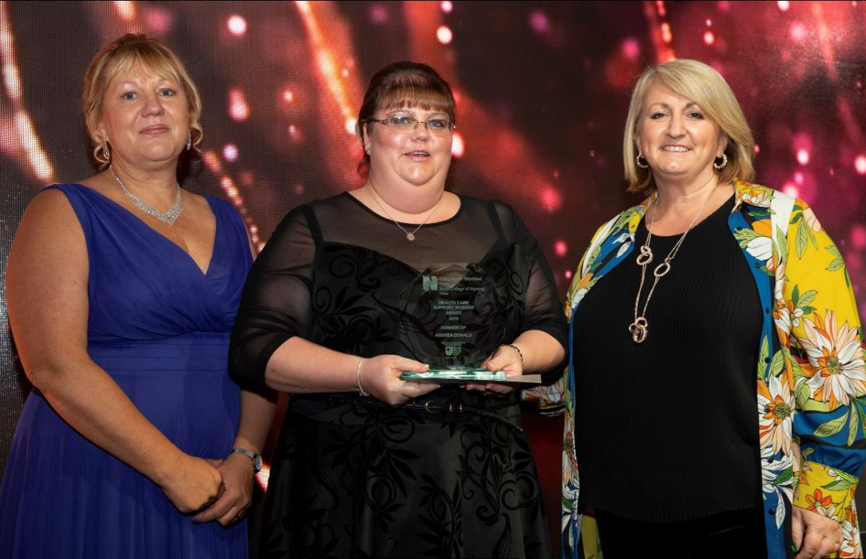
She has shown huge commitment to motivating patients at Gorseinon Hospital to become more active and generally more social.

Right: Andrea receiving her award

Andrea said: “Our aim is to get them from their pyjamas into their day clothes and to sit away from their beds and interact more with each other.

“I really want them to feel like more of a community and talk to each other.

“We have now introduced activities twice a week – from bingo to arts and crafts, and church twice a month.

“I am completely shocked I was nominated, let alone awarded runner-up.

“I am absolutely honoured and would like to thank my team for thinking of me.”

ABMU Director of Nursing and Patient Experience, Gareth Howells, said: “The RCN Awards is a fantastic way to showcase and share the amazing work that contributes to patient care across all the health boards in Wales.

“We are delighted for Hannah, Alison, Jonathan and Andrea and are extremely proud of all of our nurses, midwives and health visitors at ABMU.

“This success at the awards really highlights the best of our teams and our primary focus, which is doing the best by the people we look after and their families.”

Source: Abertawe Bro Morgannwg University Health Board

