Hospital volunteer of 15 years celebrates 90th birthday
Friday, 2 November 2018
A hospital volunteer who is celebrating her 90th birthday says she cannot imagine not being there for the patients.
Angelina Jenkins has volunteered every Thursday at a palliative care day centre in Bridgend for the last 15 years.

And despite turning 90 she has no intentions of slowing down anytime soon.

Angelina has become a listening ear for patients during her time volunteering at Y Bwythyn Newydd in Princess of Wales Hospital.

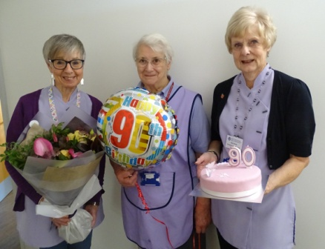
She said: “I have often thought about finishing, but I just can’t bear the thought of not coming to the centre and chatting to the patients here.

“You really get to know people.

“Although we are so thrilled when they are able to leave the unit and return home, it’s really sad to say goodbye.”

Pictured left: Volunteers Yvonne Brown, Angelina Jenkins and Helen Berron - celebrating Angelina's 90th birthday at Y Bwythyn Newydd. A combined 44 years of volunteering for ABMU Health Board.

She is best known in the centre for her creative skills – holding regular arts and crafts sessions for patients.

Angelina said: “We have so much fun.

“I’ve even learnt some arty skills from some of the patients.

“We have been making birthday and Christmas cards which we then sell to raise money for the centre.”

The art sessions have brought out an artistic flair in some patients and a hobby they can continue enjoying when they return home.

This helps reduce boredom and loneliness, which many patients face.

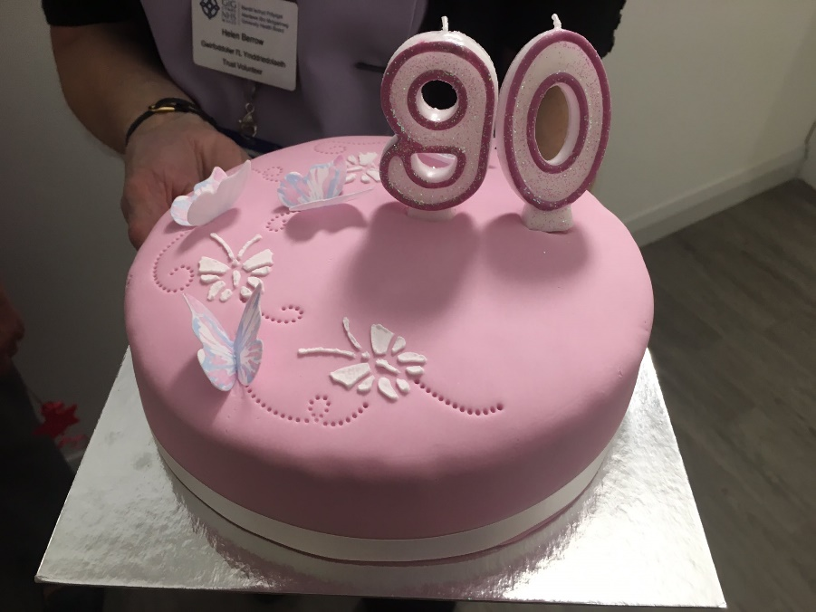
Service Director Jan Worthing said: “Angelina is brilliant with the patients and such an asset to the centre.

“They really bond with her and look forward to seeing her on a Thursday.

“I have great respect for Angelina and the help and support she provides patients while at Y Bwythyn Newydd.

“Thank you Angelina for dedicating your time to volunteering and Happy 90th Birthday.”

Volunteer Services Manager Jo Parry added: “Angelina is one of over 550 people who regularly volunteer as part of team ABMU.

“Their dedication and commitment bring added value and complement our existing services to enhance patient and visitor experience."

ABMU Health Board is always looking for new volunteers and new departments to involve volunteers in creative ways. If anyone would like to discuss this further please contact the Volunteering Services Department volunteer.centre@wales.nhs.uk

Source: Abertawe Bro Morgannwg University Health Board

