Morriston Hospital gets new specialist facilities at a cost of £1.1 million
Friday, 2 November 2018
An investment of more than £1 million is creating two new specialist facilities at Morriston Hospital.

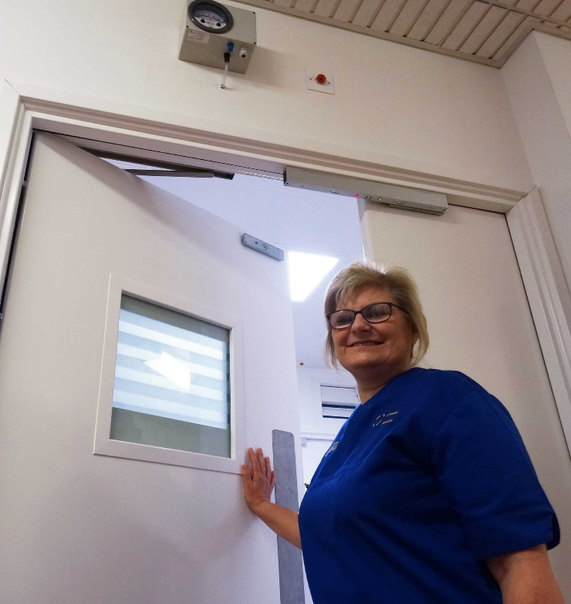
Work starts on Monday (Mon 5th) on a £700,000 negative pressure isolation suite within the Emergency Department.
It will be used for patients suspected of having infectious respiratory diseases such as pulmonary tuberculosis.

This follows the opening last month of a matching facility in Ward S, one of Morriston’s general medical wards.

Morriston Hospital clinical educator Heather Harries outside the Ward S negative pressure suite. Above the door is a pressure gauge – an alarm will sound if the pressure falls too low

Negative pressure is an isolation technique commonly used in hospitals to prevent cross-contamination between rooms.
It includes a ventilation system which allows air to flow in the isolated area but not to escape from it. Air from the room is instead diluted before being released to a safe area.
Becky Gammon, Head Nurse at Morriston ED (pictured below right), said: “As airborne infections can spread, this suite will help us to keep patients and staff safe.
“It will ensure patients receive the specialist treatment and care they need as quickly as possible.
“This will be a completely self-contained isolated area, with bathroom and a robing and disrobing area for staff. There will also be one-to-one nursing.
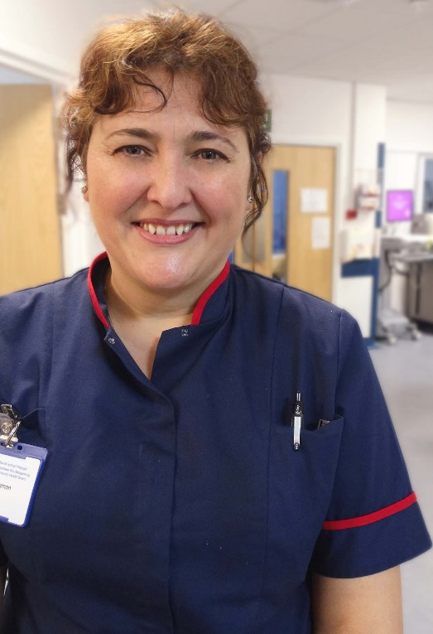
“The aim is to have it open early next summer. It’s a great development for ED and it recognises there is the need for such a facility – it’s the gold standard.”
Project Manager Marcus Eyre said work on the ED development would be phased to minimise disruption during the busy winter period.
“People using the ED will see very little difference. A small area next to the main entrance will be closed off but the entrance itself will be kept clear.”
Ambulance drop-off will not be affected, although six parking spaces will be temporarily lost to accommodate skips and a material store.
Becky said: “We would ask the public to bear with us while this essential work is carried out, and to park responsibly and appropriately during the construction period.”

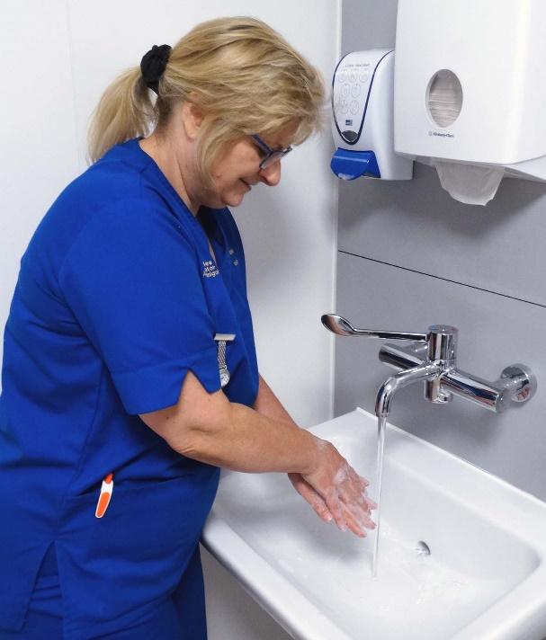
Left: Heather scrubs up in the Ward S isolation suite anteroom
The negative pressure isolation suite in Ward S opened a few weeks ago and cost around £400,000 to develop. It can be used as an additional general medical bed when not needed for isolation.
Acting Infection Control Matron Lisa Manchipp-Taylor said such facilities were common in hospitals and the development at Morriston would bring it into line with the latest Welsh Government standards.
She added: “It’s about improving safety and the level of patient care we are able to provide.”
Source: Abertawe Bro Morgannwg University Health Board

